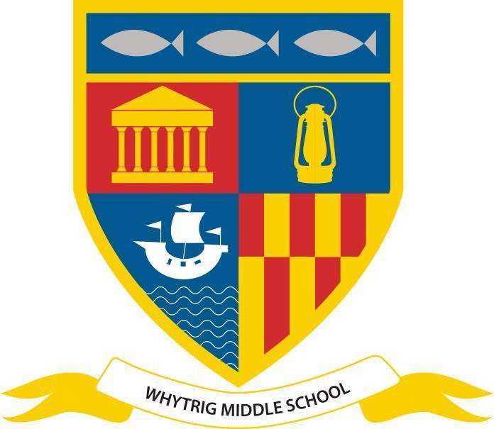
WHYTRIG MIDDLE SCHOOL
One of the Seaton Valley Federation of Schools

Elsdon Avenue, Seaton Delaval, Northumberland NE25 0BP
Tel: 0191 2371402
Email: wms@svf.org.uk
www.svf.org.uk

Executive Headteacher: John Barnes
Head of School: Jonathan Souter

Notices - Week beginning 10th June 2024

Attendance

Please remember to call in or send a message via MCAS if your child is unwell and will not be attending school by 8:30am. It is important that we have evidence for each day your child is absent, even if they were sent home the previous day.

Please also send evidence of medical/dental appointments so we can attach these to your child’s profile on our system.
Mental Health Tip of the Week
Less a tip, as such, this week. Rather some information which may help you
open up a conversation about anxiety.
What is Anxiety? | Mental Health Literacy
Year 5 - Whitehouse Farm Trip - 4th June

Year 5 had a fantastic trip to Whitehouse Farm on Tuesday!
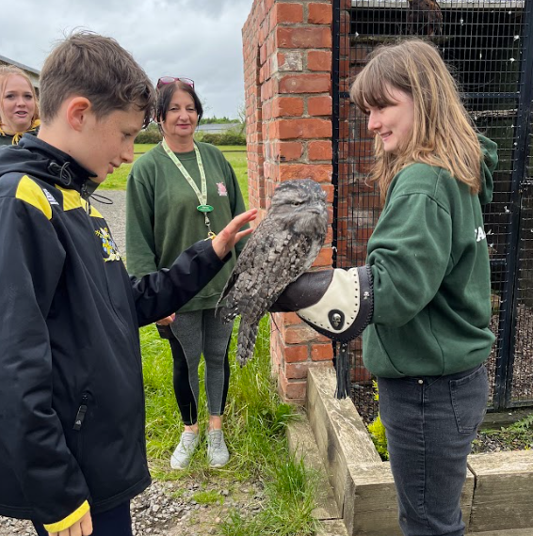
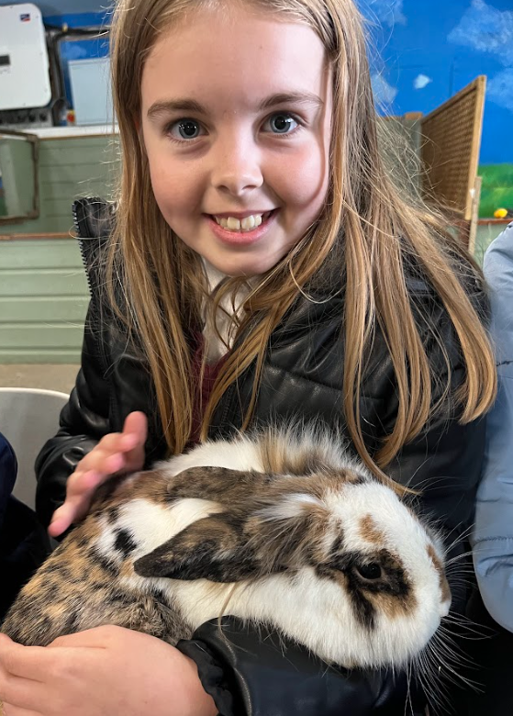
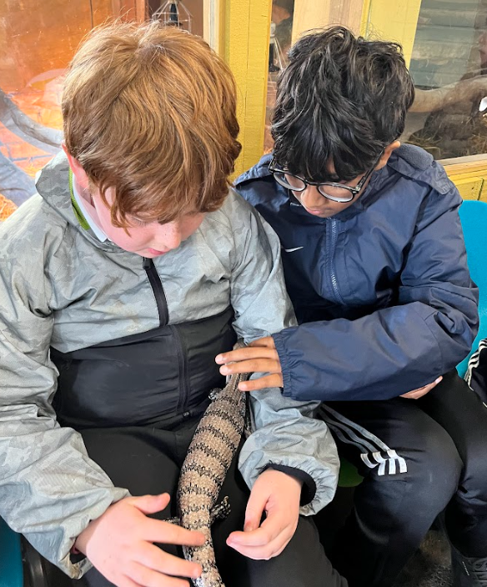
After School Sports Clubs

Mondays - Y5 Swimming (starts 10th June)
Tuesdays - KS2 Cricket (starts 11th June) & Bike Club (Mr Edwards) & KS3 Girls Swimming
Wednesdays - KS2 Girls Cricket & KS3 Boys swimming
Thursdays - Girls football & KS3 Cricket
Fridays - Netball

Please note that NUFC girls football on Friday evenings has now stopped.
Y5 Swimming Club

Please complete the form using the link below if you would like to sign your child up for the Y5 swimming club, which starts on Monday 10th June:

https://forms.gle/uCGLmUWubba7Lupi7
Football Results
KS2 girls were out at a football competition today and came 6th.
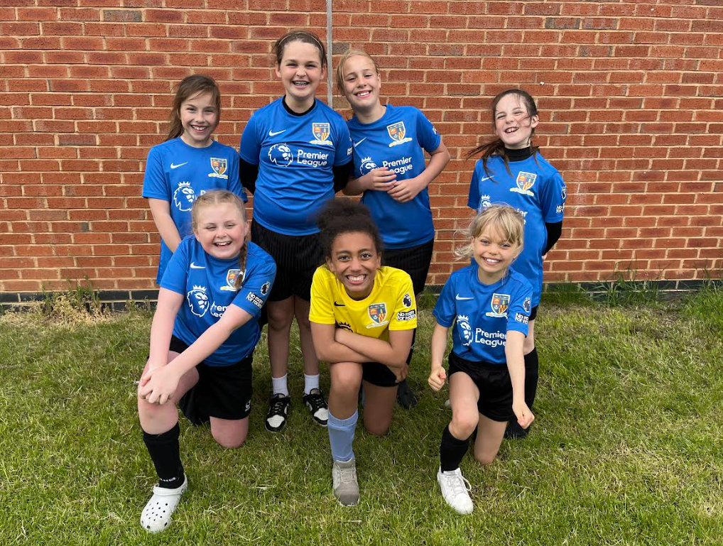
National Wraparound Childcare Programme

The National Wraparound Childcare Programme is part of the childcare reforms announced at the 2023 Spring Budget. The government’s ambition is that by 2026, all parents and carers of primary school-aged children (ages 5-11), who need it, will be able to access term time childcare in their local area from 8:00am to 6:00pm.
From September 2024, parents will therefore start to see an expansion in the availability of wraparound care across Northumberland, (before and after school), between 8:00am and 6:00pm.
Help paying for your childcare
You could get Government help with your childcare costs. Whether you have toddlers or
teens, you could get support. This could be one of the following:
Tax-Free Childcare
Tax Credits
Universal Credit
Visit www.childcarechoices.gov.uk for more information.
Would you use wraparound childcare if it was available?
We would be grateful if you could complete this questionnaire by 12:00 noon on Tuesday
11 June. The information you give will help us to assess what the demand would be for
wraparound care in the area. Please note that at this stage we are just trying to understand what people might want, and there is no guarantee that we will be able to meet everybody’s needs. https://forms.gle/XckHnAhq48yLU5vN8
Mr B Watson
Business Director
Stars of the Week

Our Stars of The Week are nominated each week by staff for a variety of reasons, which might be contribution to the school community, school work or something outstanding. Each week their success is shared in school in the Star of the Week video and they receive a certificate and chocolate bar.

Week ending 07/06/24:

5C: Jude J; 5K: Oliver E; 5L: George H;
6E: Harry E; 6F: Ben A; 6L: Oliver S;
7H: Jenson A; 7L: Joy E; 7T: Jessica F;
8M: Millie E; 8Ro: Cameron S; 8Ru: Harry L;
Head of School SOTW: James E (6E)
Year 5 End of Year Trip to Adventure Valley

To help raise money towards funding our end of year trip to Adventure Valley we are holding a chocolate tombola after half term. We would be grateful for any contributions towards our chocolate tombola. Please send any wrapped chocolate into school with your child after half term.
PE Kit Reminder

Please remember that correct PE kit includes:

- trainers (not converse boots or similar)
- plain black shorts/leggings/joggers (no huge brand labels)
- black socks
- white shirt with badge
- black jumper/hoodie with badge
- long hair must be tied back with bobble or equivalent
- all jewellery must be removed before the lesson- rings, necklace, watches etc
- if your child swims- swimming costume/shorts/trunks plus a towel

If your child is to be excused from PE, please add a note in their planner.

SCHOOL FOOTBALL KITS
If your child has a school football kit, please return to Mr Robinson as soon as possible:
Girls- Red/Black stripes
Y6 Boys- Blue Joma (full kit)
Y7 Boys- Red/Blue Prostar
Y7 Boys- Yellow Nike
Y8 Boys- Blue/White Adidas
Y8 Boys- Blue/Black stripes

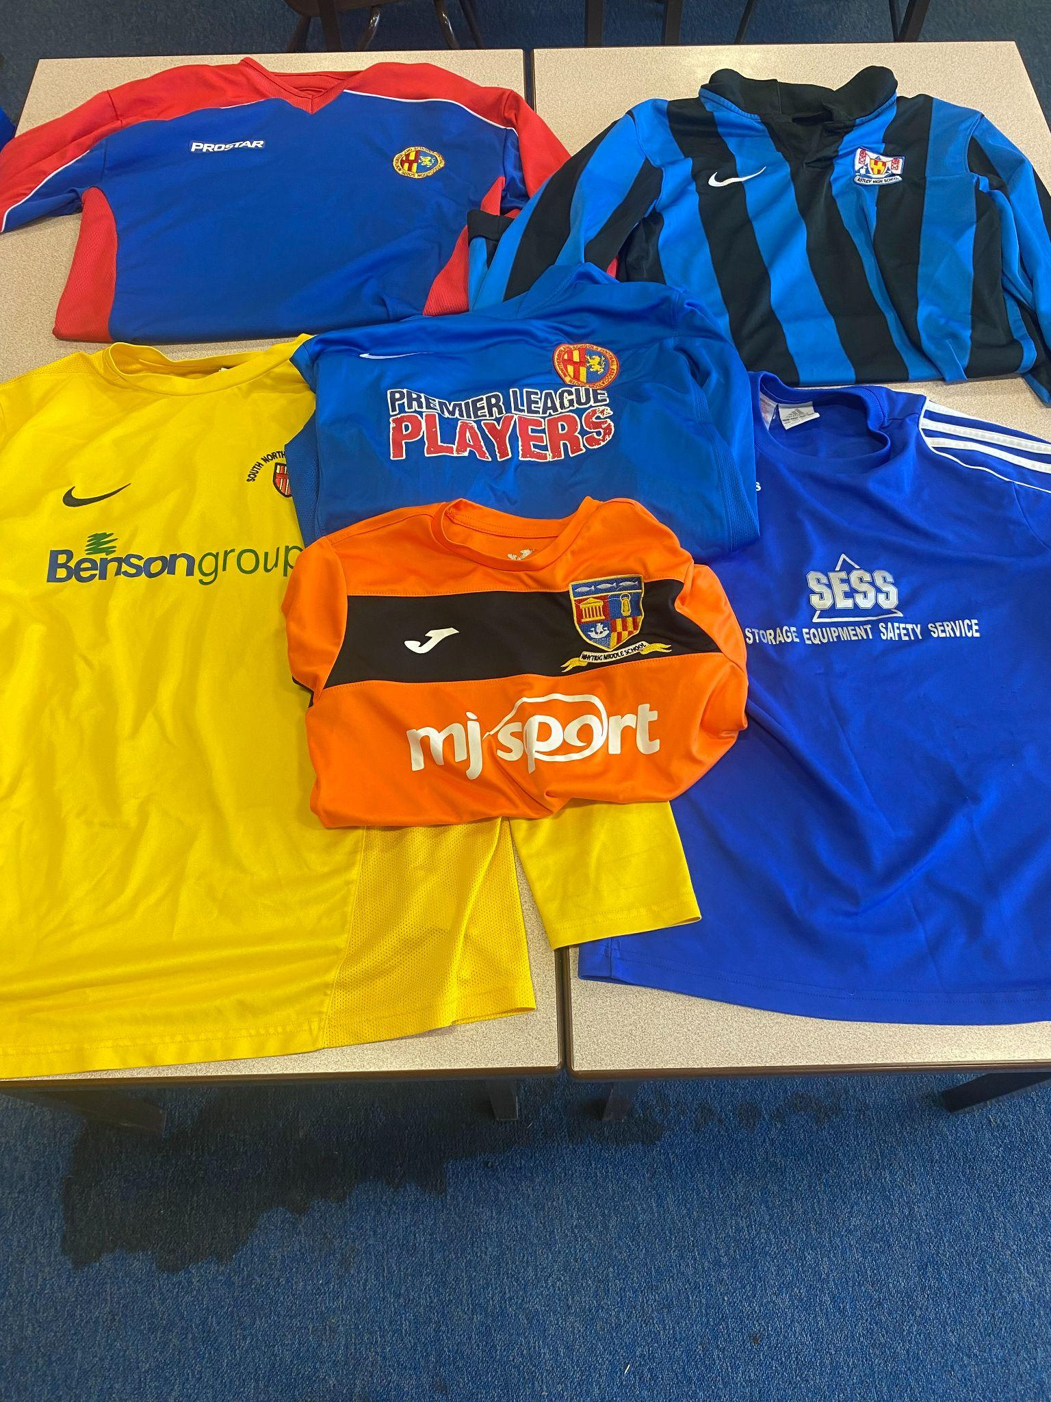
Social Media Channels

Don’t forget to keep up to date with everything else on our social media channels
X - @WhytrigMS | Facebook - @Whytrig Middle School

