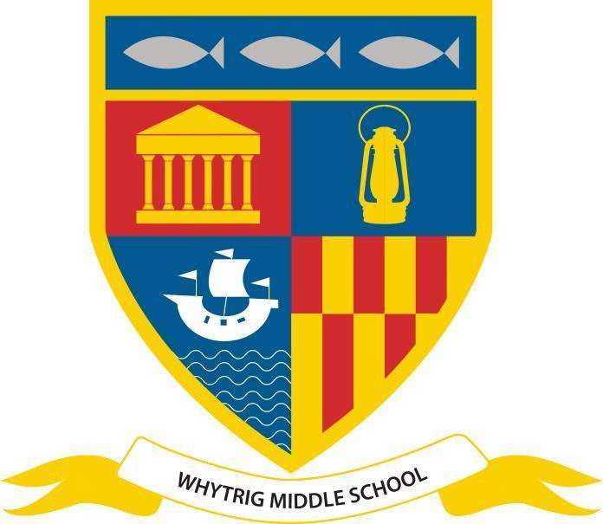
WHYTRIG MIDDLE SCHOOL
One of the Seaton Valley Federation of Schools

Elsdon Avenue, Seaton Delaval, Northumberland NE25 0BP
Tel: 0191 2371402
Email: wms@svf.org.uk
www.svf.org.uk

Executive Headteacher: John Barnes
Head of School: Jonathan Souter

Notices - Easter Break 2024

End of Term

We’ve had a fantastic term at Whytrig with lots of activities taking place across all year groups.
School restarts at 8:50am on Tuesday 16th April. Have a safe Easter break and see you at the start of the summer term!

Samba Band
Mrs Mac and Mrs Linney’s Samba Band will be up and running next term, on a Wednesday after school!! More details will follow when we come back in April. Meanwhile, make sure you have your sequinned headdress ready to go!! ;)

Northumbria Police have shared the following update with us about messaging sent out last week:

On Friday, March 22, communication was shared about a report of a group on a social media messaging app containing inappropriate content aimed at young people.

Although this messaging was shared in good faith, some of the details had at that point not been verified.

We would therefore ask you to please not reference this, including on social media.

As always, we would also ask that you continue to take an interest in your children’s use of social media and if you do have concerns that you report these to the police.

Officers take matters such as this extremely seriously and are investigating the report of the social media group.

Swimming Clubs

We’ve secured funding for another year of swimming clubs after school!
Clubs will start after Easter.

Sporting Achievements

Year 8 Boys 6-0 Ponteland HS B team
KS3 Girls 0-2 Ponteland HS B team
KS3 Girls 2-0 Ponteland HS C team

New Club starting
Wed 17th April- KS2 Boys Football

Stars Of The Week - Thursday 28th March 2024
Our Stars of The Week are nominated each week by staff for a variety of reasons, which might be contribution to the school community, school work or something outstanding. Each week their success is shared in school in the Star of the Week video and they receive a certificate and chocolate bar (although this week given the occasion they received an Easter egg).
Year 5: 5C - Owen B; 5K - Toby H; 5L - Robbie T;
Year 6: 6E - JE; 6F - Bobbie F; 6L - Lucas S;
Year 7: 7H - Kish D; 7L - Joy E; 7T - Bobby M;
Year 8: 8M - Lewis L; 8Ro - Maggie F; 8Ru - Lexi D;
Head of School: Cameron H (8M)
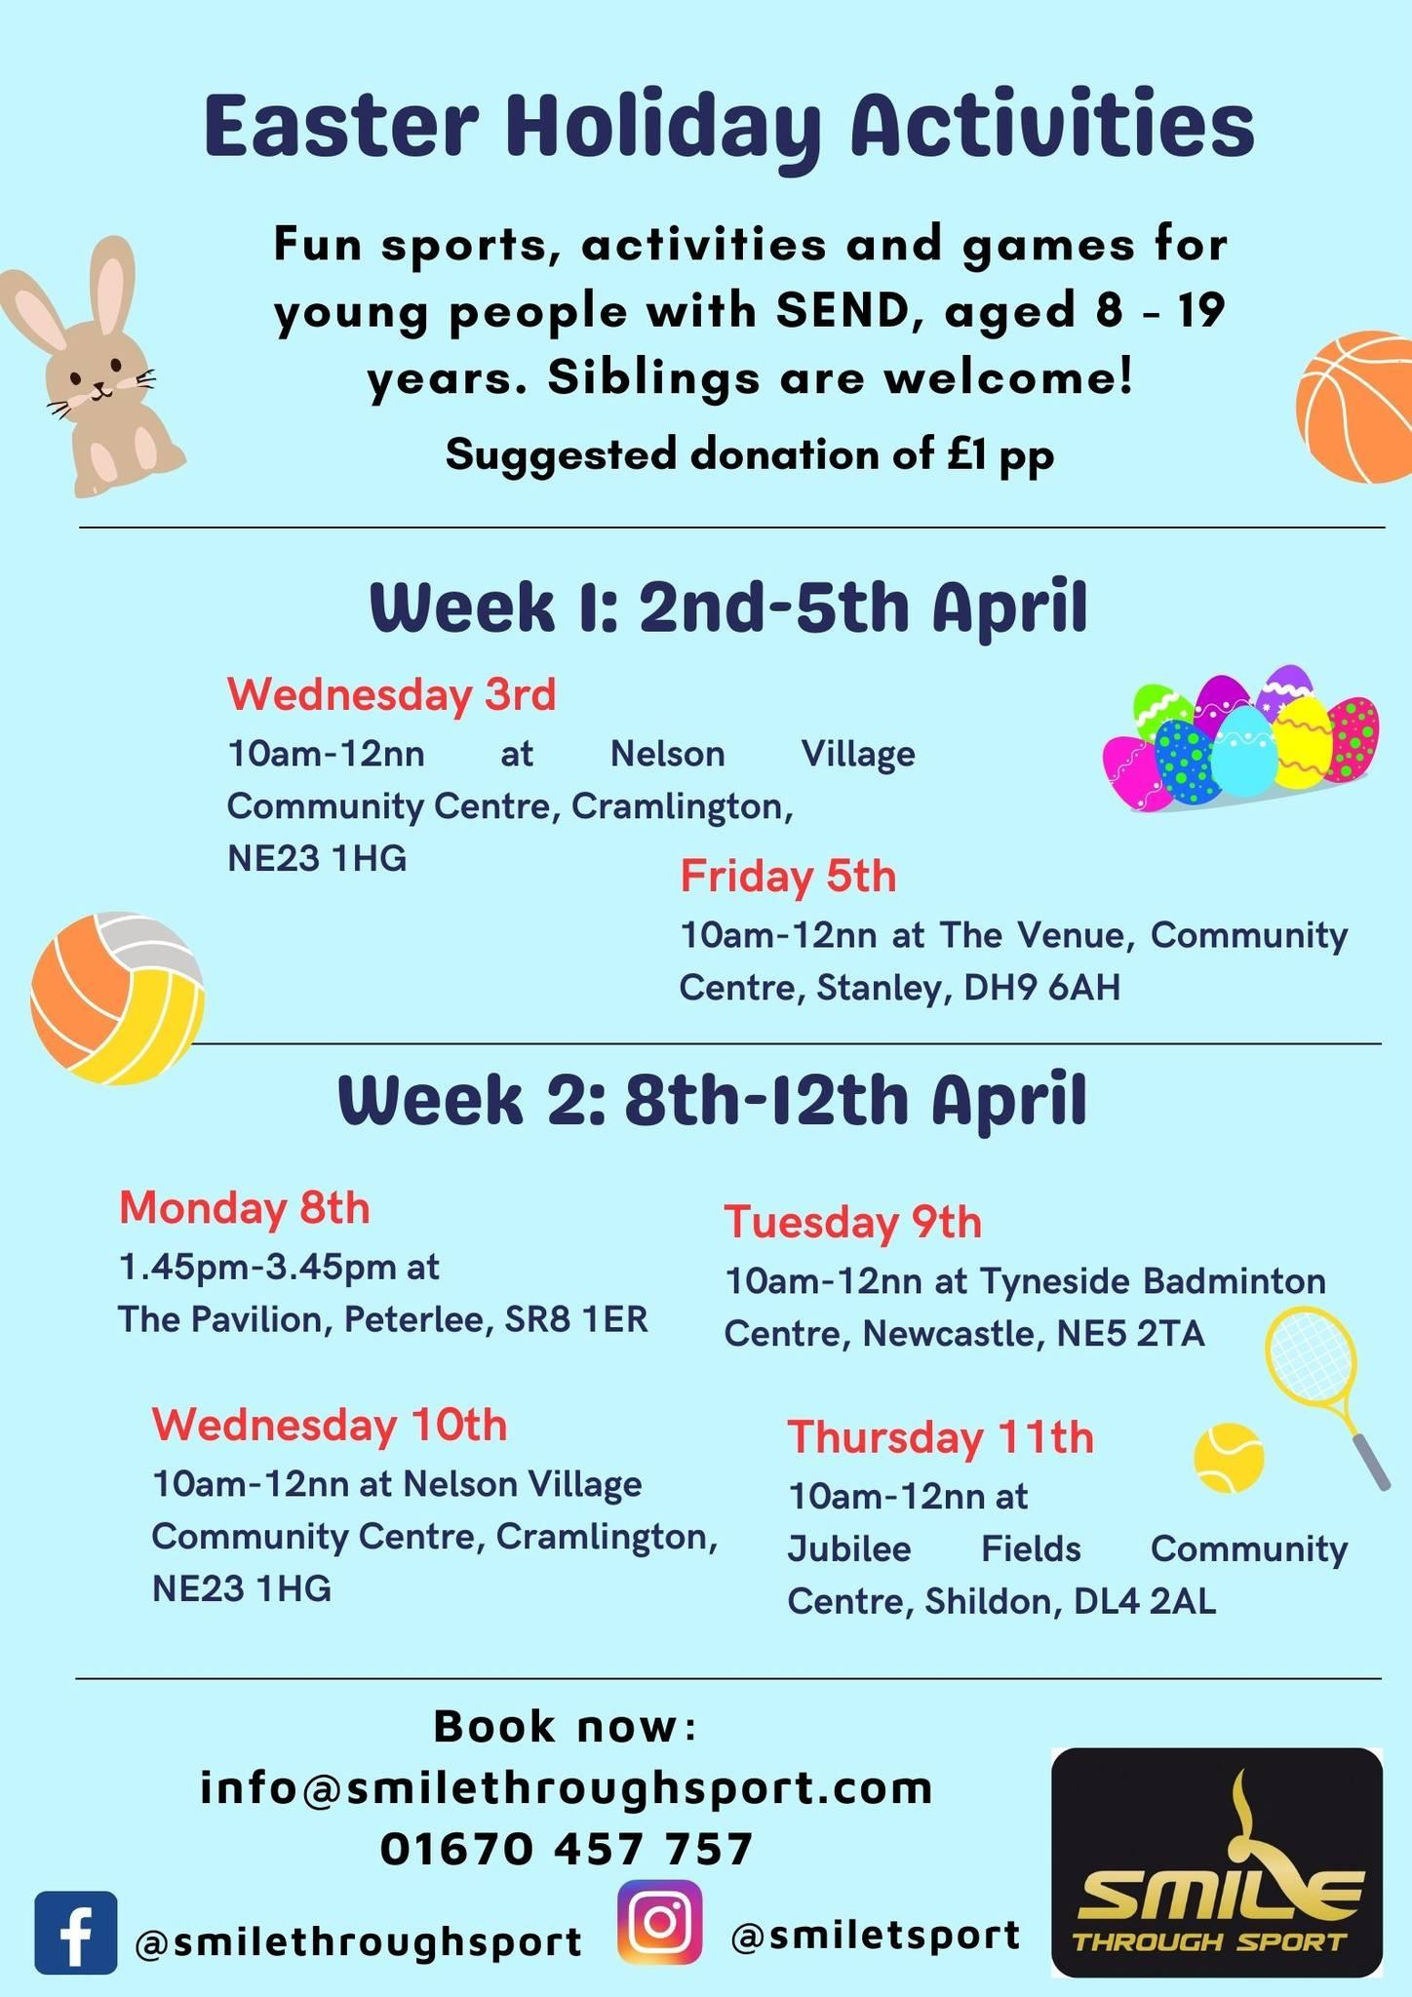
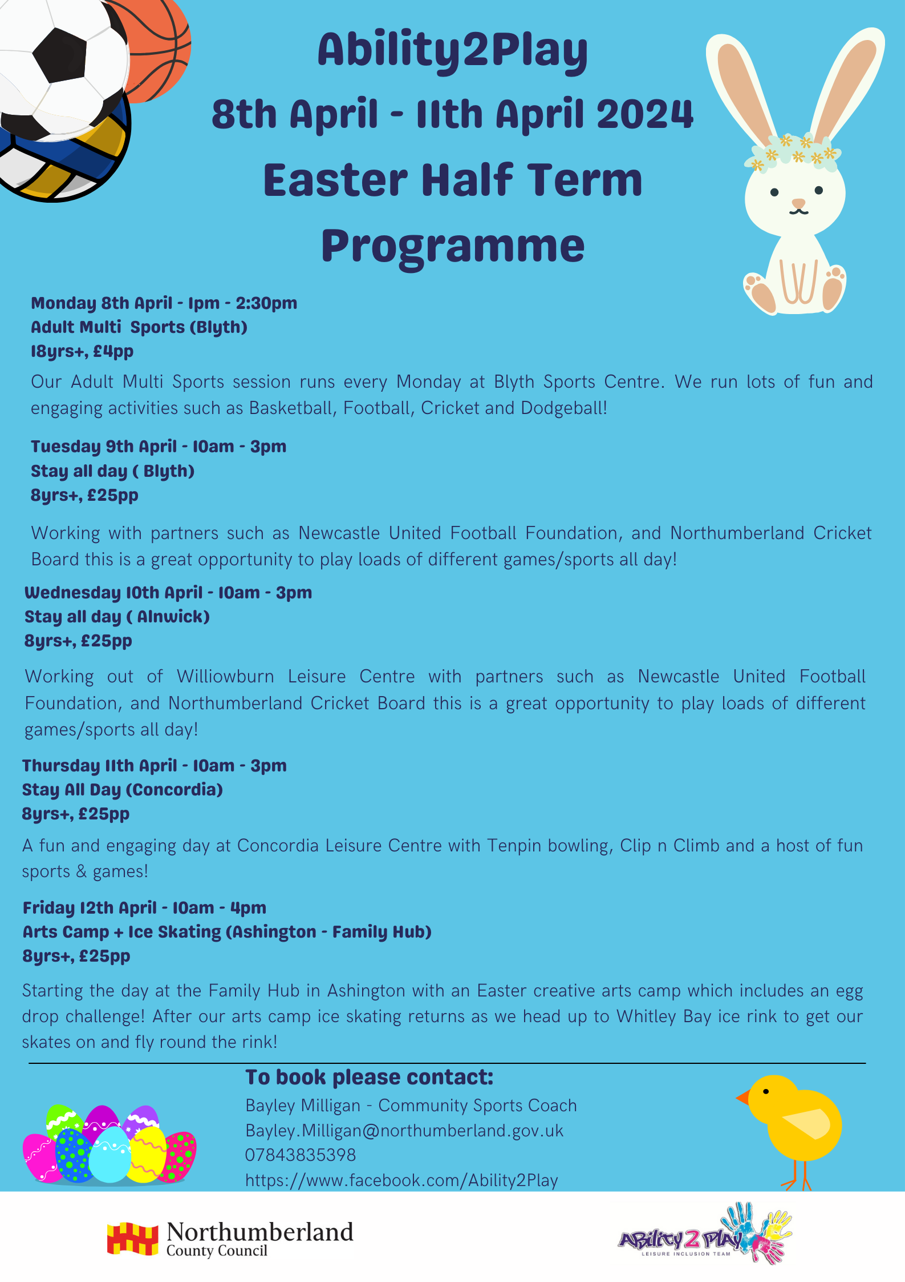

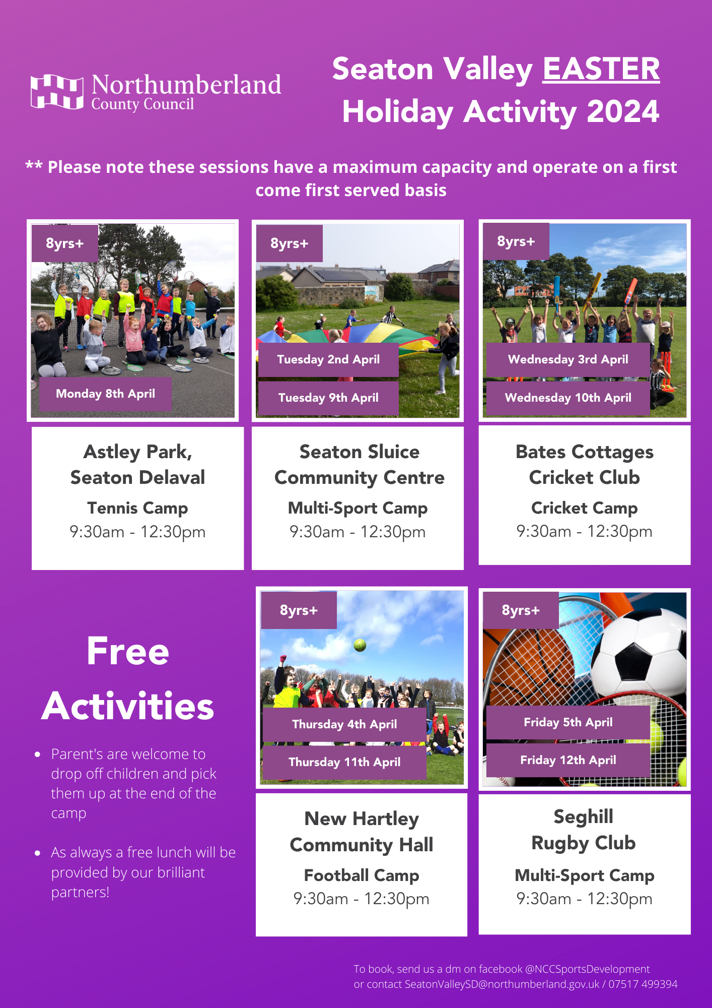
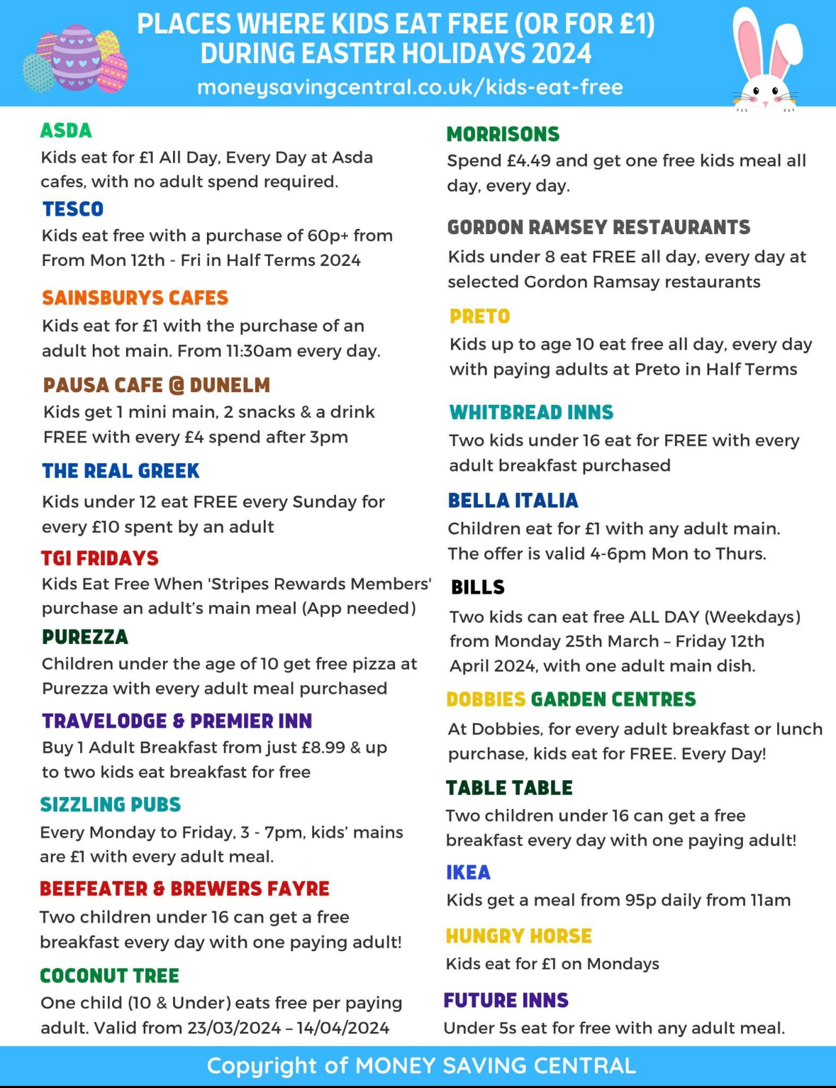
NHS Advice on Measles

There is currently an outbreak of measles in the UK, please read the NHS guidance below on how to identify measles and how to look after your family if there is an outbreak.
https://www.nhs.uk/conditions/measles/
Social Media Channels

Don’t forget to keep up to date with everything else on our social media channels
X - @WhytrigMS | Facebook - @Whytrig Middle School

