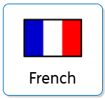

**Curriculum Implementation**

Our curriculum ensures that pupils learn **vocabulary** appropriate to themselves and their age group, applying this to spoken French and simple conversation with increasing fluency and correct pronunciation. This is explicitly taught through clearly sequenced lessons that are adapted to ensure all learners succeed.

As children progress through Key Stage 2, they will be introduced to reading and writing French with developing complexity, providing a platform for further study in secondary school.

Although children in Early Years and KS1 are not taught French explicitly, they will become familiar with other languages through day-to-day classroom discussions and experiences. This will provide them with basic foundations, ready to begin formal French lessons in KS2. Across the school we provide a language for the term providing children opportunities to learn other languages.

**Curriculum Intent**

Our modern foreign language curriculum seeks to provide children in Key Stage 2 with a strong foundational **knowledge** of the French language.

For the majority of our children, this is their first experience of formally learning a foreign language. Our lessons enable pupils to develop increasing **vocabulary**, a strong **understanding** of what they learn and develop **skills** in an additional language. We intend this to cultivate curiosity in how people communicate around the world.

The language provision will allow children to appreciate different cultures and languages as well as celebrating the first languages of EAL speakers, who make up around one fifth of the school.

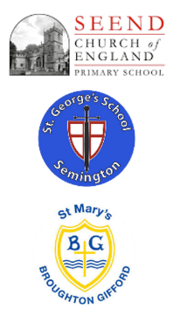

**Curriculum Impact**

The implementation of this curriculum, ensures that when all children leave our school, they are able:

To have a passion for learning a language.

To have a strong awareness of the French culture.

To have the confidence to speak French with good pronunciation.

To read simple French texts fluently.

To be able to write in French accurately and fluently.

**Assessment**

Teachers will asses learning during each lesson and unit of work to build up accurate judgements of children’s attainment. Teachers record the progress of each child termly and use this to inform and adapt future planning.

MFL at ‘The Three Schools’