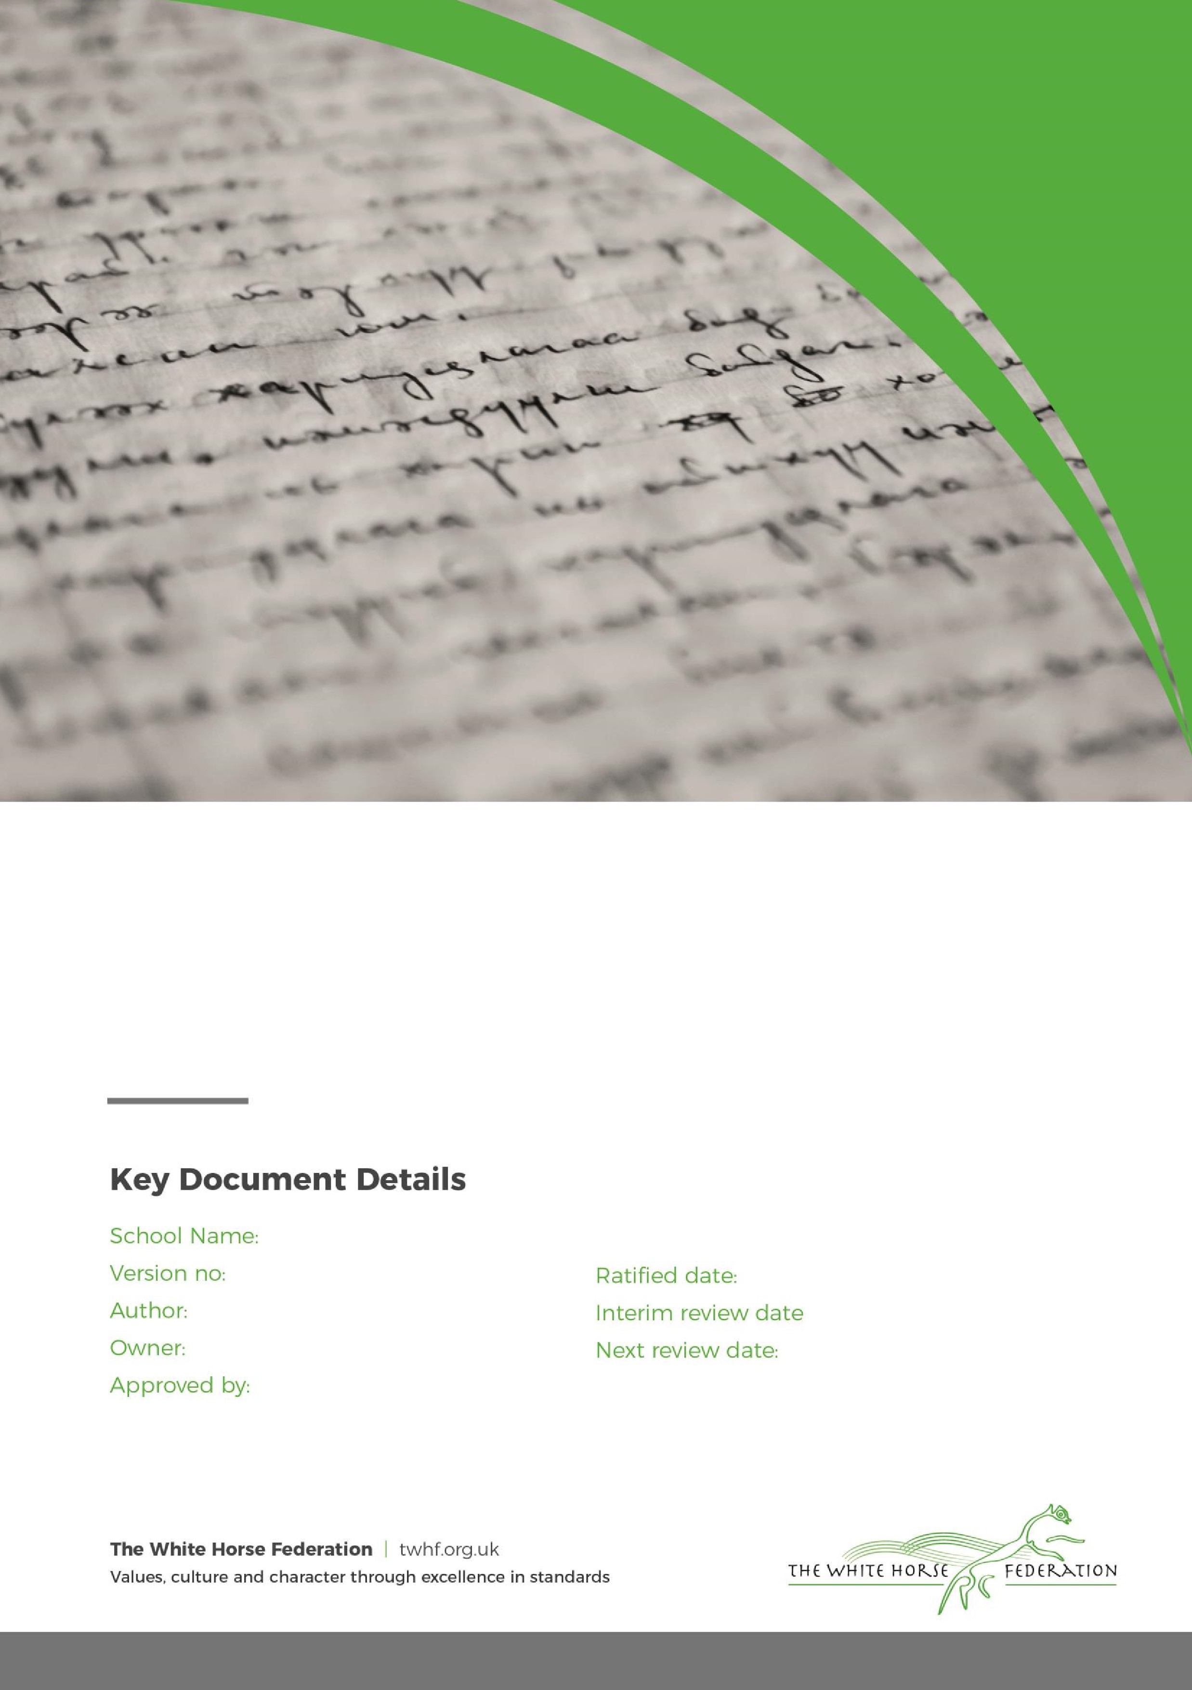

Anti-Bullying Policy

Principal

Principal

September 2024

September 2025

Seend

2



Seend Church of England Primary School

Anti-Bullying Policy 2024-25

At Seend C. of E. Primary School we regard bullying as particularly serious and take firm action against it. We encourage children, parents and staff to work against it and report any incidents of bullying.
We define bullying as ‘Behaviour by an individual or group, repeated over time, that intentionally hurts another individual or group either physically or emotionally.’
‘Bullying is the physical or verbal abuse of another individual so that their safety, confidence and happiness are diminished.’ (This definition has been adopted by Wiltshire’s Children and Young People’s Trust Board and Wiltshire’s Anti-Bullying Steering Group.)
All bullying is psychologically harmful and can take the form of physical assault, verbal threats and taunting and harm to personal equipment. Bullying can include communication through the use of computers and mobile technology.
Aims
At Seend C of E. Primary School we aim to:
• Protect every person’s right to feel supported and valued within the school environment.
• Ensure that our school community is secure in the knowledge that all reported or discovered incidents will be dealt with promptly.
• Prevent bullying before it starts by educating children and through embodying the school values of tolerance, respect, friendship, honesty and forgiveness.
• Be aware of the ‘bullying hotspots’ around our school and take measures to ensure these are supervised.
• Promote ways to deal with bullying issues by having an ‘Anti Bullying Week’ every year.
Objectives At Seend C of .E. Primary School we will encourage:
• Adults and children to understand that if they are experiencing bullying themselves or are aware of bullying themselves, it is important and right to tell someone about their fears and concerns.
• All staff to be aware that bullying can take place in our school.
• Adults and children to be aware that bullying can be physical, verbal, emotional or cyber by a single person or group and usually takes place over a period of time. All incidents of unkindness or anti social behaviour will be acted upon and dealt with independently.
Incidents of bullying can include:
• Name calling
• Malicious gossip
• Damaging or stealing property
• Coercion into acts they do not wish to do
• Violence and assault
• Jostling
• Teasing
• Intimidation
• Extortion
• Exclusion from groups
• Making threats
• Deliberately ignoring
• Cyber bullying (text message bullying, chat room bullying, email bullying)
Approach and Organisation
All reported incidents of bullying will be shared with all staff at the earliest opportunity. Staff should be vigilant for signs of bullying by noting when a person exhibits:
• Changes in normal behaviour.
• Signs of withdrawal or friendlessness.
• Not wanting to go into the playground.
• Not wanting to come to school.
• Feigning illness.
• Experiencing sleeplessness or anxiety.
• Being unable to concentrate.
• Physical abuse.
Who is more vulnerable?
Anyone can become the victim of bullying but there are groups who are more vulnerable because they may be seen as “different” in some way. These include those who:
• Have special educational or physical needs
• Have a less conventional family / parenting structure
• Are from a higher or lower social group than the majority of the school
• Are from a different cultural background than the majority of the school (see separate anti-racism policy)
• Are gay, lesbian, bisexual or transgender.
Procedure for Complaints
Staff will take seriously all reported acts of bullying, referring them to a responsible person at the earliest opportunity. All reported acts of bullying will be followed up with minimum delay and appropriate action taken, which would range from informal talks with the participants to exclusion by the Governing Body in extreme cases. The Head teacher will assess each incident and decide whether its seriousness warrants the formal intervention of parents or in the case of adults, friends of those affected by bullying.
In the case of children, once parents have been informed, there will be opportunities for them to meet with the class teacher/head teacher to discuss the matter and become involved in working towards a positive conclusion.
If the case of an adult feeling bullied arises, the Governors should be kept informed and be involved in mediation if necessary.
All incidents of confirmed bulling will be recorded on the log sheet and kept in the behaviour folder in the head teachers’ office. held by the Head teacher.
If further action is required
• The Racial Incident book will be used to record the incident if appropriate.
• Official complaints procedure.
• Report to the Governors by the Head teacher.
Reviewed Sep 2024
Next review date Sep 2025

