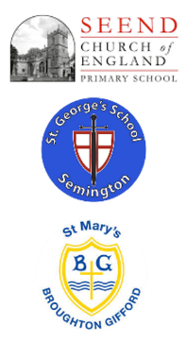

EYFS at

‘The Three Schools’

**Curriculum Implementation**

At Seend, St George’s and St Mary’s, teachers and practitioners plan for high quality learning opportunities, inside and outside that are tailored to children’s starting points, needs and interests. Teaching across the EYFS is based on teaching children new skills and giving them opportunity to practice and master these skills through their own play. Skills are carefully mapped out to ensure that they are progressive from nursery through to reception.

An offer of an appropriate balance of whole class, small group and independent play activities that reflect the needs of all children ensures that all pupils receive a balance of adult initiated and child-initiated learning.

All staff within the EYFS make accurate assessments of our pupils which enable them to make judgements and identify achievable next steps for those children who are not on track.

Meaningful learning across the curriculum that provide opportunities for communication, sustained shared thinking and challenge to build on existing skills, taking into account the Characteristics of Effective Learning.

All children have access to rich first-hand experiences to widen experiences, language, awe and wonderment. Children are given opportunities to engage in exploratory learning, creative thinking and problem solving through a balance of adult led activities and child-initiated play across all areas of the curriculum.

**Curriculum Impact**

By the time our pupils leave Reception, they will be:

* Independent learners who can apply the skills that they have been taught in their own learning.
* Confident communicators who have a broad range of ambitious vocabulary.
* Confident learners who are ready for the next stage in their education.

**Curriculum Intent**

At Seend, St George’s and St Mary’s, it is our intent that children who enter our EYFS begin their lifelong learning journey by making progress physically, verbally, cognitively and emotionally from their individual starting points whilst developing a love of learning.

At Seend, St George’s and St Mary’s School our aim is to:

* Create high quality learning environments that support, enhance and invite every child’s curiosity, confidence and development regardless of backgrounds or needs.
* To work collaboratively with parents and carers to encourage independent and enthusiastic learners who thrive and reach their full potential.
* Ensure that every child has access to a broad, balanced and differentiated curriculum that reflects our community which prepares them for now and for the future in terms of opportunities and experiences.
* To support all children through a language rich environment and give opportunities to become skilful communicators who connect with others through language and play.