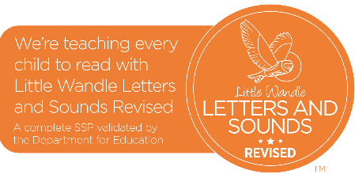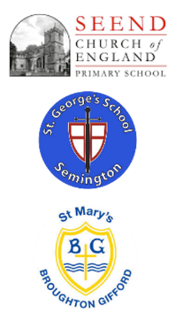

**Curriculum Impact**

At Seend, St George’s and St Mary’s we aim to ensure that children master the necessary sounds, keywords and reading skills to achieve the age-related benchmarks at appropriately mapped out time points. We aim for all pupils at Seend, St George’s and St Mary’s to leave our school with a passion for reading and to have obtained all the skills they need to access and enjoy any book of their choosing

**Curriculum Implementation**

At Seend, St George’s and St Mary’s, we follow the Little Wandle Letters and Sounds Revised programme. The Little Wandle programme is taught as a daily lesson to all children and is regularly assessed to check where the learning gaps are. At Seend, St George’s and St Mary’s, we ensure that each child feels successful in their learning so every reading book that is given to a child will be phonically decodable and will match their phonic level. We ensure that regular reading sessions are held where the children can enjoy books and adults model the importance of reading books for pleasure.

When pupils are secure within phase 5 phonics, they move onto a whole class teaching of reading approach which focuses on the key reading skills; vocabulary, retrieval, inference and the continuation of developing prosody. These skills are developed through the use of high-quality texts.

**Curriculum Intent**

At Seend, St George’s and St Mary’s, we believe that all our children can become fluent readers and writers. We start teaching phonics in Reception and follow the [*Little Wandle Letters and Sounds Revised* progression](https://www.littlewandlelettersandsounds.org.uk/wp-content/uploads/2021/06/Programme-Overview_Reception-and-Year-1.pdf), which ensures children build on their growing knowledge of the alphabetic code, mastering phonics to read and spell as they move through school.

As a result, it is our intention that all children are able to tackle any unfamiliar words as they read. At Seend, St George’s and St Mary’s School,we also model the application of the alphabetic code through phonics in shared reading and writing, both inside and outside of the phonics lesson and across the curriculum. We have a strong focus on language development for our children because we know that speaking and listening are crucial skills for reading and writing in all subjects.

Phonics and Early Reading at

‘The Three Schools’