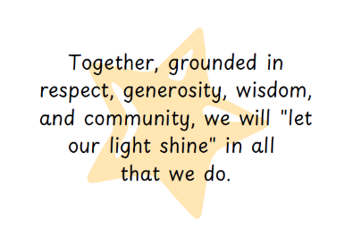

|  |  |  |
| --- | --- | --- |
| **Seend Home School Agreement**  Every school within The White Horse Federation will work in close partnership with children and their families in sharing responsibility for their learning, wellbeing, behaviour and safety. | | |
| **School**  **We will:**   * Uphold our core values at all times. * Ensure all children are safe and secure during school time. * Prioritise your child’s well-being along with their social and emotional health. * Encourage and support your child to achieve their best in all they do. * Keep you informed about school news and your child’s progress. * Provide a broad, balanced and exciting curriculum. * Inform you about what your child has been learning each week via a whole class Class Dojo post. * Let you know early on if there are any concerns or problems that affect your child’s work or behaviour. * Treat everyone as an individual. We will provide the appropriate nurture and care required for each child to enable them to be ready to learn. * Encourage all children to understand the importance of being part of a school community. We will support them to take responsibility for themselves, each other and their school environment. | **Pupil**  **I will:**   * Uphold and demonstrate our core values in my behaviour, learning, attitude and interactions with others. * Follow school rules and expectations at all times. * Listen to others. * Respect other people and the differences between us and care about others’ feelings. * Try my best in all I do and allow others to do their best too. * Complete my school and homework as well as I can. * Behave well in school, when travelling to and from school on school trips and activities. I understand and accept that the school will take action if I make poor choices. * Take pride in and good care of our school environment and equipment. * Make sure I am smartly dressed in my school uniform each day. | **Parents/Carers**  **I/We will:**   * Positively support the school, embrace our core values and encourage our child to uphold these at all times. * Read with our child at home in line with school policy. * Encourage our child to do their best at all times, including supporting them with homework. * Encourage our child to behave well in line with the school policy. I/We understand that poor choices which contravene our behaviour policy will result in consequences. * Make sure our child is smartly dressed in school uniform each day. * Make sure my child arrives on time and with the necessary items. * Collect my child on time. We will notify the school if we are unexpectedly delayed. * Make sure my child has good attendance. We will provide an explanation before the start of the school day if our child is absent. * Tell the school of any problems that might affect my child’s work, behaviour, health or happiness. * Attend parent/teacher consultations to discuss my child’s progress and attend special school events where possible. |
| **Please sign to confirm you have read and understood the appropriate statements and agree to abide by them.** | | |
| Signed Head of School:    Print Name: **Emma Hembury** | Child-signed:  *(To be signed by parent for Reception children)* | Signed Parent/Carer:  Print Name: |
| Date Agreed: |  |  |