
Seend C of E Primary school
Anti-Bullying Policy for Children

At Seend we want bullying to STOP!
What can we do if bullying is happening?

What can we do if bullying is happening?

What is bullying?




Several
Times
On
Purpose
Start
Telling
Other
People!

If you are being bullied or you know someone else is being bullied, you can STOP it by telling other people.
Bullying when a person or group REPEATEDLY says or does something to hurt me or someone else ON PURPOSE.

Several
Times
On
Purpose
What is bullying?

When someone says or does something UNINTENTIONALLY hurtful and they do it ONCE…

…that’s THOUGHTLESS/CARELESS and that person should apologise and try to be more careful.

When someone says or does something INTENTIONALLY hurtful and they do it ONCE…

…that’s MEAN and that person should apologise and think about how they’ve hurt/upset someone

When someone says or does something INTENTIONALLY (ON PURPOSE) hurtful and they KEEP DOING IT (REPEATEDLY) – even when you tell them to stop or show them that you’re upset…

…that’s BULLYING and it should STOP. It is not part of our school values.

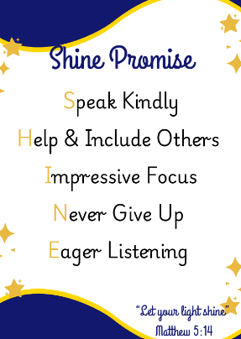
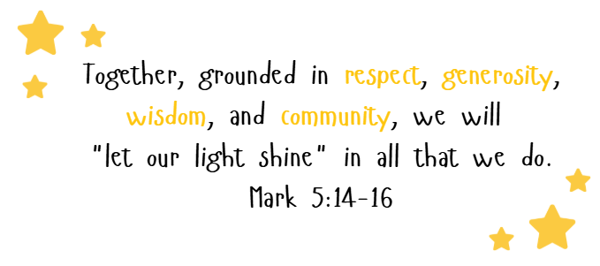

Types of bullying

Bullying is behaviour that hurts someone else, it can be physical, verbal, emotional, online/cyber or even silent.
Bullying can include:

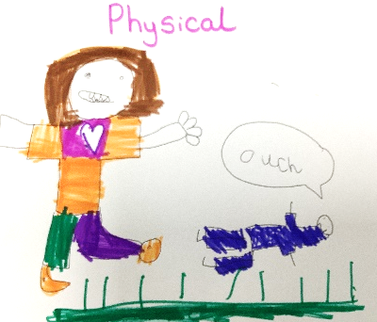  Physical: pushing, poking, kicking, hitting, biting, pinching, unwanted physical contact, inappropriate touching etc | Verbal: name calling, sarcasm, spreading rumours, threats, teasing, belittling etc  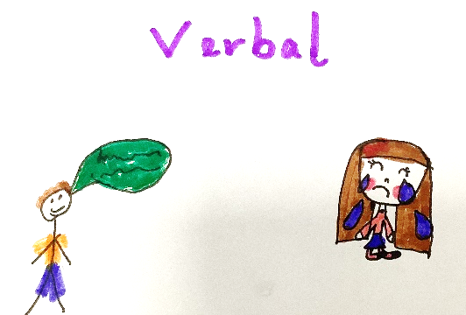
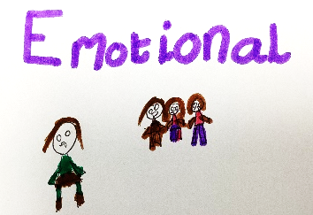  Emotional: isolating others, tormenting, hiding books, threatening gestures, ridicule, humiliation, intimidating, excluding, manipulation and coercion etc | 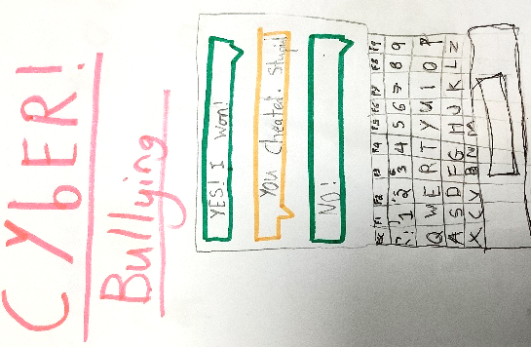  Online/Cyber: posting on social media, sharing photos, sending nasty text messages, social exclusion
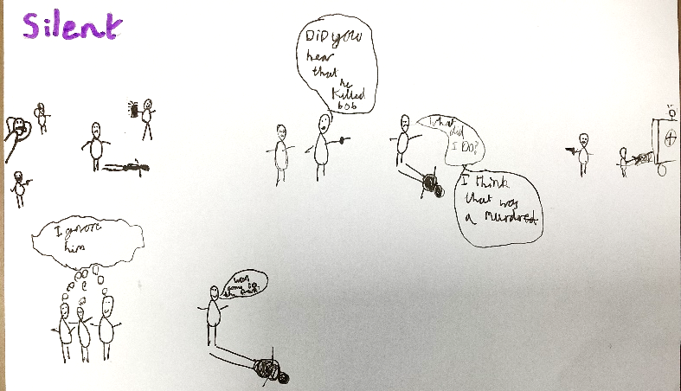
Silent: excluding someone on purpose, making nasty faces at someone, ignoring someone to be unkind, freezing a person out, telling others not to talk or play with a person, spreading rumours or gossip about a person, doing nothing to stop it happening to someone else.

Whatever form bullying takes, it is never okay and should always STOP!

What can we do if bullying is happening?

Start
Telling
Other
People!

If you are being bullied you can:
- Tell a Trusted Adult
- Tell the person to stop
- Make eye contact and tell the bully to leave you alone.
- Ignore the bully and walk away; don’t hurt them back or do what they tell you to do

If you see someone else being bullied, you can help that person by:
- Tell a Trusted Adult
- If you can, and it is safe, tell the bully to stop, but never get angry or hit them Help that person
- You should never walk away or ignore it

Always remember that if you are being bullied, it is not your fault and you are never alone.

Who can I talk to?

If bullying is happening, you can help it stop by talking to a Trusted Adult and they will always help! Trusted Adults include:
Seend Safeguarding Leads:
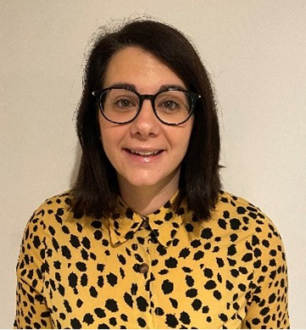

All Staff:

TAs
Teachers
MDSAs

Admin

Miss Chivers (DSL)
Mrs Hembury (DDSL)

We are always here for you if you have any worries or concerns

Other Trusted Adults might also be:
- Any member of staff at school
- Your parents
- Your grandparents
- A family member
- A neighbour
- Childline (0800 1111)
- National Bullying Helpline (0300 323 0169)

We listen…we support…we take action!

How do we make sure bullying never happens at Seend?

At Seend, all adults and children will be expected to live out our vision and show the School Christian Values. We do this through our shine promise:

The more values we show, the stronger our Seend heart will grow

Our Teachers and TAs also help us to learn how to be safe and happy by:
- Always listening to us when we have worries/concerns
- Learning about our School Christian Values in worship
- Taking part in circle time and having PSHE lessons
- Having themed assemblies/weeks such as Anti-Bullying Week, NSPCC Speak Out, Stay Safe assemblies, and assemblies to learn about what bullying is and what is/isn’t okay
- Showing us how to follow the school rules and helping us learn from our mistakes

