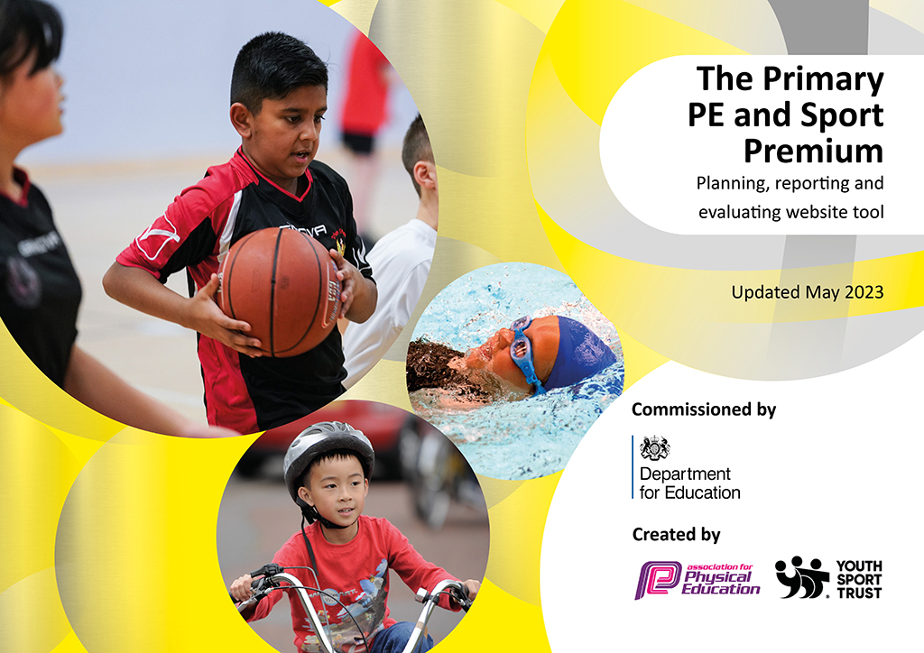
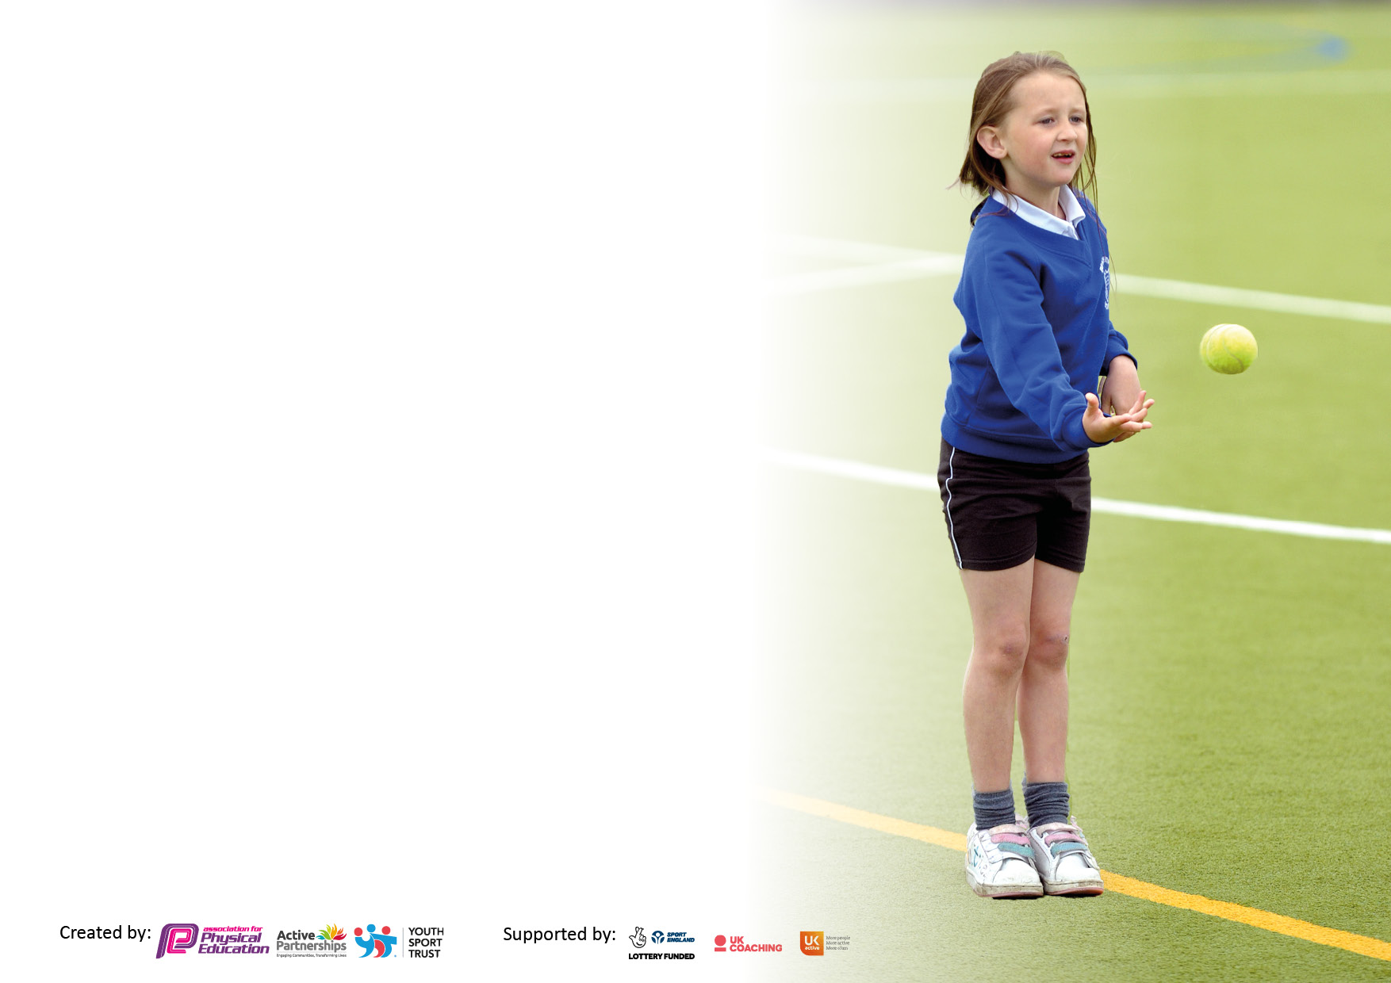

It is important that your grant is used effectively and based on school need. The Education Inspection Framework makes clear there will be a focus on ‘whether leaders and those responsible for governors all understand their respective roles and perform these in a way that enhances the effectiveness of the school’.

Under the Quality of Education Ofsted inspectors consider:
Intent - Curriculum design, coverage and appropriateness
Implementation - Curriculum delivery, Teaching (pedagogy) and Assessment
Impact - Attainment and progress

To assist schools with common transferable language this template has been developed to utilise the same three headings which should make your plans easily transferable between working documents.

Schools must use the funding to make additional and sustainable improvements to the quality of Physical Education, School Sport and Physical Activity (PESSPA) they offer. This means that you should use the Primary PE and sport premium to:

- Develop or add to the PESSPA activities that your school already offer
- Build capacity and capability within the school to ensure that improvements made now will benefit pupils joining the school in future years
- The Primary PE and sport premium should not be used to fund capital spend projects; the school’s budget should fund these.

Pleasevisitgov.ukfortherevisedDfEguidanceincludingthe5keyindicatorsacrosswhichschoolsshoulddemonstrate animprovement.Thisdocumentwillhelpyoutoreviewyourprovisionandtoreportyourspend.DfEencouragesschools to use this template as an effective way of meeting the reporting requirements of the Primary PE and Sport Premium.

We recommend you start by reflecting on the impact of current provision and reviewing the previous spend.

Schools are required to publish details of how they spend this funding, including any under-spend from 2021/2022, as well as on the impact it has on pupils’ PE and sport participation and attainment. All funding must be spent by 31st July 2023.

We recommend regularly updating the table and publishing it on your website throughout the year. This evidences your ongoing self-evaluation of how you are using the funding to secure maximum, sustainable impact. Final copy must be posted on your website by the end of the academic year and no later than the 31st July 2023. To see an example of how to complete the table please click HERE.

Details with regard to funding
Please complete the table below.

Total amount carried over from 2022/23 SEEND | £0
Total amount allocated for 2022/23 | £16,650
How much (if any) do you intend to carry over from this total fund into 2023/24? | £0
Total amount allocated for 2023/24 | £16,650
Total amount of funding for 2023/24. To be spent and reported on by 31st July 2024. | £ 16,650
Swimming Data
Please report on your Swimming Data below.

Meeting national curriculum requirements for swimming and water safety.  N.B. Complete this section to your best ability. For example you might have practised safe self-rescue techniques on dry land which you can then transfer to the pool when school swimming restarts.  Due to exceptional circumstances priority should be given to ensuring that pupils can perform safe self rescue even if they do not fully meet the first two requirements of the NC programme of study | Self rescue techniques practice for year 5 and 6 Term 3 (impact of COVID).  2024 £1569
What percentage of your current Year 6 cohort swim competently, confidently and proficiently over a distance of at least 25 metres?  N.B. Even though your pupils may swim in another year please report on their attainment on leaving primary school at the end of the summer term 2022.  Please see note above | 69%
What percentage of your current Year 6 cohort use a range of strokes effectively [for example, front crawl, backstroke and breaststroke]?  Please see note above | 69%
What percentage of your current Year 6 cohort perform safe self-rescue in different water-based situations? | 100%
Schools can choose to use the Primary PE and sport premium to provide additional provision for swimming but this must be for activity over and above the national curriculum requirements. Have you used it in this way? | Yes/No

Action Plan and Budget Tracking
Capture your intended annual spend against the 5 key indicators. Clarify the success criteria and evidence of impact that you intend to measure to evaluate for pupils today and for the future.

Academic Year: 2023/24 | Total fund allocated: 16,830 | Date Updated: 11.12.23
Key indicator 1: The engagement of all pupils in regular physical activity – Chief Medical Officers guidelines recommend that primary school pupils undertake at least 30 minutes of physical activity a day in school |  |  |  | Percentage of total allocation:
 |  |  |  | %
Intent | Implementation |  | Impact
Your school focus should be clear what you want the pupils to know and be able to do and about  what they need to learn and to  consolidate through practice: | Make sure your actions to achieve are linked to your intentions: | Funding allocated: | Evidence of impact: what do pupils now know and what can they now do? What has changed?: | Sustainability and suggested next steps:
Ensure a broad PE curriculum taught.  2 x session per week  Broaden the curriculum offer that enables children to be physically active whilst also developing their resilience communication and team work skills through character education | Use of Real PE online curriculum  Invest in the Commando Joe’s school programme for EYFS to Year 6.  Provide training in how to use the programme for all staff.  Implement use of the programme as additional time to the statutory PE curriculum for children to be physically active | £360  £2,000 over 2 years with PPG support too | Programme ensures progression of skills taught and assessed by non specialist PE teachers.  Training for all staff who will deliver the programme. Monitoring of the impact of the programme through the use of observation and pupil voice.  Engagement with the Commando Joe’s education platform | Maintain as core curriculum  2 year programme 2023-2025
Key indicator 2: The profile of PESSPA being raised across the school as a tool for whole school improvement |  |  |  | Percentage of total allocation:
 |  |  |  | 0%
Intent | Implementation |  | Impact
Your school focus should be clear what you want the pupils to know and be able to do and about  what they need to learn and to  consolidate through practice: | Make sure your actions to achieve are linked to your intentions: | Funding allocated: | Evidence of impact: what do pupils now know and what can they now do? What has changed?: | Sustainability and suggested next steps:
Pupils understand the importance of healthy lifestyles | Engage with the Healthy Schools initiative to achieve the first level award  Nominate school adult to lead this | £  previous years funding used to register | Lunch hall monitoring shows better balance of food in packed lunch boxes.  Children more aware of links between bedtimes and ability to focus on learning  More children taking responsibility for the snacks they eat and physical activity they partake in | 2 year programme – review after year 1

Key indicator 3: Increased confidence, knowledge and skills of all staff in teaching PE and sport |  |  |  | Percentage of total allocation:
 |  |  |  | %
Intent | Implementation |  | Impact
Your school focus should be clear | Make sure your actions to | Funding | Evidence of impact: what do | Sustainability and suggested
what you want the pupils to know | achieve are linked to your | allocated: | pupils now know and what | next steps:
and be able to do and about | intentions: |  | can they now do? What has
what they need to learn and to |  |  | changed?:
consolidate through practice:
Use of PE coaches to deliver 1 x session of PE a week alongside a TA for CPD  Attendance at sports conference for PE lead across 3 schools | Team teaching for session 1 and 2 by TAs and Coaches and then sessions 3 and 4 delivered by Tas having edited for age groups with coaches the day before  Attendance to develop PE lead as new to role | £4166  £110 | Children have broad and balanced PE curriculum taught by skilled members of staff  Strengthen leadership across 3 schools -access to competitions | School staff will be upskilled by end of Academic year to teach all PE content to all year groups  One off cost
Key indicator 4: Broader experience of a range of sports and activities offered to all pupils |  |  |  | Percentage of total allocation:
 |  |  |  | %
Intent | Implementation |  | Impact
Your school focus should be clear | Make sure your actions to | Funding | Evidence of impact: what do | Sustainability and suggested
what you want the pupils to know | achieve are linked to your | allocated: | pupils now know and what | next steps:
and be able to do and about | intentions: |  | can they now do? What has
what they need to learn and to |  |  | changed?:
consolidate through practice:
For younger and older children to develop bikeability skills for confidence and for option to bike to school when Year 7  For all children to have series of forest school sessions to [promote outside activity and link to health and resilience benefits | 1 x term bikelability session with balance bikes for EY progressing to pedal bikes  1 x 2 days session of bike safety, maintenance and safe travel for year 6  Every child has termly group of sessions | £500  £4480  £100 equipment | Development of gross motor skills for younger children impacting on fine motor skills and confidence  Bike confidence and safety when cycling on the road  Develop teamwork, resilience, confidence and problem solving | Maintain sessions after taught session so mor children able to ride pedal bikes  Skill necessary for next stage of education  Review term 5 and 6 funding?

Key indicator 5: Increased participation in competitive sport |  |  |  | Percentage of total allocation:
 |  |  |  | %
Intent | Implementation |  | Impact
Your school focus should be clear | Make sure your actions to | Funding | Evidence of impact: what do | Sustainability and suggested
what you want the pupils to know | achieve are linked to your | allocated: | pupils now know and what | next steps:
and be able to do and about | intentions: |  | can they now do? What has
what they need to learn and to |  |  | changed?:
consolidate through practice:
To engage with the new Melksham football league led by ‘Future of Football’  To become members of the Wiltshire Schools Sports partnership | For all children from year 2- 6 to have the opportunity to play in a competitive league just for Melksham schools – for boys and girls  Yearly fee for opportunity for new sports/ competitive sports/ sports for children with SEND | £290  (£200 kit boxes)  £200 | 3 x tournaments a year – good uptake for tournament one -some children who have never had the opportunity to play in a team before played  Wider opportunities for all children to compete in new sports | Maintain for 24-25  Maintain 24-25

Signed off by
Head Teacher: | 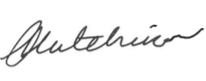
Date: | Sept 23 (update Nov 23)
Subject Leader: | Glesni Stone
Date: | Sept 23
Governor: | Chris Downham
Date: | Sept 23

