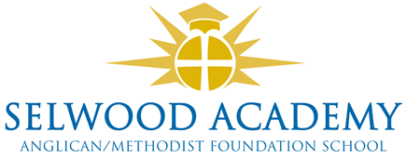
Academy Trust, Committees and Panels 2022-3
Members

Clare Cardnell (Chair), Richard Philips, Rev Liz Dudley, Frank Collins, David Oliver

Trust Board

Clare Cardnell (chair), Kyrstie Kirkwood (vice chair), Linda Puttock, Laura Su, Damon Hooton, Paul Acres, Abi Lyons,

Clerk to the Trust Board
Emma Hardy

Committees

Quality of Education Committee
Kyrstie Kirkwood (chair), Clare Cardnell, Laura Su, Linda Puttock
Resources Committee (audit and risk)
Paul Acres (chair), Clare Cardnell. Damon Hooton, Linda Puttock, Abi Lyons

Panels
Head Teacher Performance Review
Clare Cardnell (chair), Richard Phillips, Abi Lyons
Appraisals Panel
Abi Lyons (chair), Linda Puttock, Paul Acres
Appraisal Appeals Panel
Damon Hooton (chair),Clare Cardnell, Laura Su
Complaints Panel
Abi Lyons (chair), Damon Hooton, Trustee

Other Panels called as required by the Chair- Admissions, Exclusions,

