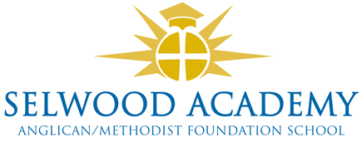
Academy Trust, Committees and Panels 2022-3
Members

Clare Cardnell (Chair), Richard Phillips, Rev Liz Dudley, Frank Collins, David Oliver

Trust Board

Clare Cardnell (Chair), Kyrstie Kirkwood (Vice Chair), Linda Puttock, Laura Su, Paul Acres, Abi Lyons.

Clerk to the Trust Board
Emma Hardy

Committees

Quality of Education Committee
Kyrstie Kirkwood (chair), Clare Cardnell, Laura Su, Linda Puttock
Resources Committee (audit and risk)
Paul Acres (chair), Clare Cardnell, Linda Puttock, Abi Lyons

Panels
Head Teacher Performance Review
Clare Cardnell (Chair), Paul Acres, Abi Lyons
Appraisals Panel
Abi Lyons (Chair), Linda Puttock, Paul Acres
Appraisal Appeals Panel
Clare Cardnell, Laura Su, Kyrstie Kirkwood
Complaints Panel
Abi Lyons (Chair), Trustee, Trustee

Other Panels called as required by the Chair - Admissions, Exclusions

