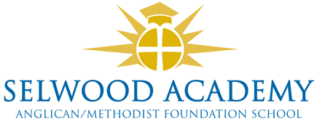
Academy Trust, Committees and Panels 2023-4
Members

David Oliver (Chair), Rev Liz Dudley, Richard Phillips, Frank Collins, Clare Cardnell

Trust Board

Clare Cardnell (Chair), Kyrstie Kirkwood (Vice Chair), Linda Puttock, Paul Acres, Abi Lyons, Luke Snape

Governance Professional
Emma Hardy

Committees

Quality of Education Committee
Kyrstie Kirkwood (Chair), Clare Cardnell, Linda Puttock
Resources Committee (audit and risk)
Paul Acres (Chair), Clare Cardnell, Abi Lyons, Linda Puttock, Luke Snape

Panels
Head Teacher Performance Review
Clare Cardnell (Chair), Paul Acres, Abi Lyons
Appraisals Panel
Abi Lyons (Chair), Paul Acres, Linda Puttock,
Appraisal Appeals Panel
Kyrstie Kirkwood (Chair), Clare Cardnell, Luke Snape
Complaints Panel
Abi Lyons (Chair), Trustee, Trustee

Other Panels called as required by the Chair eg. Admissions, Exclusions

