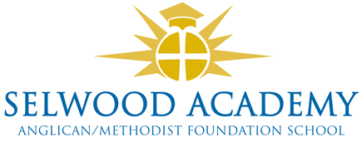

**Academy Trust, Committees and Panels 2025-6**

**Members**

David Oliver (Chair), Rev Liz Dudley, Richard Phillips, Frank Collins, Clare Cardnell

**Trust Board**

Clare Cardnell (Chair), Kyrstie Kirkwood (Vice Chair), Linda Puttock, Paul Acres, Abi Lyons, Luke Snape, Russ Morrison, Garrod Musto

**Governance Professional**

Emma Hardy

**Committees**

**Quality of Education Committee**

Garrod Musto (Chair)

**Resources Committee (audit and risk)**

Luke Snape (Chair)

All trustees are members of both committees.

**Panels**

**Head Teacher Performance Review**

Clare Cardnell (Chair), Paul Acres, Abi Lyons

**Appraisals Panel**

Abi Lyons (Chair), Paul Acres, Linda Puttock,

**Appraisal Appeals Panel**

Clare Cardnell, Luke Snape, Russ Morrison

**Complaints Panel**

Abi Lyons (Chair), Trustee, Trustee

**Admissions Panel**

All trustees

*Other Panels called as required by the Chair e.g. Exclusions, Appeals*