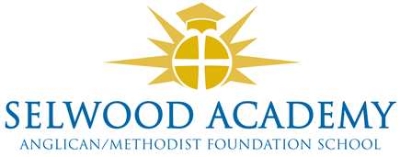
Academy Trust, Committees and Panels 2025-26

Members
David Oliver (Chair), Rev Liz Dudley, Richard Phillips, Frank Collins, Clare Cardnell

Trust Board
Clare Cardnell (Chair), Mrs K Kirkwood (Vice Chair), Linda Puttock, Paul Acres, Luke Snape, Russ Morrison, Garrod Musto

Governance Professional
Emma Hardy

Committees

Quality of Education Committee
Garrod Musto (Chair)
Resources Committee (Audit and Risk)
Luke Snape (Chair)

All trustees are members of both committees.

Panels
Head Teacher Performance Review
Clare Cardnell (Chair), Paul Acres, Trustee
Appraisals Panel
Trustee (Chair), Paul Acres, Linda Puttock,
Appraisal Appeals Panel
Clare Cardnell, Luke Snape, Russ Morrison
Complaints Panel
Trustee (Chair), Trustee, Trustee

Other Panels called as required by the Chair e.g. Admissions, Exclusions

