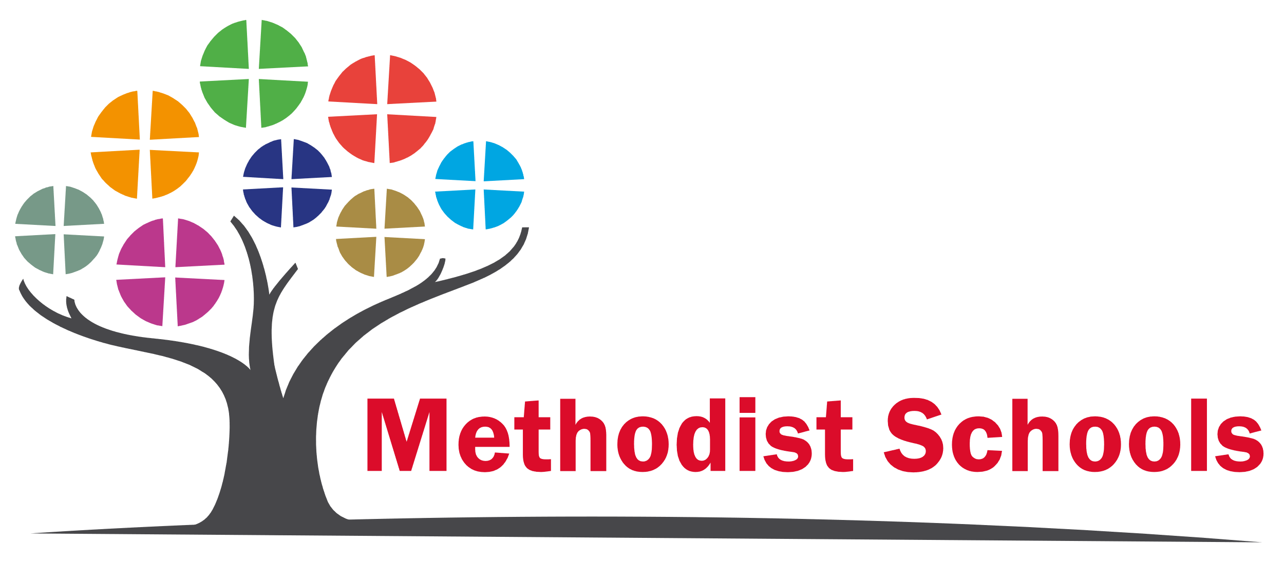
Foundation Status
Selwood Academy has a joint Anglican/ Methodist Foundation and is the only Anglican/Methodist Middle school in the country.
Anglican Foundation
Selwood Academy lies within the Diocese of Bath and Wells in Somerset.
The Diocese Education Department supports all Church of England Schools. They provide professional advice, training and assistance to support schools in all aspects of their Christian Distinctiveness, through interpreting and sharing the Church of England’s Vision for Education and its four key pillars of wisdom, hope, community and dignity. They encourage schools to develop their own unique vision in their own unique setting.
www.bathandwells.org.uk

Methodist Foundation
Selwood Academy lies in the Bristol District of the Methodist Circuit.
Methodist Academies and Schools Trust (MAST) supports and offers guidance to Methodist and joint Anglican/Methodist schools in the state sector. MAST manages the SIAMS inspection process for Methodist schools and provides a forum where good practice can be shared and excellence can be celebrated.
www.methodistschools.org.uk

Foundation Members and Trustees
Foundation Trustees are charged with bringing a Christian perspective to the life and work of the school and represent the Church's first line of support. They ensure that the guiding principles of the founding churches are incorporated into all aspects of governance and that the terms of the articles of association governing the school are adhered to.
SIAMS
All Church of England dioceses and the Methodist Church use the Church of England Education Office's framework for the Statutory Inspection of Anglican and Methodist Schools (SIAMS) under Section 48 of the Education Act 2005.
SIAMS inspections focus on the impact of the Church school's Christian vision on both pupils and adults working in the school. The inspection question evaluated is ‘How effective is the school’s distinctive Christian vision, established and promoted by leadership at all levels, in enabling pupils and adults to flourish?’
SIAMS Inspection 2014 – ‘Outstanding’

