Annual SEND Report 2022 – 2023
At Selwood, we are committed to creating a safe, happy and enriching environment where we all aspire to thrive, achieve and celebrate success together. We believe that it is essential to provide a well-balanced, challenging curriculum for all pupils, allowing our whole community to ‘let your light shine before others.’ We are committed to ensuring that all pupils, including those with special educational needs and disabilities (SEND), receive their right to a high quality, accessible and balanced curriculum.
Our aim is to promote the dignity and well-being of every pupil and staff member and ensure they flourish in the course of their journey with us and to provide all pupils with the best possible outcomes in preparation for life-long learning. We believe it is important that pupils acquire skills, knowledge and confidence that can be applied to all future learning experiences, including social, physical and spiritual development. We endeavour to raise aspirations and expectations for all pupils, especially those pupils with SEND by working in partnership with parents/carers and hearing every pupil’s voice.
SEND School Profile
SEND pupils make up about a quarter of the school’s intake. Frome have the highest number of pupils with SEND recorded in Somerset.
Mobility – Between July 2023 and now we have had 5 pupils with EHCPs leave in Year 8 and 1 join us in Year 5. We supported one year 6 (then Year 5) pupil to achieve an EHCP. No pupils with EHCPs from other Year groups have left.

Profile of pupils at Selwood with SEND
 | Year 5 | Year 6 | Year 7 | Year 8 | Total
No. of pupils on register | 37 (two at monitoring) | 45 (6 at monitoring) | 34 (7 monitoring) | 44(8 at monitoring) | 160
No. of pupils with SEN support | 34 | 32 | 22 | 28 | 116
No. of pupils with EHCP | 1 | 7 | 5 | 8 | 21

Identifying Special Educational Needs
Pupils’s needs may be categorised into four broad areas, these include:
1.Communication and Interaction 2.Cognition and Learning 3.Social, Emotional and Mental Health 4. Sensory and/or Physical

Our department is now structured around these areas to avoid a flat structure, to give TAs a lead as practitioners in their own fields. We have been able to run more interventions, give TAs more CPD around their own areas of interest and support training and promotion of a senior TA and ELSA practitioner.

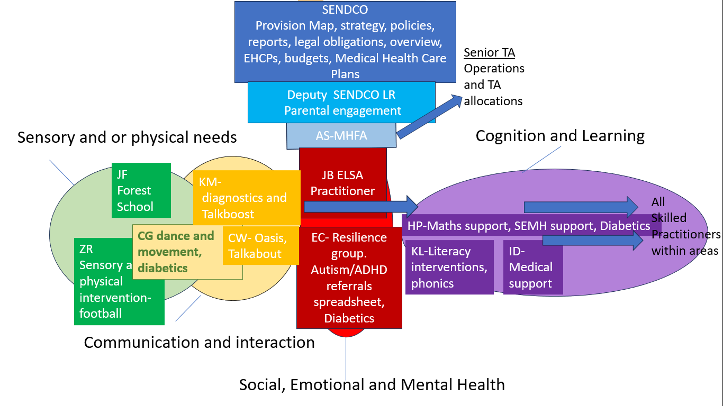

Early identification
We believe that early identification of special educational needs, whether it is social, emotional,
physical, communication or a specific learning difficulty, is crucial to the wellbeing of all of our pupils.

To support us in our early intervention we:
1. Contact the first schools and have professional dialogue for all Year 5 pupils
2. Attend where possible, transfer reviews for pupils with SEND transferring to us.
3. Encourage open communication, between school and home.
4. Provide the appropriate intervention, eg, Oasis (small group support) provided by a TA for pupils as appropriate.
5. Have a graduated approach to monitor then move pupils needing above the core offer to SEND Support on the Register of Need

Identification of SEND in pupils currently attending Selwood

Assessment of our pupils continues throughout their time with us.
In school, all members of staff are able to identify pupils who they believe might have SEND, but their needs have not yet been identified. These pupils will be discussed in curriculum team meeting and Pastoral teams and then referred to the SENDCo for further advice and possible assessments.

In addition, we also:
1. Analyse assessment data after each data drop, to identify pupils who are not meeting age related expectations
2. Subject teachers continually monitor the pupils in their department through departmental meetings, observations, discussions, marking and written feedback.
3. Providing carers/parents with the opportunity to discuss concerns at any time
4. Liaising with staff members where they have concerns about pupils

Provision
All pupils identified on the SEND register receives additional support either by having TA support in class, attending small group or 1:1 sessions or by the subject teacher making specific adaptations to the learning in the classroom, through quality first teaching.
All pupils on the SEND register have their needs and how best to support them recorded on Class Charts which is a program teachers have access to at all times to update and circulate information. Pupils at SEND Support also have a Learning Plan on Provision Map which is reviewed up to 3 times a year and fed back to parents/carers.
Parents/Carers are invited to meet with the SENDCo to review their pupil’s learning and celebrate their successes as part of their SEND Support Review and Assess, Plan, Do, Review (APDR) cycle. This year the SENDCo and Deputy held a SEND review meeting for all pupils on the SEND Register. The school exceeded its statutory obligations and went above and beyond to offer multiple reviews for all pupils, increasing parental engagement with learning plans and supporting further attainment.
For further information, please see the School SEND Information Plan on the SEN section of the school website.
David Bartram OBE, who has written for the DfE and audited over 300 schools for SEND was invited in June to inspect SEND provision. We were able to present the following figures to him in June 2023.
Attendance of SEND Pupils
 | 19-20 | 20-21 | 21-22 | 22-23
All schools National | 95.1 | 95.3 | 88.9 | 91.6
Primary School National | 95.7 | 96.3 | 92.2 | 93.5
Secondary School National | 94.4 | 94.3 | 86.6 | 89.4
LA Primary |  |  |  | 94.3
LA Secondary |  |  |  | 91.2
Somerset County Council average |  |  |  | 89.5%
Selwood Academy | 95.72 | 95.75 | 92.52 | 92.79
Selwood Academy Pupil Premium | 88.8 | 88.8 | 90.15 | 89.17
Selwood Academy SEND | 87.5 | 87.5 | 89.8 | 90.07

Behaviour

Year | 20/21* | 21/22 | 22/23
Sessions lost to suspension | 156 | 148 | 139
Sessions lost to suspension (SEND) | 109 | 103 | 100
Permanent exclusions | 0 | 0 | 0
*This year included partial closure
Referrals to Compass Centre
 | Term 1 | Term 2 | Term 3 | Term 4
Year 5 | 13 | 23 | 14 | 21
Year 6 | 32 | 27 | 19 | 24
Year 7 | 36 | 40 | 22 | 40
Year 8 | 52 | 39 | 30 | 31
Boys | 49 | 54 | 31 | 37
Girls | 18 | 27 | 21 | 26
SEND | 64 | 61 | 49 | 22
PP | 75 | 79 | 52 | 30
Total | 133 | 129 | 85 | 116

Number of pupils sent to the Compass Centre - SEND
 | T1 | T2 | T3 | T4
Year 5 | 5 | 11 | 4 | 3
Percentage of all SEND pupils | 13.51 | 28.21 | 10.26 | 7.89
Year 6 | 6 | 6 | 7 | 5
Percentage of all SEND pupils | 21.43 | 22.22 | 25.93 | 18.52
Year 7 | 8 | 9 | 8 | 7
Percentage of all SEND pupils | 26.67 | 30 | 24.24 | 21.21
Year 8 | 9 | 11 | 6 | 3
Percentage of all SEND pupils | 34.62 | 45.83 | 24 | 13.64
Cumulative | 28 | 37 | 25 | 18
Cumulative Percentage  All Year Groups | 23.14 | 30.83 | 20.16 | 14.88

Attainment
Our SATS results in 2022-2023 year showed a dip in secure combined outcomes for SEND pupils in Reading, Writing and Maths compared to 2021-2022. This is an area to be focussed on this year by using early and targeted interventions, having data review meetings with the SENCO, Deputy head, head of year and heads of English and Maths to target key pupils and put strategies in place to help remove their barriers to learning.
SEND Budget
High Needs funding for EHCP support for the financial year 2022-2023 was £101,815.
This money is spent on supporting individual pupils with an EHCP through:
- 1:1 TA support
- Alternative provision
- Specialist resources and sensory equipment (coloured overlays, sensory putty, chewables, etc)
- CPD for TAs supporting individual needs. (Mental health first aid, ASD etc)

The school budget, received from Somerset, includes money for supporting pupils with SEND This money is spent on:
- TA hours to support pupils with SEND (In class support, small group and 1:1interventions eg physio, Oasis, ELSA etc)
- CPD for all staff (Quality First teaching, SEN Expectations),
- Resources, (for ELSA support,1:1 rewards)
- Resourcing the advice from outside agencies (social communication/Talkabout intervention, structured conversations, psychologist time.)
- Meet and Greet – TA time in the mornings.
- Supervised alternative safe place to go at breaktime and lunchtime.
- Smaller class sizes and putting most qualified teachers with our most vulnerable learners.

Meetings with SEND Trustee
The SENCO and SEND Trustee (Laura Su) have maintained meetings to review SEND provision and the new SEND trustee Kirstie Kirkwood were able to meet twice at the end of the year. Meetings include reviews of provision and learning walks. A half termly report is submitted to governors which includes SEND updates. The SENDCO has presented at the quality of education meeting and is accountable to trustees.

Staffing
The above high needs EHCP pupils took up/demanded a lot of TA support and time.
Staffing was a significant concern throughout the year, with adverts running sometimes without any applicants. However we did successfully appoint Emily Cray in April and Carlia Gibb started with us September 2023. We were able to promote Andrea Sheldon to senior TA after her successful interview and Jo Barrett has been completing her ELSA practitioner training after her interview.

Parental Questionnaires
SEND Parents: Are you happy with the provision your child receives?

Percentage of “Yes” responses | Date
73% (National 66%) | May 2023
41 | September 2022
31 | June 2022
38 | Ofsted June 2022
We were very pleased by the progress in this area by the end of the academic year as shown in the grid.

David Bartram’s findings
Overall David was pleased with what he saw. He said:
- The school has made very good progress with recommendations in the Ofsted report of June 2022.
- Improvements in communicating pupil information has meant staff have a better understanding of pupil need and the strategies required to ensure they succeed.
- During the review, staff displayed a strong connection and empathy with the challenges that many pupils face, underpinned by respect, high expectations and kindness.
- Leaders with responsibility for SEND are involved in reviewing and helping teachers improve the quality of teaching for all pupils. For example, the SENCO works closely with the teaching and learning team to quality assure lessons. This includes weekly, timetabled learning walks to observe classroom teaching and evaluate whether teachers are adapting the curriculum effectively.
- During this review, pupils with SEND behaved well, demonstrating high levels of self-control and positive attitudes to their education. Transition arrangements for pupils with SEND are effective. High quality communication and information sharing takes place when pupils transition to and from the school.
- The school has worked effectively to improve communication with parents and carers. Termly coffee mornings offer an opportunity to meet informally and this is helping to develop a culture that welcomes and engages families of pupils with SEND. There are a wide range of opportunities for pupils to become fully involved in the life of the school. Enrichment is a strength of the school. Parents involved in the interviews were positive about the support their children receive from the school: ‘I honestly can’t thank [the school] enough for the patience, kindness, professionalism and understanding [they] have shown A and me…The SEN team have been outstanding.’ Parent
- Teaching assistants are well trained. They feel supported by senior leaders and welcome the quality of CPD they have received. Teaching assistants deliver a number of evidence based interventions. There is some good strategic deployment of TAs across the school.
- The school uses a wide range of data, including behaviour and attendance data, to ensure additional learning needs are not missed. A range of screening and assessment tools are used to ensure that the SEND register is accurate and reviewed regularly. The school uses outside agencies effectively to support accurate identification.

Key Priorities for 2023‐2024

David had some recommendations including:
- Use resources such as the SEND Governance Review Guide as a framework to ensure trustees are able to provide both challenge and support. Consider additional training for trustees on SEND policy and practice.
- Continue to embed approaches to improving reading for pupils with SEND.
- Review the structure of the SEND department and create teams. This includes developing roles further, by giving greater responsibility and autonomy to key members of staff so that the SENCO is able to delegate effectively. For example, the school might ensure TAs are linked to a broad area of SEND need; growing expertise and empowering colleagues to take greater responsibility
- Ensure a more forensic approach to evaluating the impact of intervention. This should include re-visiting current exit and entry criteria and adding the following components to the provision mapping process: § Desired impact § Pre-intervention assessment § Post-intervention assessment/evaluation § Average gain.
- Review current screening and assessment tools in the area of Communication and Interaction and SEMH in order to support accurate identification of SEND. An example of recommended assessments has been attached to this report. - Introduce a single referral process. Review referral data on a termly basis to inform provision and practice.

