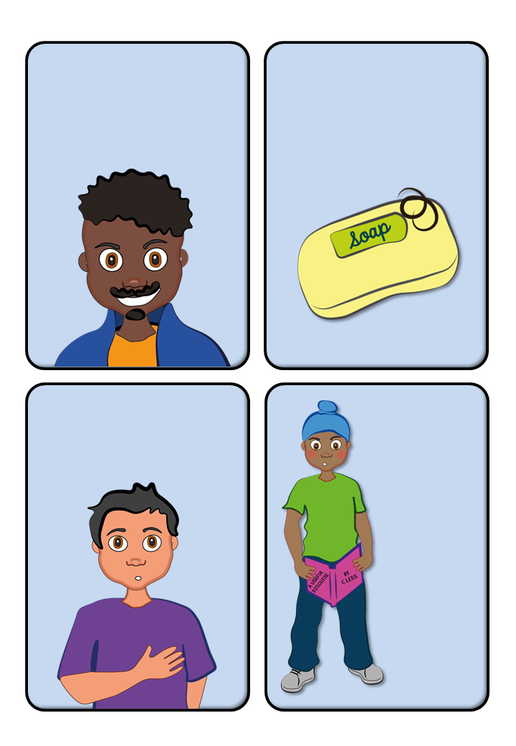

You’ll

start

to get erections.

You may start to grow facial hair as well as more on the rest of your body.

You’ll grow hair around your groin area.

You may have temporary swelling

on your chest.

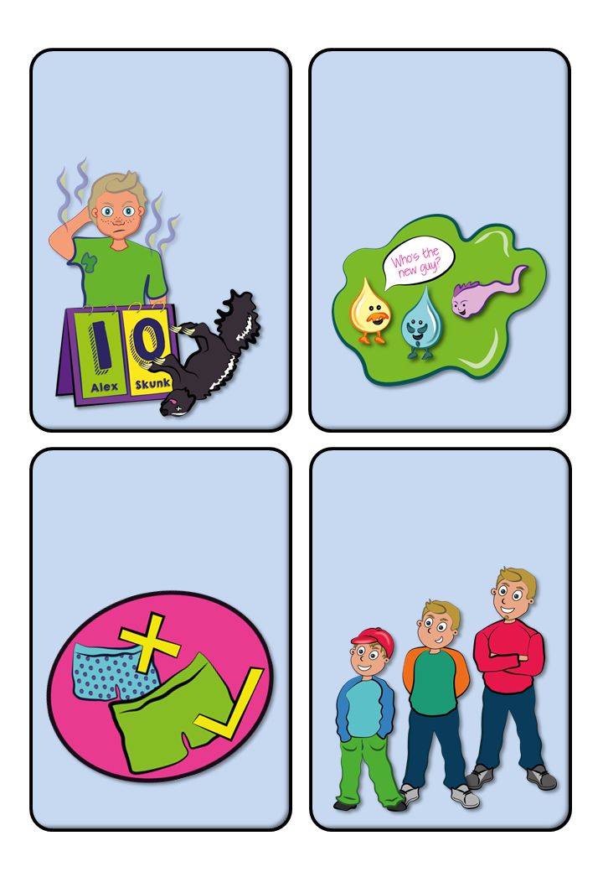

You may notice you smell a little different.

Your bits will grow bigger.

You’ll start

to produce

new fluids.

You’ll start to get bigger everywhere.

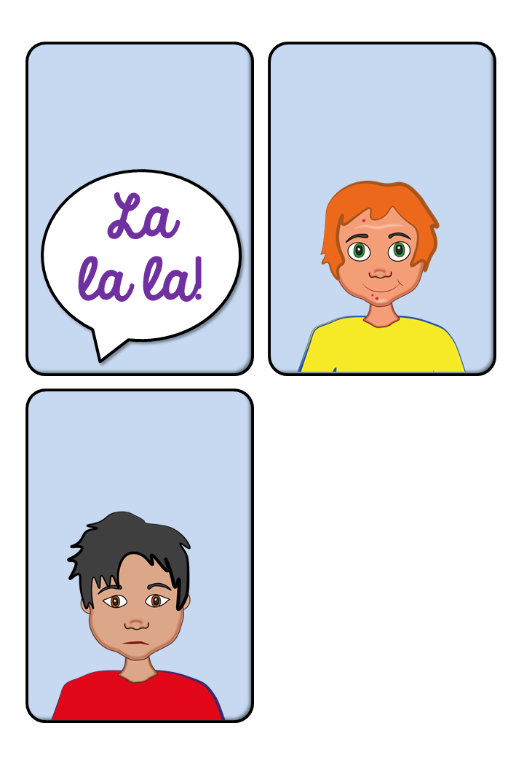

Your voice will start to change.

Your skin

may feel a bit

greasier.

You may feel

very different emotionally.

One of the first things you might notice is an enlargement of the scrotum, testicles and penis.

As your penis gets bigger, you might also start to have erections. This is when the penis fills with blood and becomes hard. This might happen when you think about something sexual, or it might happen for no reason at all.

During puberty, a boy’s body starts to make semen, which is made up of sperm and other bodily fluids. Semen might be released during an erection, which is known as ejaculation. This can sometimes happen while you are sleeping, which some people call a ‘wet dream’. Although you might find this a little embarrassing, it’s totally normal. Once your body starts to produce semen, it means that, if you were to have sex with a girl, she could become pregnant.

You’ll also start to grow long, soft hair in your genital area, known as public hair. As your pubic hair spreads, it will become darker and coarser. You might notice it moving down towards your thighs, and up towards your stomach. It might be the same colour as the hair on your head, or it might be slightly different.

Around the same time as your pubic hair grows, you’ll start to grow more hair on your face, under your arms, and on your legs.

Your arms, feet, legs and hands will all increase in size, and sometimes these areas will grow faster than the rest of your body. This might make you feel a little awkward or clumsy, but it’s completely normal, and the rest of your body will soon catch up!

You might notice an increase in body odour, often known as BO, particularly in the underarm area.

Sometimes, hormonal changes can cause swelling in the breast area, but this is temporary and will disappear as your hormones settle down.

You might notice it start to ‘crack’ sometimes when you’re speaking, and eventually it will become lower. This is often referred to as your ‘voice breaking’.

You’ll likely start to notice your skin becoming oilier, and you might start to get a few spots, often referred to as ‘acne’. When this happens, it’s important to wash your face properly every day.

You might start to feel irritable, cross or sad, even when you don’t really have a reason. All of this is normal, but of course it can be a little upsetting and confusing. If you’re feeling this way, don’t be afraid to reach out to someone you trust for support.