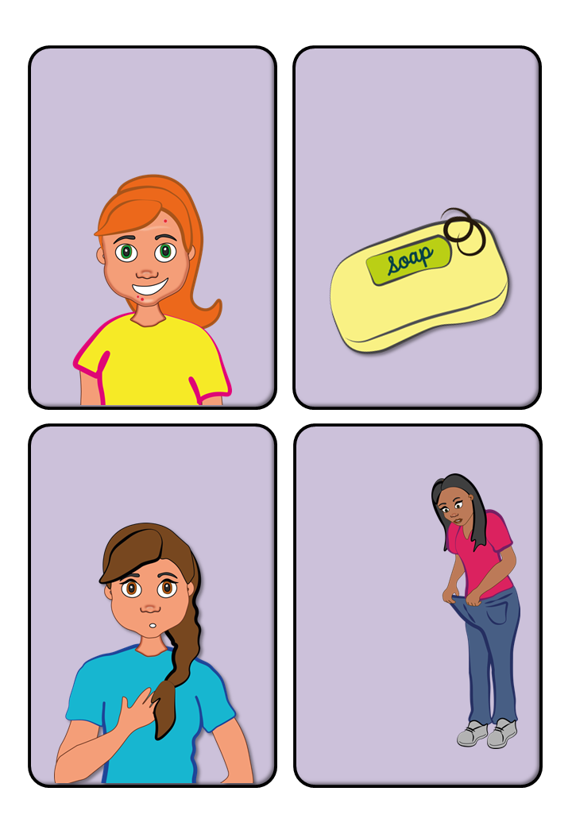

Your

genitals

will start

to grow

and

develop.

You will start to gain breast buds

You will start to grow pubic and underarm hair

.

Your skin will start to produce more oil.

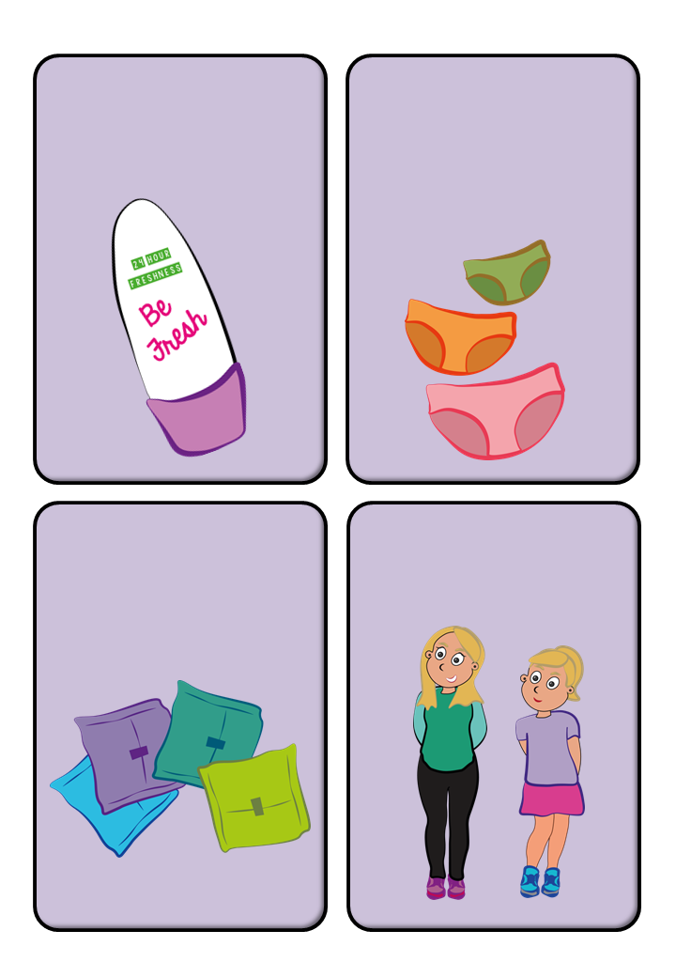

You might start to become more sweaty

Your period will start.

 You will start to get taller

.

You’ll start to notice

a fluid being produced

by your vagina.

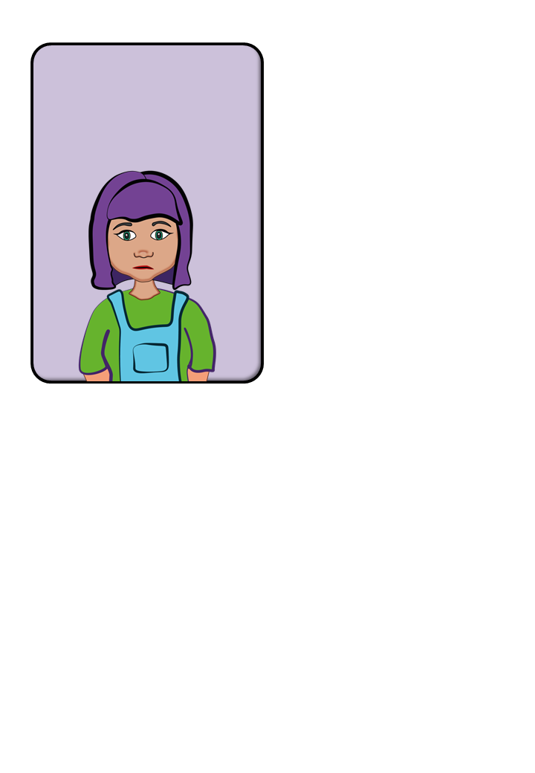

You might find your

self feeling worried, cross, sad, or anxious more often,

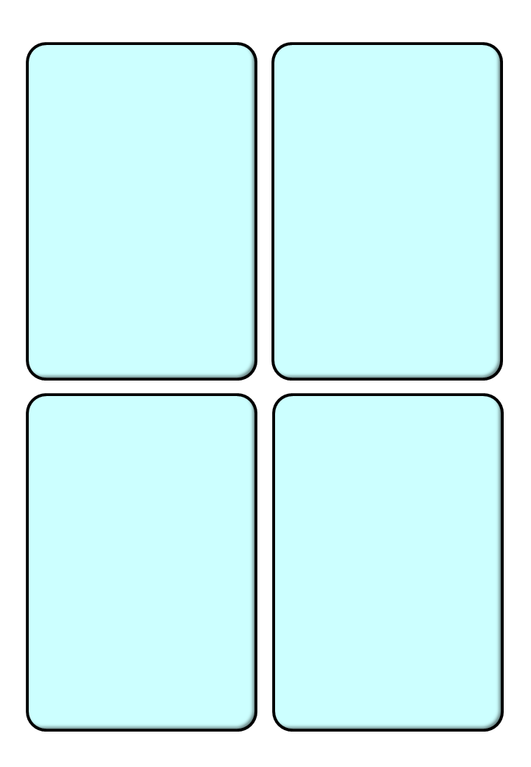

Once this happens, you might also notice more body odour, known as BO. If you start to notice this, you might choose to start wearing deodorant.

You’ll start to notice what feel like little buds in your breast area, or a swelling under your nipples. This is a sign that your breasts are starting to grow. You might start to feel a little sore, and as you grow you might require the support of a bra. How big or small your breasts will be depends on the genetics in your family.

One of the first things you’ll likely notice is that you’re getting taller - probably taller than most of the boys in your class! This is because girls experience their ‘growth spurt’ - meaning the period of time where they grow quickly - before boys do. You might also gain some weight.

You’ll start to grow hair

in places you didn’t have any before, such as your genital area. This is called pubic hair, and will grow from your lower stomach to between your legs, and sometimes also the inner thighs. As it grows, it will become coarse and curly. After pubic hair begins

to grow, you’ll also notice hair starting to grow under your arms, and on your legs.



This means that both your hair and skin might start to look and feel greasy. It’s a good idea to set up a good skin and haircare routine to help you stay clean and fresh. Because your skin is becoming oily, this might cause you to develop spots on your face, known as acne. This is very common, and there are lots of creams you can buy to help deal with it.

Your vagina is enclosed by two sets of lips, known as the vulva. The larger lips will develop pubic hair, and the inner lips might start to increase in size, which might cause your genitals to look different. Everyone’s genitals are different, and it’s important to remember that there is no ‘normal’.

This is known as ‘discharge’. This is produced by your body to keep the vagina clean and moist. When you start puberty, you’ll probably notice some yellow or white stains in your underwear. This is a sign that your period will be starting soon.

Before this happens, you might notice some pain in your tummy or lower back, often known as ‘period pains’. These can be mild, or really quite severe. Then, you’ll notice bleeding from your vagina. The blood might be bright red, brown, and might include small lumps of blood called clots. Your period will probably last between three and five days, and the process is known as ‘the menstrual cycle’. When your period starts, it means that your ovaries have begun to release eggs every month. Your ovaries are full of eggs, and one will be released every month until your periods stop when you are older. This means that if you have sex, you can become pregnant.

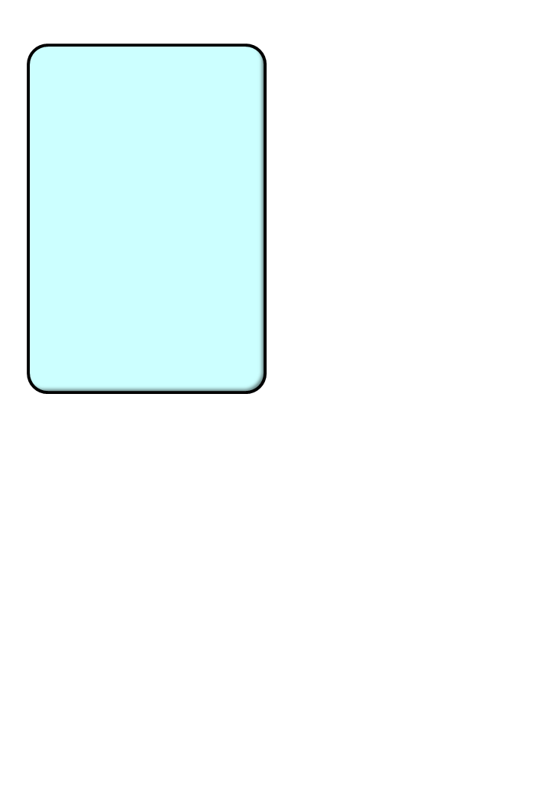

This may be for no real reason. This is perfectly normal, and is also caused by hormones. If you feel like you’re having trouble coping, talk to an adult you trust, who can give you the help and support you need.