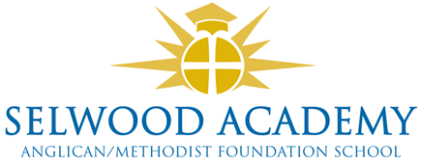

Current Trustees (Directors) 2020-21

Trustee name | Position | Start date | End date
Vacancy | Ex-Officio Anglican | n/a | n/a
Mr D Hooton | Foundation Anglican | 11/02/2020 | 10/02/2024
Rev G Slingo | Ex-Officio Methodist | 30/01/2020 | n/a
Mr R Philips | Foundation Methodist | 12/11/2019 | 11/11/2023
Mr D Jeffries | Headteacher | 01/01/2021 | n/a
Vacancy | Elected Staff | n/a | n/a
Mrs M Bailey | Elected Support Staff | 01/09/2018 | 31/07/2022
Ms E Denne | Elected Parent | 12/02/2019 | 11/02/2023
Ms J Gamble | Elected Parent | 12/02/2019 | 11/02/2023
Vacancy | Elected Parent
Vacancy | Elected Parent
Vacancy | Elected Parent
Mrs C Cardnell (Chair) | Community | 06/07/2017 | 05/07/2021
Mr C Bailey-Green | Community | 18/12/2016 | 17/12/2020
Mrs L Puttock | Community | 11/6/2019 | 10/06/2023
Mrs K Kirkwood | Community | 18/12/2016 | 17/12/2020
Vacancy | Co-opted
Vacancy | Co-opted

Academy Board Members

Mrs C Cardnell Chair
Mr C Bailey-Green Vice-Chair
Mr D Hooton Anglican Foundation
Mr R Phillips Methodist Foundation
Mrs K Kirkwood Trustee
Mrs J Gamble Trustee
Mrs E Denne Trustee
Mrs L Puttock Trustee

