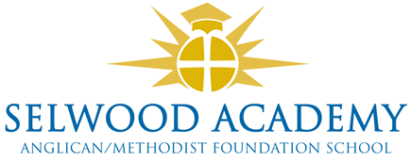

Current Trustees 2021-22

Trustee name | Position | Start date | End date
Mrs L Puttock | Foundation Anglican | 01/04/2021 | 31/03/2025
Mr D Hooton | Foundation Anglican | 11/02/2020 | 10/02/2024
Rev G Slingo – on sick leave | Ex-Officio Methodist | 30/01/2020 | n/a
Mr R Phillips | Foundation Methodist | 12/11/2019 | 11/11/2023
Mr D Jeffries | Headteacher | 01/01/2021 | n/a
Ms J Gamble | Elected Parent | 12/02/2019 | 11/02/2023
Mrs L Su | Associate Parent | 01/09/2021 | 31/08/2025
Mr P Acres | Community | 31/03/2022 | 30/03/2026
Mrs C Cardnell (Chair) | Community | 06/07/2017 | 05/07/2025
Mrs K Kirkwood | Community | 18/12/2016 | 09/12/2024

Academy Board Members

Mrs C Cardnell Chair
Mr D Hooton Anglican Foundation Member
Mr R Phillips Methodist Foundation Member
Mrs K Kirkwood Member
Mrs J Gamble Member
Mrs L Puttock Member
Vacancy Member

Trustees/Members who have left in the past 12 months
Name | Left on: | Reason
Mr C Bailey-Green | 03/02/2022 | Resigned
Mrs E Denne | 05/11/2021 | Resigned
Mrs M Bailey | 30/07/2021 | Retired
Ms K Preston | 24/02/2021 | Resigned

