Dear Parent/Carer
Thank you to the many Parents/Carers who are already accessing the Sims Parent App, Later this week, we will be uploading your child’s first ‘settling-in’ report. Here you will be able to view information about your child’s attitude towards learning in each subject. Attached to this report is a full explanation of the content of the report.
Have you accessed your child’s information through the Sims Parent App yet? Any parents who have not registered yet will receive an activation email in the next few days, so please keep an eye out for this and register ASAP.

About SIMS Parent
SIMS Parent is an online website and app, which is accessible to parents to provide them with information about their child.
You can access the new system from a smartphone, tablet or PC – anytime, anywhere.
What will you find in the SIMS Parent App?
- Important information such as attendance and latest reports.
- School term and INSET dates and contact details available at the click of a button.
- Access to update your contact details at any time, so we always have the most up-to-date information in case of emergency.
- If you have more than one child at school, you will have access to information for all your children, from the same app.
The information that you receive through the app will help you to stay up-to-date with your child’s school life as well as support your child’s development and progress.
Getting started with the SIMS Parent app
- Provided you have supplied the school with an up-to-date email address, we will send you an activation email; simply click on the link from your tablet, PC or smartphone to activate your account.
- You can then login using your normal Facebook, Twitter, Google or Microsoft username and password.
- From your smartphone or tablet, download the app from the Google Play or Apple App store - search for SIMS Parent.
- From a PC or Windows phone, login online at www.sims-parent.co.uk
Please note that your activation email is unique to you and should not be used by anyone else. If you require an additional login then please contact your school.
Your activation email will expire after 14 days if it is not used, please contact your school if you require a replacement after this date.
We no longer provide paper copies of reports and instead, our new app will provide you with all the information you need. If you have trouble accessing the app, please contact the school: selwoodacademy@educ.somerset.gov.uk .
Please see attached for a step-by-step guide to activate and access your account

Yours sincerely,
Adam Broad
Deputy Head Teacher

SIMS PARENT APP REGISTRATION INSTRUCTIONS

To register for SIMS parent you will need one of the following accounts:
Facebook, Twitter, Google, Microsoft or Office 365. Please note activating and registering is a two-step process

STEP 1

Open the email that was sent to you from noreply@sims.co.uk to the email address you have provided to the school. Check your junk/spam box first if not received in your inbox, otherwise contact the school with an up-to-date address.

Click on the “Click this link” link within the email that will direct you to a sign in page

Choose the account you would like to use to register, this will be an existing account you already use e.g. Your Facebook/twitter log in, google mail, office 365 (outlook) or Microsoft for email from another provider. Please be aware that SIMS ID cannot be used.

This will then direct you to a different log in screen relevant to the Third party account that you have selected. Once the new screen is displayed, please enter your existing account details for this provider.

You may need to click on a permission button to allow SIMS Parent account to attach to your Third Party account.

Once you have entered your account details, this will then be directed to the following page

Please check your details are correct.
Click on register.

You will then be asked a security question e.g. date of birth of one of your children at the school.

Enter the date of birth in the correct format e.g. 01/12/2000.

Click on Verify

This will check our system to ensure that this matches our records, should this not allow you to access your account, please contact the school office.

You have now activated your account and will be able to log in to SIMS Parent for the first time.

STEP 2

Please now sign into your SIMS Parent account using the details you entered at the registration stage.

You will be able to access this via the website (a link to this can be found on the Selwood Academy website) and/or by downloading the SIMS Parent App to your smartphone or tablet device.

Website version (app version very similar)
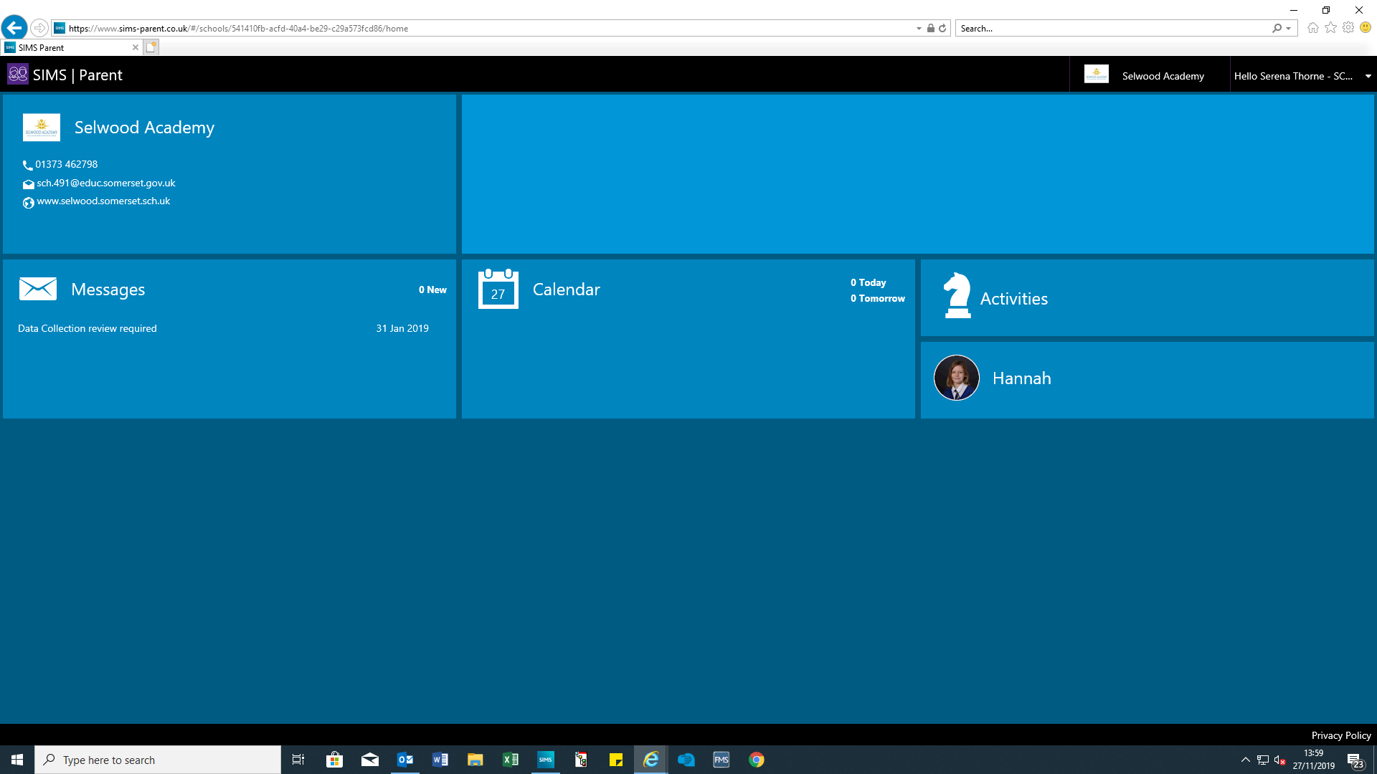

When you click on an individual child on the home page, you will have access to your child’s attendance, their latest report and any previous reports from the current academic year and a copy of their timetable.

