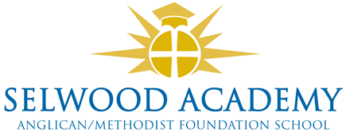

Trust Board - Committees 2021-22

Resources Committee

Richard Philips (Chair)
Clare Cardnell*
Daniel Jeffries*
Damon Hooten (Vice-Chair)
Linda Puttock
Paul Acres (Associate Trustee)

In attendance: Melissa Singer, Business Manager

Teaching and Learning Committee

Kyrstie Kirkwood (Chair)
Daniel Jeffries*
Joy Gamble
Clare Cardnell*
Graham Slingo
Laura Su (Associate Trustee)

In attendance: Andrew Owen, Deputy Headteacher
Andy Ellett, Assistant Headteacher

Committee Clerk: Emma Hardy

*Please note that the Headteacher and Chair of Trustees are ex-officio members of all non- statutory committees.

