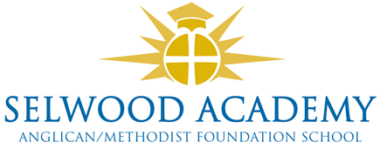
Trustee Links and Responsibilities 2022-3

Contact
Please address any correspondence to the Chair of Trustees, Mrs Clare Cardnell via the clerk, Mrs Emma Hardy: Emma.Hardy@selwood-academy.co.uk

Named Trustees
Responsibility | Trustee
SEND (S) | Laura Su
Safeguarding (S) Prevent  Child Protection, LAC | Kyrstie Kirkwood
Health and Safety (S) | Abi Lyons
Finance | Paul Acres
Foundation/SIAMS | Linda Puttock
Pupil Premium | Kyrstie Kirkwood
Sports Premium | Kyrstie Kirkwood
HR./Careers | Abi Lyons

Link Trustees
Faculty | Faculty Head | Trustee
Mathematics | Oliver Littlewood | Clare Cardnell
English | Oliver Crook-Wynn | Kyrstie Kirkwood
Science / Technology / Computing | Steve Wilkie | Kyrstie Kirkwood
Languages / MFL / EAL |  | Laura Su
R&P/ PASH / Citizenship | Jenni Howell | Linda Puttock
PE | S Hershbein | Damon Hooton
Humanities | Richard Sage | Paul Acres
Arts / Music / Drama | Claire Ibbitson | Abi Lyons

Clerk to Trustees and Training administrator -Emma Hardy

