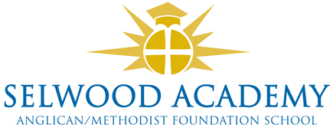
Trustee Links and Responsibilities 2023-4

Named Trustees
Responsibility | Trustee
SEND (S) | Kyrstie Kirkwood
Safeguarding (S) Prevent  Child Protection, LAC | Kyrstie Kirkwood
Health and Safety (S) | Paul Acres
HR/Careers | Abi Lyons
Sports Premium | Luke Snape
Pupil Premium | Vacant
SIAMS | Linda Puttock
Training | Kyrstie Kirkwood

Faculty Link Trustee
Faculty | Faculty Head | Trustee
Mathematics | Oliver Littlewood | Clare Cardnell
English | Oliver Crook-Wynn | Kyrstie Kirkwood
Science & Technology | Steve Wilkie | Kyrstie Kirkwood
Languages | E Collins | Vacant
PSHE | Jenni Howell | Linda Puttock
PE | Stuart Hershbein | Luke Snape
Humanities | Richard Sage | Paul Acres
Performing Arts | Claire Ibbitson | Abi Lyons

Governance Professional and Training administrator - Emma Hardy

Contact
Please address any correspondence to the Chair of Trustees, Mrs Clare Cardnell via the clerk, Mrs Emma Hardy: Emma.Hardy@selwood-academy.co.uk

