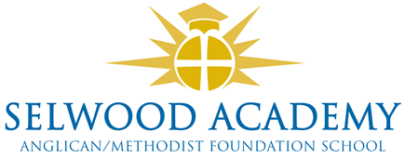

Trustee Links and Responsibilities 2025-26

Named Trustees

|  |  |
| --- | --- |
| **Trustee** | **Responsibility** |
| Kyrstie Kirkwood | SEND (S) |
| Kyrstie Kirkwood | Safeguarding (S)  Prevent Child Protection, LAC |
| Paul Acres | Health and Safety (S) |
| Abi Lyons | Careers, HR |
| Luke Snape | Sports Premium |
| Kyrstie Kirkwood | Pupil Premium |
| Linda Puttock | SIAMS, Wellbeing, Anglican Foundation |
| Garrod Musto | SIAMS, Methodist Foundation |
| Russ Morrison | Cyber crime |

Trustee Faculty Link

|  |  |  |
| --- | --- | --- |
| **Faculty** | **Faculty Head** | **Trustee** |
| Mathematics | Oliver Littlewood | Clare Cardnell |
| English | Oliver Crook-Wynn | Luke Snape |
| STEM | Steve Wilkie | Garrod Musto |
| Languages | Emma Collins | Russ Morrison |
| PASHE | Jenni Howell | Linda Puttock |
| PE | Stuart Hershbein | Luke Snape |
| Humanities | Gill Wareham | Paul Acres |
| Performing Arts | Claire Ibbitson | Abi Lyons |

Governance Professional and Training administrator - Emma Hardy

Contact

Please address any correspondence to the Chair of Trustees, Mrs Clare Cardnell via the clerk, Mrs Emma Hardy: Emma.Hardy@selwood-academy.co.uk