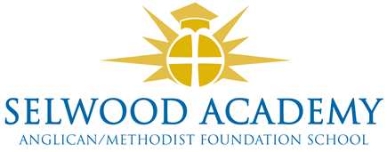
Trustee Links and Responsibilities 2024-5

Named Trustees
Trustee | Responsibility
Mrs K Kirkwood | SEND (S)
Mrs K Kirkwood | Safeguarding (S)  Prevent Child Protection, LAC
Paul Acres | Health and Safety (S)
Vacancy | Careers, HR
Luke Snape | Sports Premium
Mrs K Kirkwood | Pupil Premium
Vacancy | SIAMS, Wellbeing
Garrod Musto | SIAMS
Russ Morrison | Cyber crime

Trustee Faculty Link
Faculty | Faculty Head | Trustee
Mathematics | Oliver Littlewood | Clare Cardnell
English | Oliver Crook-Wynn | Luke Snape
STEM | Steve Wilkie | Garrod Musto
Languages | E Collins | Russ Morrison
PASHE | Jenni Howell | Vacancy
PE | Stuart Hershbein | Luke Snape
Humanities | Gill Wareham | Paul Acres
Performing Arts | Claire Ibbitson | Vacancy

Governance Professional and Training administrator - Emma Hardy

Contact
Please address any correspondence to the Chair of Trustees, Mrs Clare Cardnell via the clerk, Mrs Emma Hardy: Emma.Hardy@selwood-academy.co.uk

