Year 6 Curriculum Overview 26-27
Subject | Term 1 | Term 2 | Term 3 | Term 4 | Term 5 |  | Term 6
Some recommended reads | Look Both Ways by Jason Reynolds; The Super Miraculous Journey of Freddie Yates by Jenny Pearson; The Middler by Kirsty Applebaum; The Girl of Ink and Stars by Kiran Millwood Hargrave; Boy in the Tower by Polly Ho-Yen and Skellig by David Almond.
English   | Concept - Writing styles  Text-  The last Bear | Concept - Story telling  Myths and Legends | Novel study: Characters  Text-  Windrush child | Novel study: Setting  Text-  Windrush child | Concept – Literacy greats  Contemporary and Classic  Short stories and Shakespeare
Maths  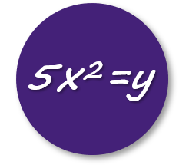 | Place value  Four operations | Converting measures  Position and Direction | Fractions  Decimals  Percentages | Geometry | Statistics  Ratio  Algebra |  |  |  | Year 7 Curriculum  Sequences  Algebraic notation
Science   | Living things and their environment | Electricity | Evolution | Light | Animals including humans
Art   | Visual Literacy  Insects  (Wire sculpture) | Generate Ideas  Day of the Dead (Clay sculpture)  Pop Art (printing) |  | Create  Pop Art (printing) | Present  Surrealism  (Drawing, texture, landscape, imagination)
Computing   | Computing systems and networks  Communication and collaboration | Websites (Google Sites)  Web page creation | Data and information  Introduction to spreadsheets | Programming  Scratch -Variables in games | Creating media  3D Modelling |  |  |  | Programming  Sensing
Drama  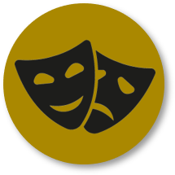 | Physical Characterisation - Kensuke’s Kingdom | Vocal and Physical Characterisation- The Lion, the witch and the wardrobe | Page to Stage- Ernie’s Incredible Illucinations | Character Development- Myths and Legends | Shakespeare- The Tempest |  |  | Theatre Makers- Darkwood Manor
French   | Moi et ma Famille  Me and my family | Ma famille  My family | Où j’habite  Where I live | En Ville  In the town |  |  |  |  | Au snack  At the snack bar
Geography   | Europe – small yet mighty | Biomes – big and beautiful | North America – a continent with it all | Terrifying Tectonics | .What a wonderful world – South America
History  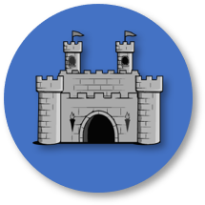 | Causes and Consequences- The Black Death- Health in the Middle Ages  To understand how medicine, health and hygiene were different and the same as they are today. |  | Chronology and Significance -The Age of Exploration  To understand the discoveries which key individuals made in their explorations |  | Causation, Chronology, Source Analysis-Henry VIII and the Wider World  To understand the different types of Christianity and why they were in conflict in the 16th Century
Music   | Solo Performance Skills  Ukulele 101 | Understanding Traditional music  The Baroque Era | Listening & Notation skills  Music Theory | Discovering World music  Indian music | How to compose Music  Music in advertising |  |  |  | Ensemble performance skills  Musical Theatre
PASHE  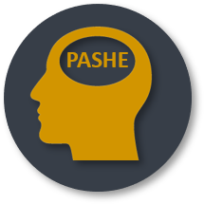 | Aspiration (the wider community)  Harvest festival | Health (physical wellbeing)  Personal (mental wellbeing)  How can I treat people fairly and respectfully? | Personal (mental wellbeing) Economics (Enterprise Project)  How can I turn my ideas into a business that supports wellbeing? | Health (physical wellbeing)  How can my choices affect my wellbeing? | Social (RSHE)  What do I need to know about growing up? |  |  |  | Personal (mental wellbeing online)  How do I look after myself online?
PE   | Team building and Social skills (Rugby)  Self confidence and rhythm (Gymnastics)  Discipline & coordination skills (Hockey) |  | Understanding rules and officials (Basketball)  Marginal gains and tactics (Ball games)  Leadership (Cricket) |  | How to be your best (not the best)  (Athletics) |  |  |  | Wellbeing in sport and physical activity  (Outdoor and adventurous activities)
Religion and Philosophy   | Philosophy  (An introduction to philosophy) | Judaism  (Increase awareness and understand similarities and differences to other religions) | Christianity  (Understanding Christian beliefs) | Christianity  (Increase understanding of Easter and why it is celebrated in school) | Islam  (Increase awareness and understand similarities and differences to other religions) |  |  |  | Islam/Humanism  (Further increase awareness and introduction to secular belief syste, Humanism)
Technology   | Topic 1 Topic 2 Topic 3 Topic 4  Design technology Product Development Cooking and Nutrition Textiles  Structures Marble run Snack bars No sew cushion
Visits, Visitors and performances | Harvest | Pantomime |  |  | Portsmouth History Trip |  |  |  | Year 6 Mendip residential

Suggestions on how you can support your child at home:
- Hear your child read and have discussions around the book together
- Practice spelling words from the Year 6 spelling list in the National Curriculum https://assets.publishing.service.gov.uk/government/uploads/system/uploads/attachment_data/file/239784/English_Appendix_1_-_Spelling.pdf
- Support your child with practicing their times tables
- Support your child with completing their homework
- Encourage participation in after-school clubs, sports and art activities and tap into community resources with visits to a library, museum, zoo or theatre

