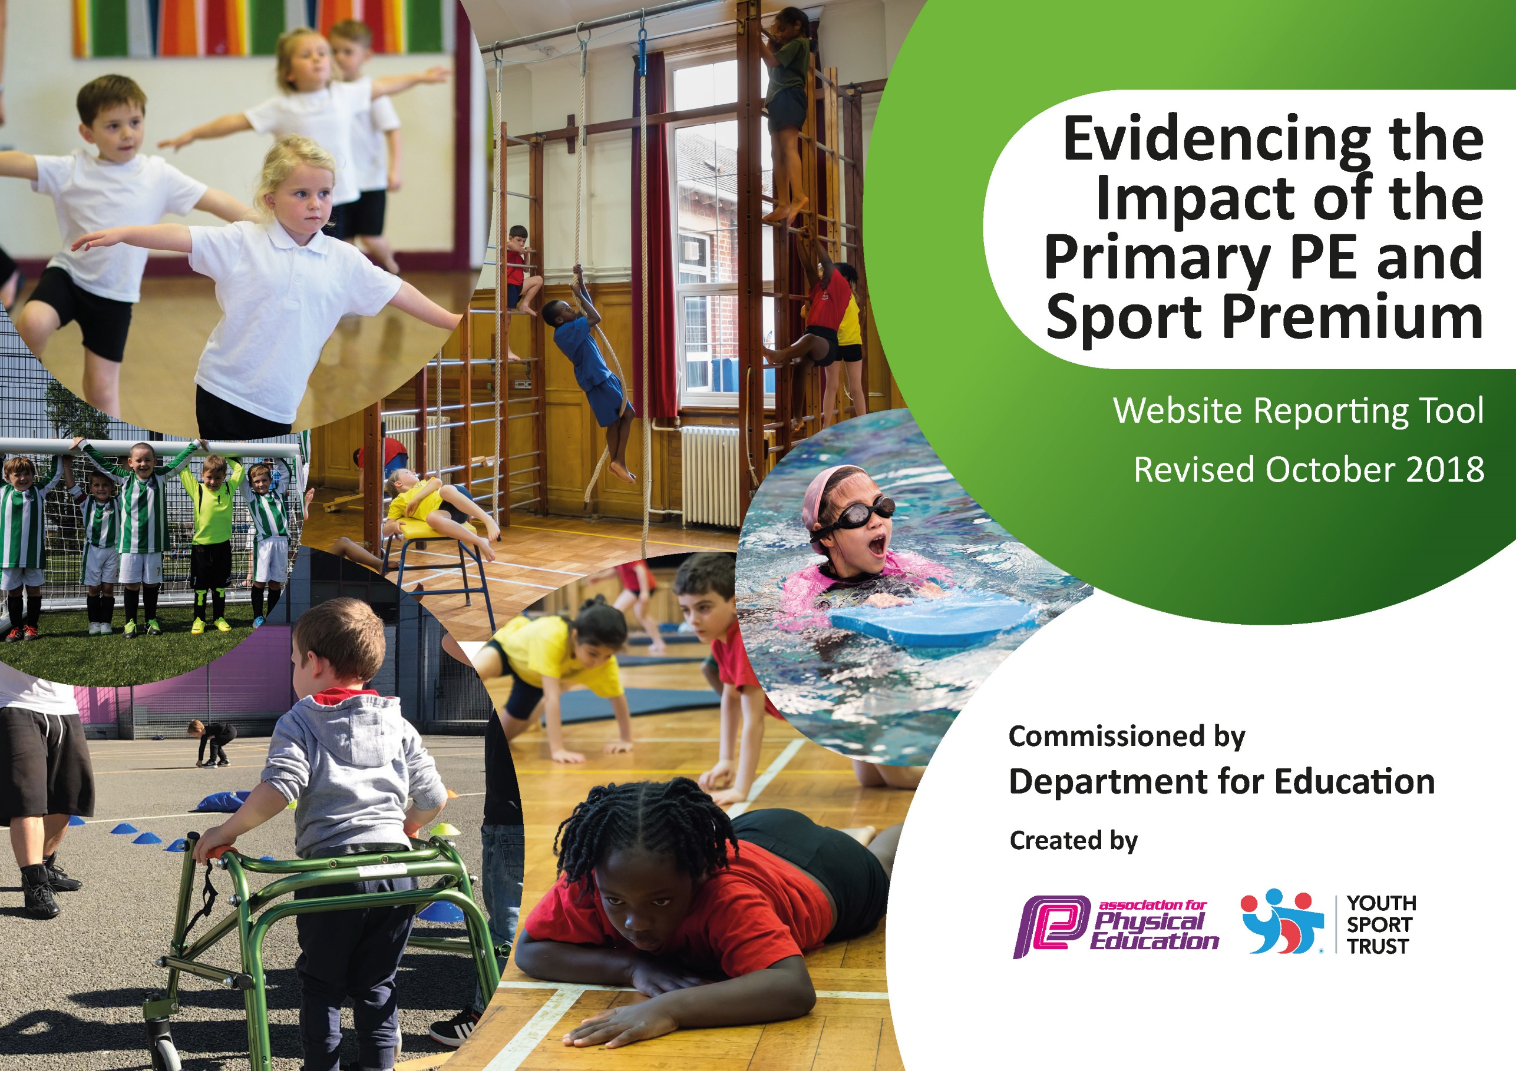
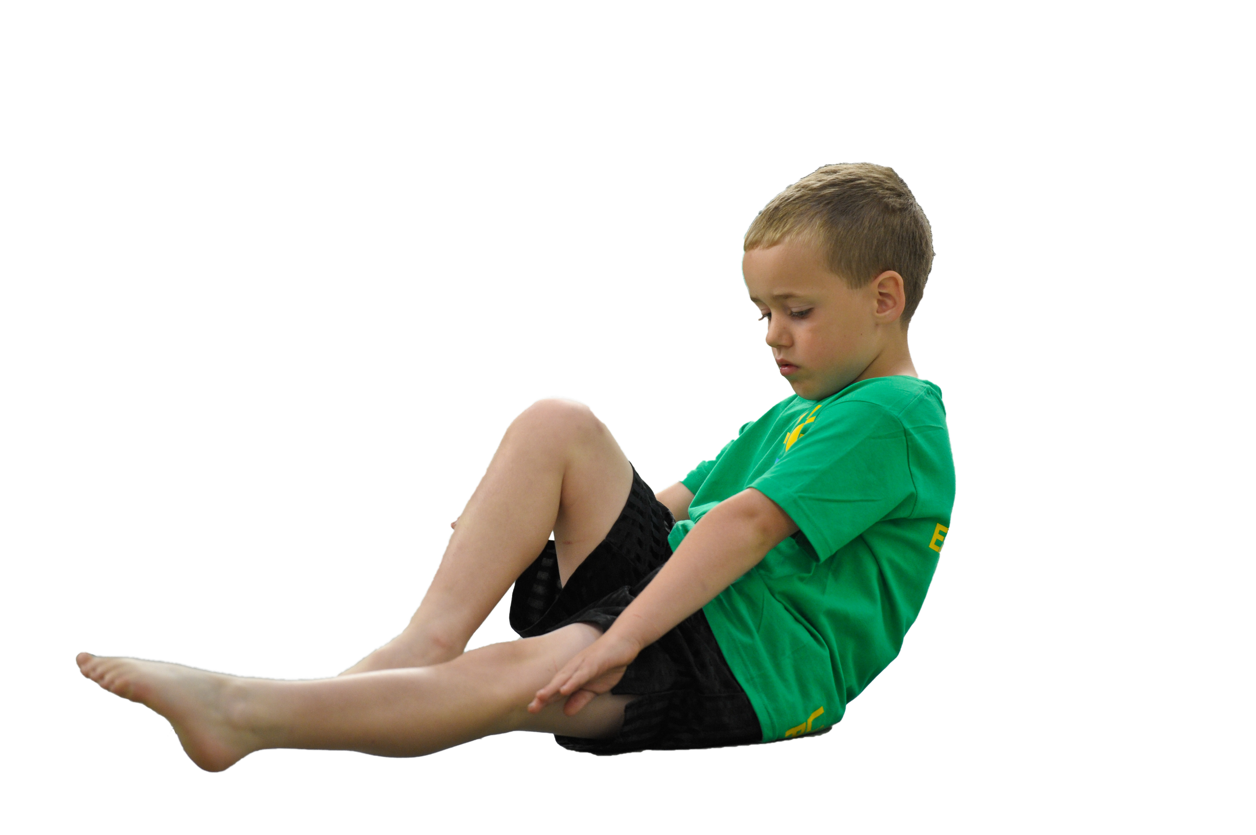
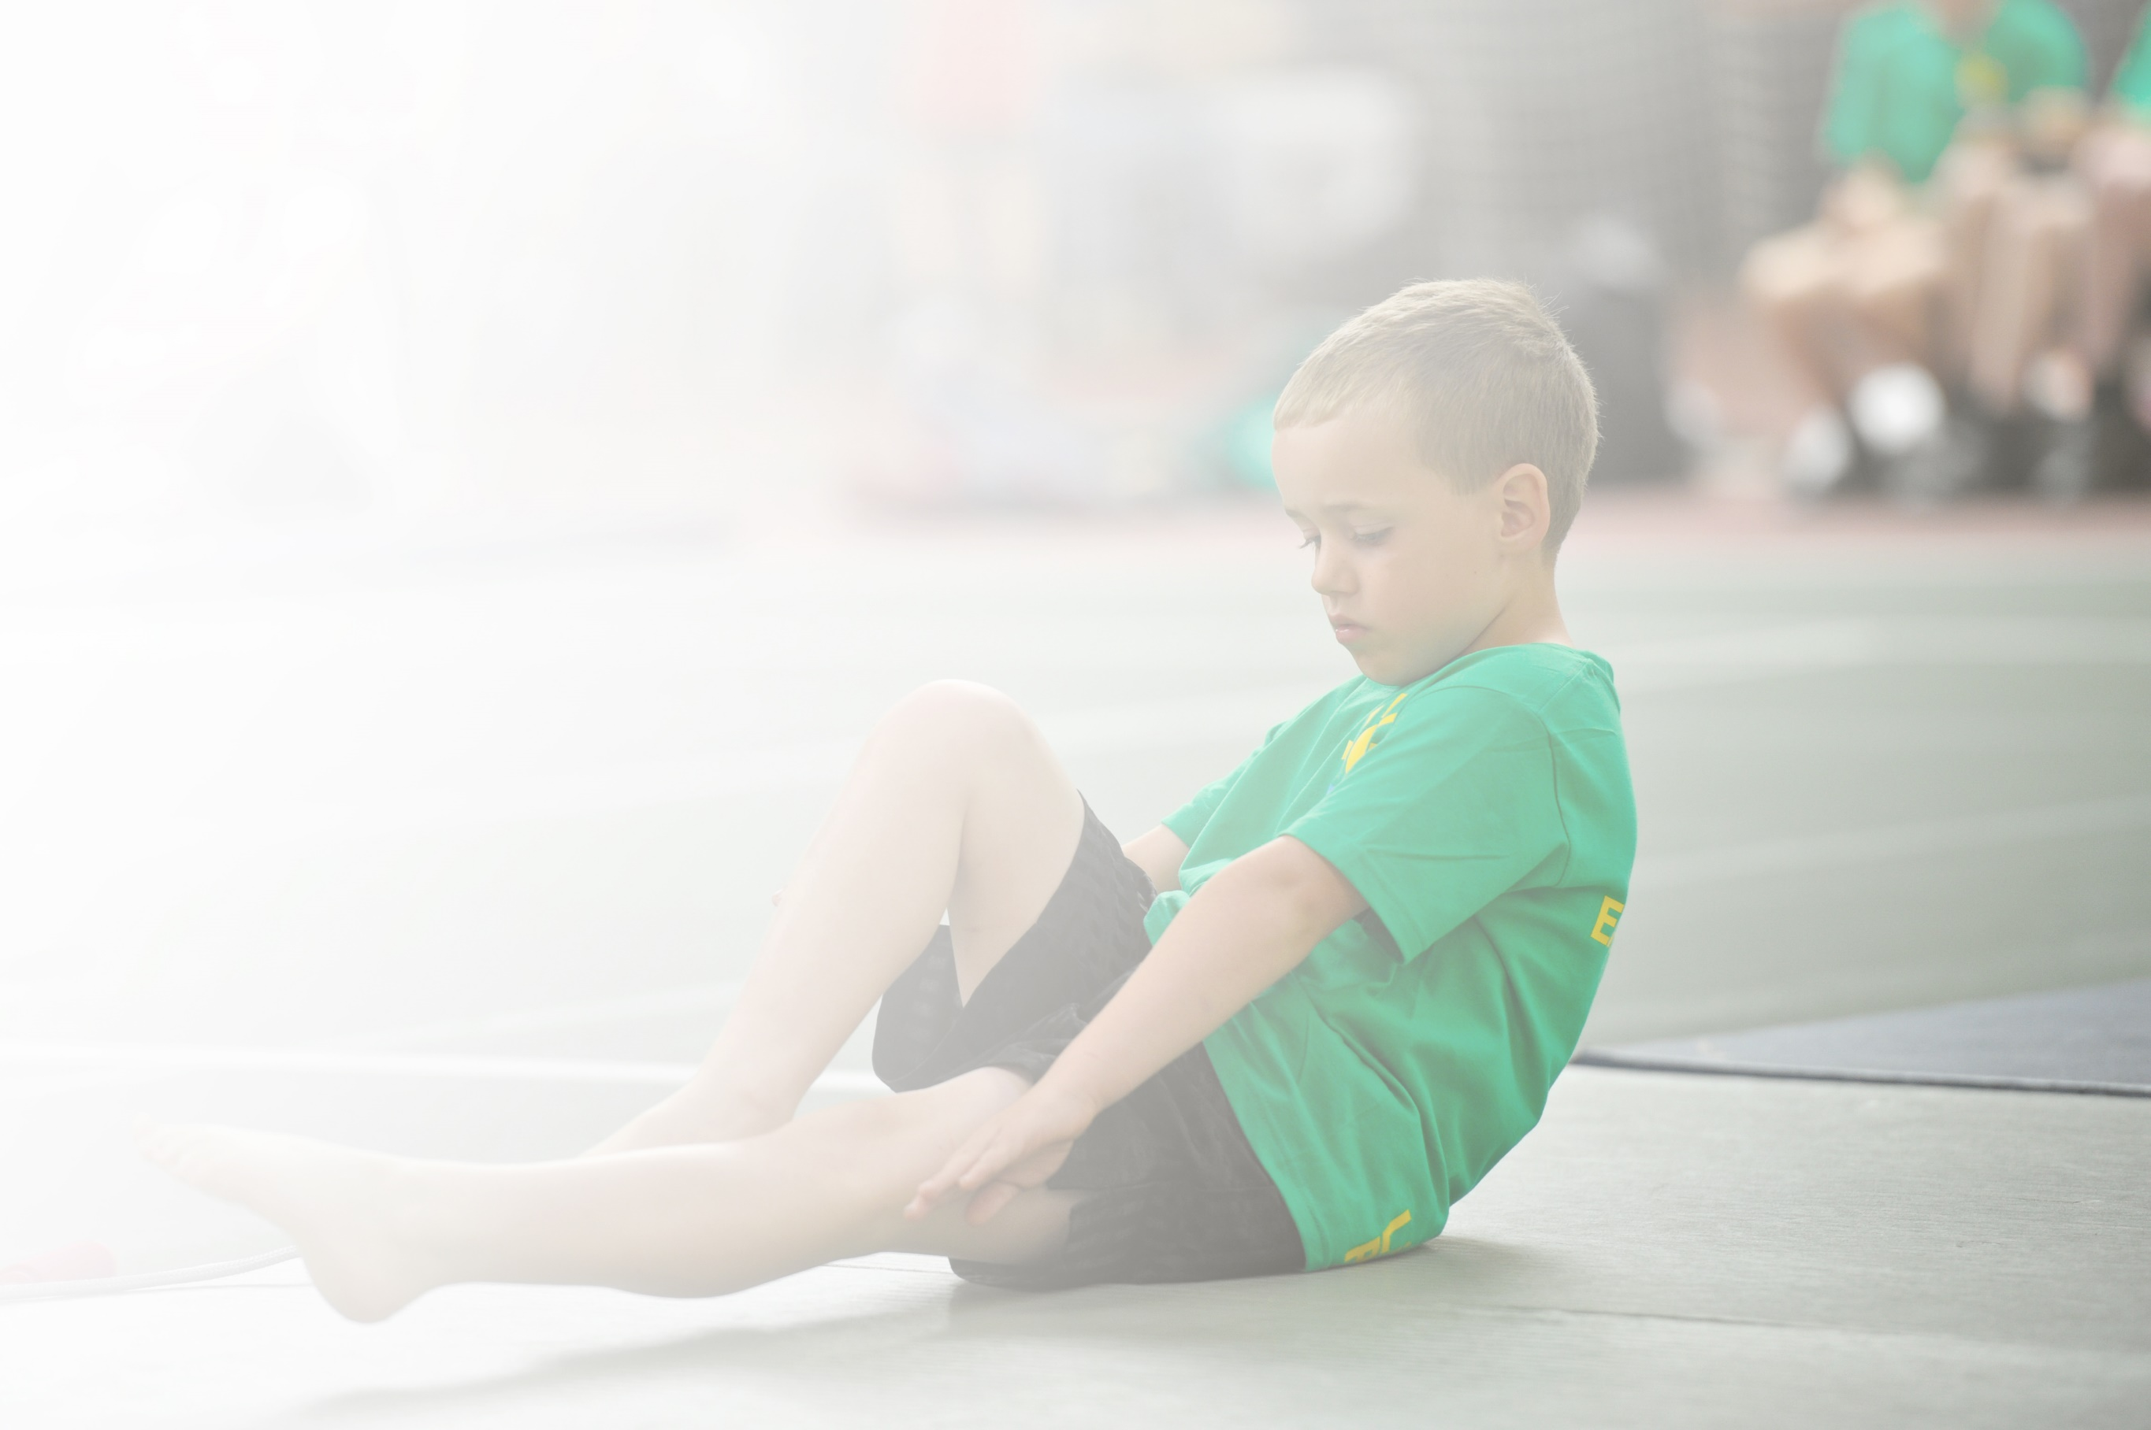
Schools must use the funding to make additional and sustainable improvements to the quality of Physical Education, Sport and Physical Activity (PESPA) they offer. This means that you should use the Primary PE and Sport Premium to:

- Develop or add to the PESPA activities that your school already offer
- Build capacity and capability within the school to ensure that improvements made now will benefit pupils joining the school in future years

Please visit gov.uk for the revised DfE guidance including the 5 key indicators across which schools should demonstrate an improvement. This document will help you to review your provision and to report
your spend. DfE encourages schools to use this template as an effective way of meeting the reporting requirements of the Primary PE and Sport Premium.

We recommend you start by reflecting on the impact of current provision and reviewing the previous
spend. Under the Ofsted Schools Inspection Framework, inspectors will assess how effectively leaders use the Primary PE and Sport Premium and measure its impact on outcomes for pupils, and how effectively governors hold them to account for this.

Schools are required to publish details of how they spend this funding as well as on the impact it has on pupils’ PE and sport participation and attainment by the end of the summer term or by 31 July 2019 at the
latest.
We recommend regularly updating the table and publishing it
on your website throughout the year, as evidence of your
ongoing review into how you are using the money to
secure maximum, sustainable impact. To see an
example of how to complete the table please
click HERE.

Support for review and reflection - considering the 5 key indicators from DfE, what development needs are a priority for your setting and your students now and why? Use the space below to reflect on previous spend, identify current need and priorities for the future.

Key achievements to date: | Areas for further improvement and baseline evidence of need:
- 2 hours P.E taught during curriculum time consistently across school.  - Additional physical activity and sports activities provided for all children through afterschool clubs and breakfast clubs.  - Built capacity and capability within school to ensure that improvements made now will benefit pupils joining the school in future years.  - Engagement of pupils in 30 minutes activity per day during the school day by 15 active minutes during afternoon break time and young leaders leading games during lunchtimes.  - The profile of P.E raised across the school including P.E kits for all staff to wear on P.E days.  - Increased confidence, knowledge and skills of all staff in teaching P.E and sport through CPD sessions.  - Broader experiences of sports and activities offered to all pupils through after school clubs and sports competitions.  - Increased participation in competitive sport. School games mark achieved at silver level.  - Support and involve least active pupils by providing targeted activities. | - Arrange a date for children in the current year 6 class to have additional swimming lessons for those children that did not achieve national curriculum requirements at the end of their swimming lessons in Year 5.  - Enter or run more sports competitions for Ks1 pupils.  - Continue to support least active pupils by providing targeted activitied and monitor their participation in physical activity closely during break  times and lunchtimes.

Meeting national curriculum requirements for swimming and water safety | Please complete all of the below:
What percentage of your current Year 6 cohort swim competently, confidently and proficiently over a distance of at least 25 metres?  N.B. Even though your children may swim in another year please report on their attainment on leaving  primary school. | 52.7%
What percentage of your current Year 6 cohort use a range of strokes effectively [for example, front crawl, backstroke and breaststroke]? | 52.7%
What percentage of your current Year 6 cohort perform safe self-rescue in different water-based situations? | 94.4%
Schools can choose to use the Primary PE and Sport Premium to provide additional provision for swimming but this must be for activity over and above the national curriculum requirements. Have you used it in this way? | We are currently trying to arrange additional swimming lessons for the children currently in Year 6 who did not achieve national curriculum requirements for swimming.

Action Plan and Budget Tracking
Capture your intended annual spend against the 5 key indicators. Clarify the success criteria and evidence of impact that you intend to measure to evaluate for students today and for the future.

Academic Year: 2019/2020 | Total fund allocated: £17, 700 | Date Updated: October 2019
Key indicator 1: The engagement of all pupils in regular physical activity – Chief Medical Officer guidelines recommend that primary school children undertake at least 30 minutes of physical activity a day in school |  |  |  | Percentage of total allocation:
 |  |  |  | %
Intention | implementation |  | Impact evidence of impact on pupils including wider impact on
School focus with clarity on intended impact on pupils: | Actions to achieve: | Funding allocated: | Evidence and impact: | Sustainability and suggested next steps:
Subject leader has used the sports funding to purchase training and equipment for young leaders and welfare staff to run active games during lunchtimes. | Subject leader purchased 2 equipment bags through South Ribble Sports. These bags both include at least 8 games cards with rules on how to play each game and what equipment is needed ( bought in 2017 and then 2018)  South Ribble SGO Miss Jackson came in to deliver training for young leaders from Year 5 & 6 and welfare staff on how to play the games in the 2 equipment bags.  Subject leader and P.E specialist alongside Year 6 young leaders have trained some new Year 5 children how to play the games from the equipment bags and Welfare staff | £300 bag 1 (from 2017 budget)  £300 bag 2  (from 2018 budget)  SGO welfare staff and young leader training £75 ( from 2018 budget)  Included in subject leaders wage and P.E specialist teaching assistant wage/role. | - Because of training young leaders and welfare, staff to play a variety of active games and have the equipment easily accessible, active games are run every lunchtime by our young leaders and over seen by welfare staff.  - Children from nursery to Year 6 enjoy playing a variety of active games at lunchtime.  - Increased physical activity at lunchtimes.  - Least active children also enjoy joining in active lunchtime games. | The subject leader will liaise with the Year 5 & 6 class teachers at the beginning of each academic year and arrange for the Year 6 young leaders to train up some Year 5 children to be young leaders. The subject leader will lead this session/ P.E specialist-teaching assistant.
Active mile launched/ active break time | Subject leader attended Daily Mile training run by Lancashire sport.  Subject leader liaised with other P.E subject leaders in the local area on how they complete the active mile/ daily mile.  Subject leader used staff meeting time to explain the importance of a daily active mile and this was launched across the whole school. | £75 from 2017 budget | - All classes now have a 15 minute break time every afternoon. Each class does this differently e.g., they may do an active mile, go noodle, dance from the heart videos, skip or play active games.  - Each time a class completes an active mile they record it on their class Do Jo.  - Clast year classes received wristbands for completing half a marathon, full marathon and super marathon. | The subject leader will keep class teachers up to date with research on why it is important to complete an active mile. The subject leader will monitor that all classes are doing an active break time. Subject leader will provide certificates for classes that are completing the active break times.  The subject leader will deliver this training again when she returns from maternity leave.
Active English and maths lessons. | The P.E subject leader attended active maths and active English training.  The P.E subject leader then led staff meetings to deliver the training received on these courses.  The P.E subject leader has the tops cards/ ideas for future use for all members of staff. | Courses free as part of south Ribble bought in offer. | - The P.E subject leader has the tops cards/ ideas for future use for all members of staff.  - Classes have used the hall to complete active SPaG sessions.  - Classes have used outside to complete active maths sessions. | The subject leader is able to deliver training on active maths or English lessons using the resources from the course to any new members of staff.
Key indicator 2: The profile of PESSPA being raised across the school as a tool for whole school improvement |  |  |  | Percentage of total allocation:
 |  |  |  | %
School focus with clarity on intended impact on pupils: | Actions to achieve: | Funding allocated: | Evidence and impact: | Sustainability and suggested next steps:
Teaching high quality gymnastics and dance lessons inset day for teachers and teaching assistants. | The P.E subject leader organised an inset day focusing on teaching dance and gymnastics across the school for all teachers and teaching assistants. This was run by Jess from Lancashire Primary P.E. | £400 | - As a result, of excellent CPD all staff now feel more confident in teaching gymnastics and dance.  - All staff are now teaching bunny hops, caterpillar and the bear move correctly.  - Staff are aware of health and safety issues in dance and gymnastics.  - Staff are effectively using apparatus in gymnastics confidently. | Staff are now have the knowledge and skills to effectively teach gymnastics and dance across school for the foreseeable future. If we get new staff into school the P.E subject leader has the knowledge to support them in teaching gymnastics and dance lessons.
Staff twilight on how to use the Lancashire P.E curriculum app. | - In January teachers will receive a twilight session led by Glen Swindlehurst the head of Lancashire P.E on how to use the new Lancashire P.E app. | £200 | - Staff will be able to successfully use the new P.E app for lesson plans.  - Staff will be able to use the new P.E app to track children’s progress in P.E.  - The P.E subject leader will be able to monitor pupil progress including specific groups of children e.g. least active pupils. | School will need to renew the licence for the app each year.  School will need to purchase the Ks1 and EYFS section of the app once these become available.
2 hours P.E curriculum lessons taught to every class each week. | - All classes have at least one lesson with our P.E specialist-teaching assistant.  - Some classes have one-hour P.E lesson taught by their class teacher.  - Our P.E specialist and subject leader are always available to support class teachers in delivering P.E lessons.  - In 2014 we purchased the Ks1 and Ks2 new units of P.E lessons from Lancashire.  - In 2017 we purchased the new OAA upper ks2 lesson plans.  - In 2019, we have received the new updated ks2 P.E lesson plans from Lancashire. This was included in the P.E app training session. | £9651 | - All classes receive 2 hours P.E Curriculum lessons every week.  - Attainment levels for P.E are above 60% for most classes.  - Least active pupils are all fully included in all P.E lessons.  - SEN pupils are all included in all P.E lessons. | We have a good range of lesson plans from Lancashire to support teachers in teaching high quality P.E lessons.  We have P.E specialists in school who can effectively support teachers in adapting P.E lessons to suit children’s individual needs.
Staff P.E kit | - Using the sports funding all staff now have a P.E kit to wear on P.E days.  - This fits in with our risk assessment.  - Staff wear these kits when attending sports events. | £942.15 | - All staff including teaching assistants participate during P.E lessons twice per week.  - Staff from Seven Stars Primary school are clearly visible when attending sports events. | Staff will be able to continue to wear their P.E kits.  Staff can purchase more kit if they wish to do so from John Harrison sports in Leyland.
P.E updates during staff meetings. | - The P.E subject leader regularly has time during staff meeting to pass on any updates about the P.E curriculum, health or sport. | Included in the P.E subject leaders role and responsibility. | - The P.E subject leader stays up to date with any updates regarding the curriculum, health or sport by liaising with the South Ribble SGO`s, Head of Lancashire Primary P.E and direct.gov. | The P.E subject leader will continue to stay up to date with P.E. and continue to update staff.
P.E subject leader report | - The P.E subject leader submits a report on P.E each year which is show to governors. | Included in the P.E subject leaders role and responsibility. | - Governors are made aware of what is happening during P.E lessons, sport and health throughout school.  - Governors are made aware of what the sports funding is being spent on. | The P.E subject leader will continue to write a report on P.E and sport.

Key indicator 3: Increased confidence, knowledge and skills of all staff in teaching PE and sport |  |  |  | Percentage of total allocation:
 |  |  |  | %
School focus with clarity on intended  impact on pupils: | Actions to achieve: | Funding  allocated: | Evidence and impact: | Sustainability and suggested  next steps:
Subject leader undertook afPE level 5 accredited course run by Glen Swindlehurst September – July 2018/2019. In order to up-skill, her own knowledge and understanding so she can confidently disseminate to all staff, thus increasing their knowledge and confidence. | Enrolled on the locally delivered asPE course Level 5 with Lancashire.  Liaised with SLT to ensure staff meeting time was allocated to disseminate to staff.  Provided cover so SL could team-teach/ observe members of staff teaching P.E.  Provided cover to SL could be released from class to attend the | £975 academic year 2017 – 2018  Class cover £1000. 2018- 2019 | Because of good leadership in the subject and confident knowledgeable staff, all pupils made good progress, building on prior achievement. At the end of each key stage, we are achieving over 60%.  Increased confidence, self-esteem and a real desire to learn. The enjoyment of PE increased participation in wider activities. All of our afterschool clubs are full. | The subject leader will be allocated on going staff meeting time once per month; together with slots on professional development days to ensure staff are kept up to date and that new staff are brought up to speed.
TA3 undertook the afPE level 5 february 2019 ( this will be completed when she returns from maternity leave in April 2020) accredited course in order to raise awareness and understanding of the crucial role support staff play in raising standards. | Enrolled in locally delivered level 5 course.  Ensured staff meeting time disseminate to all support staff.  Joint/ team working undertaken in order to build knowledge and confidence. | £975 academic year 2018 – 2019  No class cover needed | Because of confidence and subject knowledge, this member of staff is now competent at delivering high quality P.E lessons. | The TA3 will be able to support the subject leader in delivering CPD to all staff during staff meetings and training development days.  The Ta3 will be able to teach effective and high quality PE lessons and support other members of staff in delivering high quality PE lessons.
Employed a member of staff who is level 2 qualified in multi skills and has a coaching degree to deliver 1 hour PE to each class per week and support teachers in delivering the second 1 hour PE lesson each week.  PE specialist also employed to run fitness or active sessions during breakfast club x 3 sessions per week.  PE specialist employed to lead 1 x fun fitness after school club per week for least active pupils.  PE specialist is currently undertaking a master’s degree in sports coaching and completing numerous sport qualifications outside of school. | Every class will receive 2 hours PE each week.  1 hour of PE will be taught bv a PE specialist to ensure that the quality of PE is consistent throughout school.  1 hour PE will be joint/team work between the class teacher and PE specialist to develop confidence and subject knowledge in teaching PE across the school.  Ensure that PE assessment data is accurate. | £9651 | Every class is being taught 2 hours PE per week.  All children are having high quality PE lessons.  PE is being assessed joint/ team with class teacher and PE specialist.  Lancashire scheme of work plans are being used and adapted to meet the needs of all children in each class. | Employed member of staff is consistently working alongside the class teachers from each class to adapt lesson plans to the needs of individual children.  Lessons are being adapted to link in with topics.  Teacher confidence and subject knowledge is improving each week with ongoing training alongside PE specialist.
Employed a member of the Lancashire Primary PE team to deliver CPD in teaching high quality gymnastics and dance lessons including safe practice.  (inset day) | Member of staff from Lancashire primary PE came into school to deliver a training session on teaching gymnastics and dance from early years through to ks2. | £400 | Teachers and teaching assistants attended the training session. This has developed confidence and subject knowledge in teaching dance and gymnastics throughout the school.  Teachers and teaching assistants were able to see the different ages and stages of teaching dance and gymnastics.  Teachers and teaching assistants competent in delivering dance and gymnastic lessons following the afPE safe practise guidelines. | Teachers and teaching assistants have the knowledge and confidence to teach dance and gymnastic units from early years to ks2.  Staff members that attended the training can support any new members of staff and bring them up to speed.
Applied for the School Games quality mark | Applied for the school games mark application for 2019 and received silver award.  The subject leader has signed up to apply for the 2020 application and started to complete the heat map. | free | Subject leader to complete the 2020 application form and complete the requirements to achieve silver award. | Completing the school games mark demonstrates that our school is using the sports funding to ensure that children are engaged in more sports activities, 2 hours P.E and have a broad range of sports.
New ks2 scheme of work and App through Lancashire P.E and a twilight training session for all staff.  Ipad purchased for PE specialist to use the app effectively during PE lessons and for all teachers to use to upload ks2 data. | Purchased the Lancashire new ks2 schemes of work.  Purchased the licence for the Lancashire ks2 scheme of work app which also enables us to add pupil data.  Paid for the upgrade to input after school club and competition registers. | £399 for the app licence  App upgrade  £199  £249 | We have only just received the app licence.  However teachers are able to use the videos to support subject knowledge e.g. how to perform a caterpillar travel/ bear travel properly. | The app will allow us to effectively track pupils progress in PE lessons.  We will be able to effectively monitor less active pupils and their participation in PE lessons, lunchtime sports and afterschool clubs.  We will be able to effectively input swimming data.
Key indicator 4: Broader experience of a range of sports and activities offered to all pupils |  |  |  | Percentage of total allocation:
 |  |  |  | %
School focus with clarity on intended  impact on pupils: | Actions to achieve: | Funding  allocated: | Evidence and impact: | Sustainability and suggested  next steps:
Additional achievements:  Young leaders training and change for life bags. | Young leaders and welfare staff to continue running a broad range of active sports or games during break or lunchtime. | Included in key principle 1. | More children are participating in physical activities at break time and lunchtimes.  Least active pupils are encouraged to participate in active games at lunchtimes. | Rolling programme to train year 5 & 6 pupils on active games at lunchtimes and welfare staff.
After school clubs run by South Ribble sports coaches. | South Ribble sports coaches in to deliver the following sports after school clubs free of charge throughout the year.  - Netball  - Fencing  - Non contact boxing  - Hand ball  - Cheerleading  - Tri golf  - Fun fitness  - Archery  - Volley ball  - Dodgeball  - Girls football  - Yoga | £1925 | All year groups will be offered an active/ sports after school club per half term.  The PE subject leader will continue to monitor which pupils attend sports clubs and will encourage the least active pupils in school to attend these clubs. | We will require sports funding to continue to employ the sports coaches.  If we no longer receive sports funding our PE specialists in school will be able to train staff to deliver after school sports clubs.
Dance from the heart roadshow | Dance from the heart road show is run by south Ribble coaches. | £75 | 8 children from Year 5 and 6 will attend the roadshow training session and then will return to school to teach the whole school the dance.  They will lead a dance session every Wednesday for ks1 and ks2.  In June the whole school will gather together and perform the dance with the South Ribble sports coaches and parents will come into school to watch their children. | We have a range of different dances from 2014 which are on our school server we can continue to use these dances as wake up and shake up routines or lead our own dance roadshows within our school.
Children’s yoga P.E sessions | South Ribble sports coaches employed to teach yoga to Year 1 and Year 2 for 5 weeks. | £350 | South Ribble coaches will model to class teachers and teaching assistants how to deliver yoga to young children. | Staff meeting time will be set aside to allow the year 1 and Year 2 staff to show effective yoga techniques used during these sessions.
New P.E equipment to support P.E lessons. | PE equipment purchased from Newitts and TTS.  PE cupboard equipment audited and new equipment purchased to improve PE lessons. E.g. new tennis balls purchased so that we can differentiate net wall games. | £158.83 | PE equipment used for PE specialist, teachers and teaching assistants to be able to teach high quality PE lessons. | PE equipment will be kept in the PE cupboard and will continue to be audited by the PE subject leader.
South Ribble sports partnership annual conference for subject leaders | The PE subject leader or PE specialist teaching assistant will attend the annual conference for PE subject leaders. | £150 | The PE subject leader will be able to liaise with the South Ribble sports partnership about any updates regarding primary school PE and how to effectively spend the sports premium. | Links with SGOS and other subject leaders have been made. Therefore, the PE subject leader can stay in contact with other subject leaders local to school.
Key indicator 5: Increased participation in competitive sport |  |  |  | Percentage of total allocation:
 |  |  |  | %
School focus with clarity on intended  impact on pupils: | Actions to achieve: | Funding  allocated: | Evidence and impact: | Sustainability and suggested  next steps:
School games infrastructure | The subject leader has purchased the school games infrastructure through South Ribble sports partnership. This enables our school to attend local sports competitions/ leagues such as football year 5 & 6, netball Year 5 & 6, Rugby Year 5 & 6, Kwik cricket Year 4,5 & 6, sports hall athletics, Year 3 & 4 tennis, ks1 Quad kids. | £1500 | Ks1 and Ks2 pupils are given the opportunity to attend competitive sports competitions throughout the academic year. | Through attending competitions the subject leader and headteacher have gained links with other schools which has enabled us to have friendly competitions with other schools. We organised a level 1 competition with Euxton Primrose Hill.
Inclusion/ change4life festivals | The subject leader has purchased the inclusion/ change 4 life festivals run by South Ribble sports partnership.  These events are specifically held for least active pupils or pupils who are less able in PE ( SEN pupils) | £200 | SEN pupils and least active pupils are given the opportunity to attend sports events specific to their needs. | We can maintain links with other schools and continue to hold inclusion festivals.

