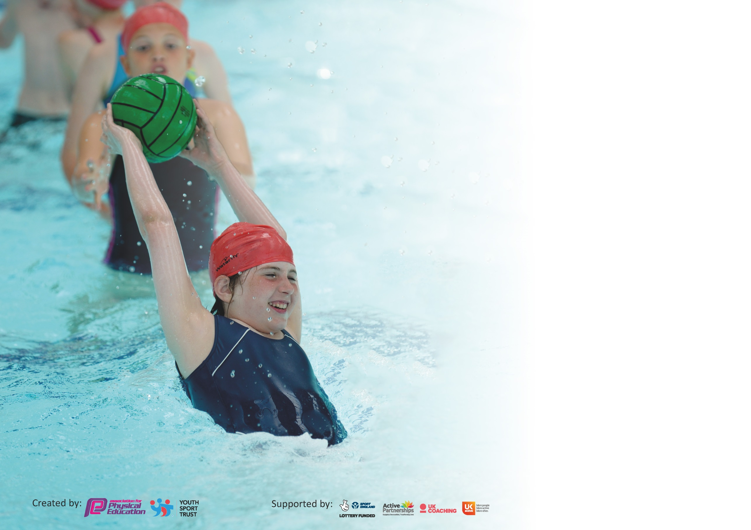

It is important that your grant is used effectively and based on school need. The Education Inspection Framework (Ofsted 2019 p64) makes clear there will be a focus on ‘whether leaders and those responsible for governors all understand their respective roles and perform these in a way that enhances the effectiveness of the school’.

Under the Quality of Education criteria (p41) inspectors consider the extent to which schools can articulate their curriculum (INTENT), construct their curriculum (IMPLEMENTATION) and demonstrate the outcomes which result (IMPACT).

To assist schools with common transferable language this template has been developed to utilise the same three headings which should make your plans easily transferable between working documents.

Schools must use the funding to make additional and sustainable improvements to the quality of Physical Education, School Sport and Physical Activity (PESSPA) they offer. This means that you should
use the Primary PE and Sport Premium to:

- Develop or add to the PESSPA activities that your school already offer
- Build capacity and capability within the school to ensure that improvements made now will benefit pupils joining the school in future years

Please visit gov.uk for the revised DfE guidance including the 5 key indicators across which schools should demonstrate an improvement. This document will help you to review your provision and to report your spend. DfE encourages schools to use this template as an effective way of meeting the reporting requirements of the Primary PE and Sport Premium.

We recommend you start by reflecting on the impact of current provision and reviewing the previous spend.

Schools are required to publish details of how they spend this funding as well as on the impact it has on pupils’ PE and sport participation and attainment by the end of the summer term or by 31st July 2020 at the latest.

We recommend regularly updating the table and publishing it on your website throughout the year. This evidences your ongoing self-evaluation of how you are using the funding to secure maximum, sustainable impact. Final copy must be posted on your website by the end of the academic year and no later than the 31st July 2020. To see an example of how to complete the table please click HERE.

Support for review and reflection - considering the 5 key indicators from DfE, what development needs are a priority for your setting and your pupils now and why? Use the space below to reflect on previous spend and key achievements and areas for development.

Key achievements to date until July 2019: | Areas for further improvement and baseline evidence of need:
- 2 hours P.E taught during curriculum time consistently across school.  - Additional physical activity and sports activities provided for all children through afterschool clubs and breakfast clubs.  - Built capacity and capability within school to ensure that improvements made now will benefit pupils joining the school in future years.  - Engagement of pupils in 30 minutes activity per day during the school day by 15 active minutes during afternoon break time and young leaders leading games during lunchtimes.  - The profile of P.E raised across the school including P.E kits for all staff to wear on P.E days.  - Increased confidence, knowledge and skills of all staff in teaching P.E and sport through CPD sessions.  - Broader experiences of sports and activities offered to all pupils through after school clubs and sports competitions.  - Increased participation in competitive sport. School games mark achieved at silver level.  - Support and involve least active pupils by providing targeted activities.  - P.E Passport app used to inform lesson planning and assessment of pupil attainment during P.E.  - P.E passport app used to keep track of pupil participation in extracurricular sports clubs and sporting events.  - Ta3 P.E specialist employed to deliver 1 hour P.E alongside teachers as CPD.  - TA3 registered to complete level 5 P.E specialist course.  - P.E coordinator completed P.E specialist course . | - Arrange a date for children in the current year 6 class to have additional swimming lessons for those children that did not achieve national curriculum requirements at the end of their swimming lessons in Year 5.  - Enter or run more sports competitions for Ks1 pupils.  - Continue to support least active pupils by providing targeted activitied and monitor their participation in physical activity closely during break  times and lunchtimes.  - Engage pupils in team games to help improve mental health and communication skills in light of the current pandemic.  - Friendly matches with local schools to improve pupil engagement in competitive sport.

Meeting national curriculum requirements for swimming and water safety.
What percentage of your current Year 6 cohort swim competently, confidently and proficiently over a distance of at least 25 metres?  N.B. Even though your pupils may swim in another year please report on their attainment on leaving  primary school at the end of the summer term 2020. | 61.1%.  We had planned to have top up swimming lessons for the children that did not achieve 25m but they could not attend these due to Covid19.
What percentage of your current Year 6 cohort use a range of strokes effectively [for example, front crawl, backstroke and breaststroke]? | 61.1%
What percentage of your current Year 6 cohort perform safe self-rescue in different water-based situations? | 94.4%
Schools can choose to use the Primary PE and Sport Premium to provide additional provision for swimming but this must be for activity over and above the national curriculum requirements. Have you used it in this way? | Yes – School had planned to provide top up swimming lessons for 10 Year 6 pupils that did not achieve National Curriculum Swimming requirements. However, due to Covid 19 schools and swimming pools were closed. These pupils’ parents were given swimming lesson leaflets.

Action Plan and Budget Tracking
Capture your intended annual spend against the 5 key indicators. Clarify the success criteria and evidence of impact that you intend to measure to evaluate for pupils today and for the future.

Academic Year: 2019/20 | Total fund allocated: £0 | Date Updated: 09/07/2020
Key indicator 1: The engagement of all pupils in regular physical activity – Chief Medical Officer guidelines recommend that primary school pupils undertake at least 30 minutes of physical activity a day in school |  |  |  | Percentage of total allocation:
 |  |  |  | 0%
Intent | Implementation |  | Impact
Your school focus should be clear what you want the pupils to know and be able to do and about  what they need to learn and to  consolidate through practice: | Make sure your actions to achieve are linked to your intentions: | Funding allocated: | Evidence of impact: what do pupils now know and what can they now do? What has changed?: | Sustainability and suggested next steps:
Pupils to participate in active games led by playground leaders for at least 15 minutes during their lunchtime break. We aim to encourage children to participate in 15 minutes physical activity and understand that they need to aim to undertake 60 minutes physical activity a day to keep their bodies and minds healthy.  Pupils to participate in an active 15 minutes with their class at a chosen time by the class teacher. We aim to encourage children to participate in 15 minutes physical activity and understand that they need to aim to undertake 60 minutes physical activity a day to keep their bodies and minds healthy. Class teachers are responsible for ensuring | Over previous years, we have purchased change 4 life bags through the sports partnership. We have also paid to have an SGO into school to train welfare staff and young leaders to play the games provided in the change 4 life bags. This academic year we used our current year 6 young leaders, P.E coordinator and ta3 specialist P.E teacher to train up some Year 5 children. We plan to repeat this next year.  Class teachers are responsible for ensuring that their class receive an additional active 15 minutes per afternoon. An active mile, skip, go noodle, BBC movers or however the class teacher deems best for their class may do this. This needs to be kept fun and all pupils should participate in the chosen activity. | Percentage of Ta3 time given to this. | We now have 6 children in Year 5 trained as young leaders. These children will be able to train a new set of Year 5 children the following year. Our young leaders have been fantastic in engaging both early years, ks1& ks2 pupils in their games. This particularly worked because of us splitting our playground into ks1 and Ks2 at lunchtimes.  Class teachers and teaching assistants take their children out every afternoon between 2 and 3 o`clock. He children sometimes play active games, skip or do an active mile. | We will be employing the ta3 sports specialist next year and part of his job role will be to carry out the young leader & welfare staff training. He will also be responsible for ensuring that the young leaders are engaging pupils and monitoring pupil engagement in these activities.  P.E coordinator will liaise withclass teachers and discuss whether or not we need any additional equipment such as skipping ropes or subscriptions e.g. go noodle to ensure that children are enjoying and engaged in 15  minutes physical activity.
Key indicator 2: The profile of PESSPA being raised across the school as a tool for whole school improvement |  |  |  | Percentage of total allocation:
 |  |  |  | %
Intent | Implementation |  | Impact
Your school focus should be clear what you want the pupils to know and be able to do and about  what they need to learn and to  consolidate through practice: | Make sure your actions to achieve are linked to your intentions: | Funding allocated: | Evidence of impact: what do pupils now know and what can they now do? What has changed?: | Sustainability and suggested next steps:
Purchase new Lancashire Ks2 scheme of work. Children to have a broad and balanced physical education curriculum. Staff to have access to high quality lessons to aid their teaching.  Purchase P.E Passport app to record data, track pupil progress in P.E, plan lessons and track pupils engagement in extracurricular physical activities.  Teacher and teaching assistants Trained how to use P.E Passport.  Daily or active 15-minute break time.  Playground leaders leading physical activities during lunchtimes.  Staff to wear P.E kit and suitable footwear during P.E lessons.  Ensure that all classes receive 2 hours P.E per week.  Attend more ks1 and ks2 sports partnership events/ competitions  Friendly matches with other schools | Teachers and Ta3 specialist P.E teacher have used the new Ks2 scheme of work units.  Teachers have used the P.E passport lesson plans. Teachers have used the P.E passport to record pupil progress in P.E. Ta3 Teaching assistant has used the app to record pupil engagement in extracurricular activities.  All pupils engage in an active break  time with their class teacher and teaching assistants.  Playground leaders deliver physical activities every lunchtime to ks1 and ks2 children.  Staff P.E kits were purchased to help raise positive attitudes towards teaching and engaging in P.E lessons.  All classes have 2 hours P.E each week. | £475  As above  As above | Children have enjoyed participating in P.E lessons from the new schemes of work led by teachers and our P.E specialist. Pupils have continued to develop their fundamental skills through engagement in invasion games, gymnastics, dance and net wall units. They have also been given the opportunity to play competitive games modified to their learning and needs. They have been able to develop flexibility, strength, technique, control and balance through gymnastic and dance units. They have engaged and performed dances using a range of movements.  Our level 3 P.E specialist has used the P.E passport to keep track of children attending sports clubs run by South Ribble coaches and by our P.E specialist. We have also monitored pupil engagement in competitive sports such as attending the football or netball league. | As a result, of Sport premium funding continuing 2020- 2021 we will purchase the level 3 subscription for P.E passport. Which will enable us to access all ks2 schemes of work and the new ks1 schemes of work. This will cost £485.

Key indicator 3: Increased confidence, knowledge and skills of all staff in teaching PE and sport |  |  |  | Percentage of total allocation:
 |  |  |  | %
Intent | Implementation |  | Impact
Your school focus should be clear | Make sure your actions to | Funding | Evidence of impact: what do | Sustainability and suggested
what you want the pupils to know | achieve are linked to your | allocated: | pupils now know and what | next steps:
and be able to do and about | intentions: |  | can they now do? What has
what they need to learn and to |  |  | changed?:
consolidate through practice:
New ks2 scheme of work units purchased. A member of staff trained on new units and then fed back information from training.  Training for all staff on how to use P.E passport app.  Support from Level 3 teaching assistant ( P.E specialist) for all teachers during 1 hour P.E per week and support in planning 2nd hour of P.E if or when needed. | New Lancashire scheme of work units purchased and used by our P.E specialist-teaching assistant and by class teachers across school.  All staff were trained how to use the P.E passport app which enables staff to view new P.E units/ schemes of work and also allows them to track pupil progress.  P.E specialist has planned and delivered P.E across the school. He also worked alongside class teachers to help them plan and deliver P.E lessons. | £475  Price included with the new sheme of work  £11094 | Children now have a broad physical education curriculum.  The app has enabled us to be able to quickly identify any children who are underachieving in P.E. It has also enabled us to be able to identify any children that are very active and attending lots of extra curricular clubs or sports events.  Children are making good progress in P.E.  Teachers feel supported and confident in teaching and delivering P.E lessons. | As we have purchased the units we will be able to continue using them alongside our 2014 P.E units.  We hope to continue receiving the sports funding to be able to continue renewing or paying for the P.E passport subscription.  We will only be able to sustain this if we continue to receive the sports premium funding.
Key indicator 4: Broader experience of a range of sports and activities offered to all pupils |  |  |  | Percentage of total allocation:
 |  |  |  | %
Intent | Implementation |  | Impact
Your school focus should be clear | Make sure your actions to | Funding | Evidence of impact: what do | Sustainability and suggested
what you want the pupils to know | achieve are linked to your | allocated: | pupils now know and what | next steps:
and be able to do and about | intentions: |  | can they now do? What has
what they need to learn and to |  |  | changed?:
consolidate through practice:

Additional achievements:  Broad range of after school clubs offered to all pupils including EYFS< ks1 & ks2  Least active pupils to participate in fun fitness after school club.  Ks1 and ks2 sports partnership/ competitive sports competitions.  Sports clubs or physical activity clubs during Golden time | Children throughout school have been offered a variety of different after school clubs throughout the year such as fun fitness, archery, volley ball, netball, fencing, non- contact boxing, handball, Tri golf , cheerleading and yoga,  Year 1 and 2 attended 2 change 4 life events.  Ks2 :  - Football league  - Netball  - Change 4 life  They were due to also attend Tag rugby and Year 3 and 4 tennis before the lockdown.  Our specialist P.E teaching assistant delivered a Fun Fitness to the children that were identified as the least active throughout school. | £2525  £1500 | Children from all classes have been able to experience a broad range of different extra-curricular activities. We found that for example the boxing club encouraged children who may not usually attend sports clubs to attend and enjoy physical activity.  Gifted and talented pupils and children working at expected or below are all able to attend a range of different competitive and fun events.  Children throughout school love participating in Fun fitness clubs. The least active pupils from reception through to Year 6 would have attended a physically active club. However, due to Coviid some year groups missed out on their club. | We will only be able to have one club per year group due to covid to enable classes to stay within their bubble. This will mean that only 2 year groups per term will be able to join one of these extra curricular clubs.  We aim to continue attending competitive competitions led by South Ribble. We intend on hosting some friendly matches with local schools.  We will continue to invite the least active pupils to join in Fun fitness club and aim to be able to have one year group each half term.

Key indicator 5: Increased participation in competitive sport |  |  |  | Percentage of total allocation:
 |  |  |  | %
Intent | Implementation |  | Impact
Your school focus should be clear | Make sure your actions to | Funding | Evidence of impact: what do | Sustainability and suggested
what you want the pupils to know | achieve are linked to your | allocated: | pupils now know and what | next steps:
and be able to do and about | intentions: |  | can they now do? What has
what they need to learn and to |  |  | changed?:
consolidate through practice:
Core tasks and P.E lessons  Competitive sport competitions led by South Ribble  Friendly competitions with local  schools | Children participate in a competition through physical education assessment lessons.  South Ribble run a range of competitions for ks1 and 2 every year such as football, netball, change 4 life, athletics, tennis, tag rugby and cricket.  We aim to use other contact information with other P.E subject leaders and headteachers to be able to arrange friendly matches with local schools. |  | Children are engaged in competitive sports with other schools.  As above

Signed off by
Head Teacher:
Date:
Subject Leader:
Date:
Governor:
Date:

