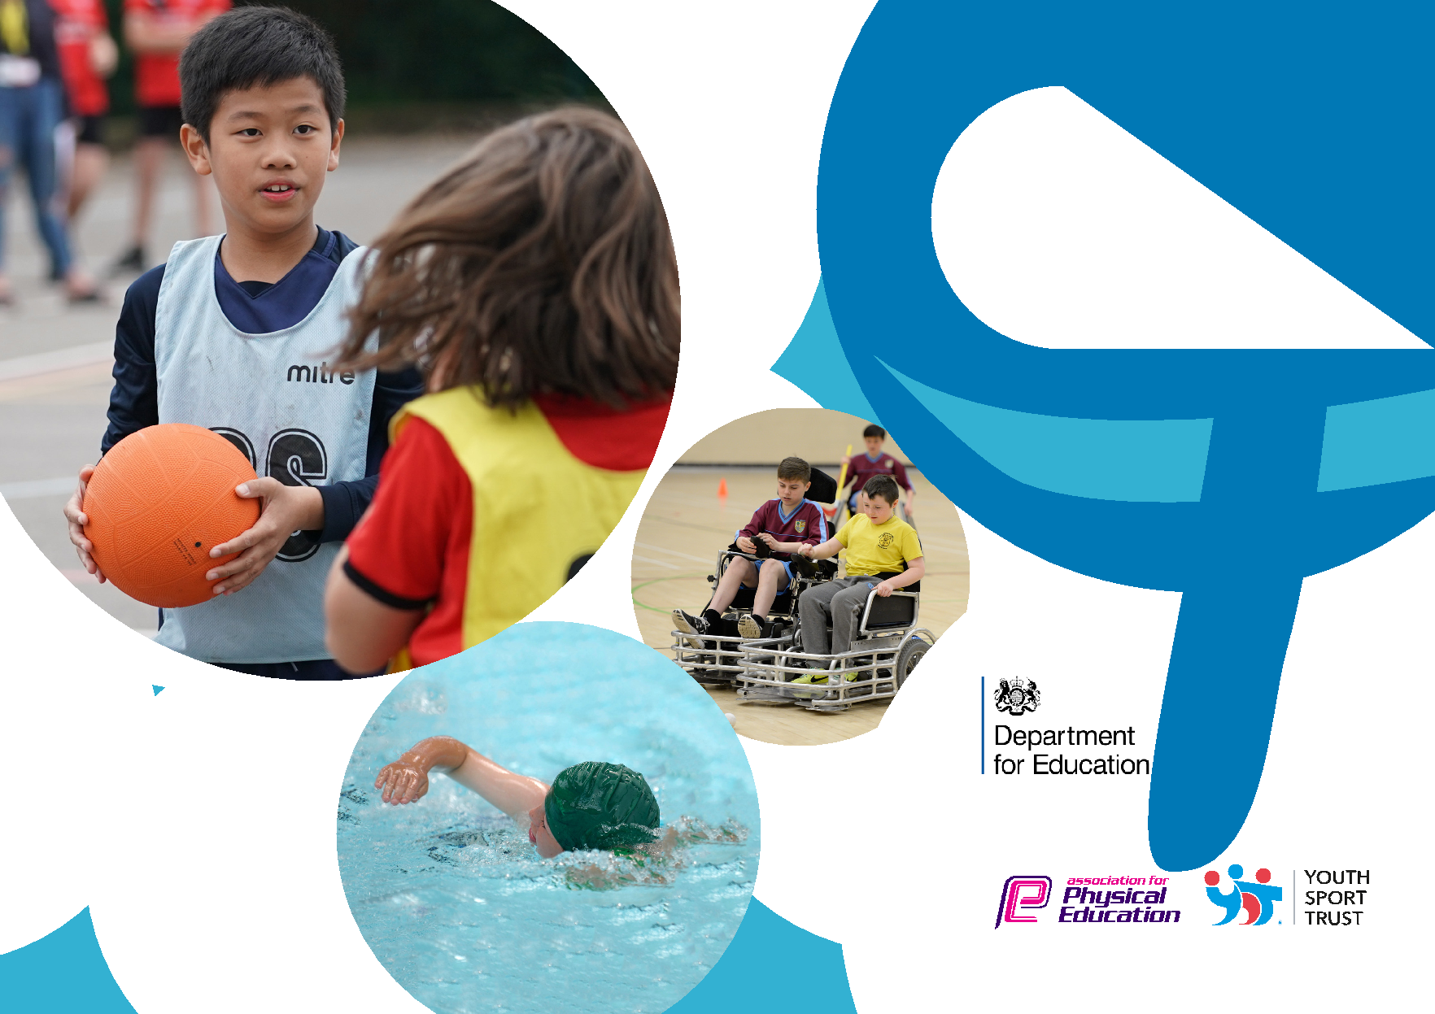
Evidencing the impact of the Primary PE and sport premium

Website Reporting Tool Revised July 2021

Commissioned by

Created by

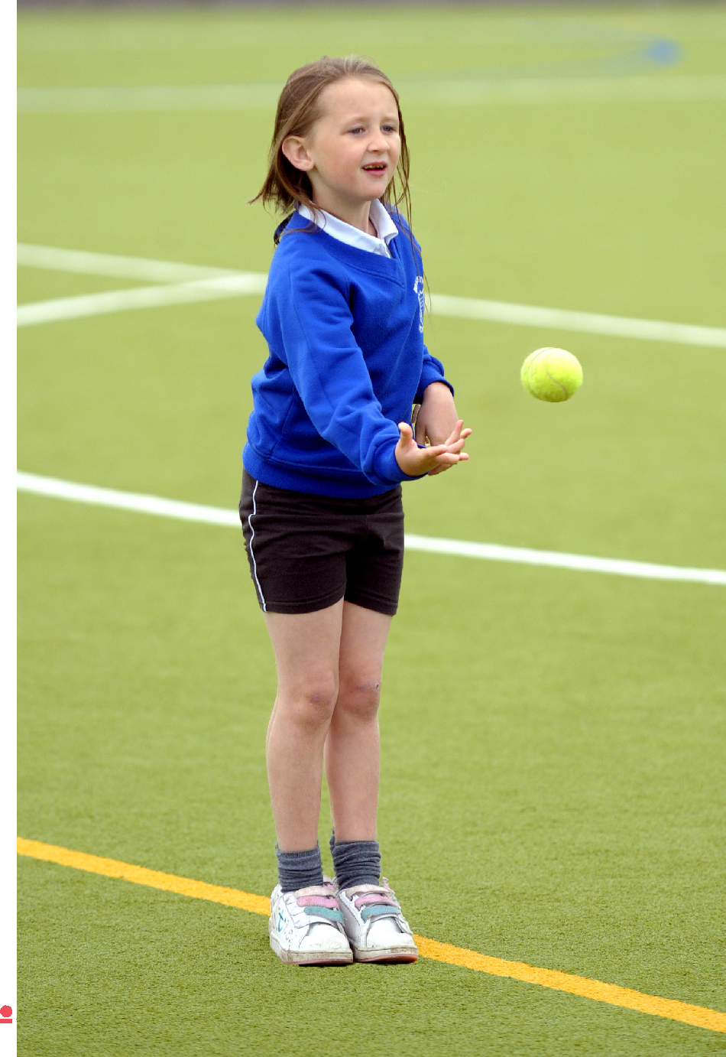
It is important that your grant is used effectively and based on school need. The Education Inspection Framework makes clear there will be a focus on ‘whether leaders and those responsible for governors all understand their respective roles and perform these in a way that enhances the effectiveness of the school’.

Under the Quality of Education Ofsted inspectors consider: Intent - Curriculum design, coverage and appropriateness Implementation - Curriculum delivery, Teaching (pedagogy) and Assessment Impact - Attainment and progress

To assist schools with common transferable language this template has been developed to utilise the same three headings which should make your plans easily transferable between working documents.

Schools must use the funding to make additional and sustainable improvements to the quality of Physical Education, School Sport and Physical Activity (PESSPA) they offer. This means that you should use the Primary PE and sport premium to:

- Develop or add to the PESSPA activities that your school already offer
- Build capacity and capability within the school to ensure that improvements made now will benefit pupils joining the school in future years

- The Primary PE and sport premium should not be used to fund capital spend projects; the school’s budget should fund these.

Please visit gov.uk for the revised DfE guidance including the 5 key indicators across which schools should demonstrate an improvement. This document will help you to review your provision and to report your spend. DfE encourages schools to use this template as an effective way of meeting the reporting requirements of the Primary PE and sport premium.

We recommend you start by reflecting on the impact of current provision and reviewing the previous spend.

Schools are required to publish details of how they spend this funding, including any under-spend from 2019/2020, as well as on the impact it has on pupils’ PE and sport participation and attainment. All funding must be spent by 31st July 2022.

We recommend regularly updating the table and publishing it on your website throughout the year. This evidences your ongoing self-evaluation of how you are using the funding to secure maximum, sustainable impact. Final copy must be posted on your website by the end of the academic year and no later than the 31st July 2021. To see an example of how to complete the table please click HERE.

Created by: Supported by:

Details with regard to funding
Please complete the table below.

Total amount carried over from 2019/20 | £ 798.53
Total amount allocated for 2020/21 | £ 18070.00
How much (if any) do you intend to carry over from this total fund into 2021/22? | £5.64
Total amount allocated for 2021/22 | £ 10.360 ( so far)  £17700 total
Total amount of funding for 2021/22. To be spent and reported on by 31st July 2022. | £ 0

Swimming Data
Please report on your Swimming Data below.

Meeting national curriculum requirements for swimming and water safety.

N.B. Complete this section to your best ability. For example you might have practised safe self-rescue techniques on dry land which you can then transfer to the pool when school swimming restarts.

Due to exceptional circumstances priority should be given to ensuring that pupils can perform safe self rescue even if they do not fully meet the first two requirements of the NC programme of study

What percentage of your current Year 6 cohort swim competently, confidently and proficiently over a distance of at |  |  |  |  |  | 64.2%
least 25 metres?
N.B. Even though your pupils may swim in another year please report on their attainment on leaving primary school
at the end of the summer term 2020.
Please see note above
What percentage of your current Year 6 cohort use a range of strokes effectively [for example, front crawl, backstroke |  |  |  |  |  | 64.2%
and breaststroke]?
Please see note above
What percentage of your current Year 6 cohort perform safe self-rescue in different water-based situations? |  |  |  |  |  | 100%
Schools can choose to use the Primary PE and sport premium to provide additional provision for swimming but this |  |  |  |  |  | Yes
must be for activity over and above the national curriculum requirements. Have you used it in this way?
Created by: |  |  |  |  | Supported by:

Action Plan and Budget Tracking
Capture your intended annual spend against the 5 key indicators. Clarify the success criteria and evidence of impact that you intend to measure to evaluate for pupils today and for the future.

Academic Year: 2020/21 |  |  |  |  |  | Total fund allocated: |  | Date Updated:
Key indicator 1: The engagement of all pupils in regular physical activity – Chief Medical Officers guidelines recommend that |  |  |  |  |  |  |  |  |  | Percentage of total allocation:
primary school pupils undertake at least 30 minutes of physical activity a day in school
 |  |  |  |  |  |  |  |  |  | %
Intent |  |  |  |  |  |  | Implementation |  | Impact
Your school focus should be clear |  |  |  |  |  | Make sure your actions to achieve |  | Funding | Evidence of impact: what do | Sustainability and suggested
what you want the pupils to know |  |  |  |  |  | are linked to your intentions: |  | allocated: | pupils now know and what | next steps:
and be able to do and about |  |  |  |  |  |  |  |  | can they now do? What has
what they need to learn and to |  |  |  |  |  |  |  |  | changed?:
consolidate through practice:
To enable Year 5 & 6 children to lead sport.  To ensure children have a wide range of opportunities to be physically active at lunchtimes through the Opal outdoor play and lunchtimes programme.  To ensure children have access to high quality resources that enable them to be physically active during break times.  To purchase resources that facilitate active play and physical development in EYFS. |  |  |  |  |  |  | - Year 5 & 6 children trained to deliver games during lunchtimes.  - Year 5 & 6 children to deliver active games during lunchtimes to all year groups.  - All staff including lunchtime supervisors trained to supervise children and encourage children to be more active during lunchtimes and break times.  - Children given a wide range of resources such as sports equipment, play equipment and large construction equipment to allow them to choose physically active activities during lunchtimes.  - Purchase a wide range of equipment for all year groups to participate in active games during lunchtime and break times.  As above | £300  £5134  £1682 | - Year 5 & 6 pupils lead active games during break times.  - Children in all year groups play new games and are motivated to join in with physically active games during break times.  - All staff enthusiastic and motivated in ensuring children are physically active during break times.  - Children have a wide range of equipment accessible to them to allow them to be physically active during break times.  - All children including girls, SEN, and non- sporty children are more active during break times.  - All children including girls, SEN and non – sporty children observed using new equipment during break times. | Sustainability  - Teachers and teaching assistants trained how to play the games.  - Year 5 pupils trained to then train Year 6 pupils the following year.  - Equipment kept in bags and looked after.  Next steps:  Teachers and current Year 5 pupils to train the 2022- 2023 pupils to lead games.  Sustainability Opal:  - All staff trained on how to deliver Opal playtimes.  - Equipment purchased.  - No additional costs.  Sustainability equipment:  - Equipment purchased  - No additional costs.
Key indicator 2: The profile of PESSPA being raised across the school as a tool for whole school improvement |  |  |  |  |  |  |  |  |  | Percentage of total allocation:
 |  |  |  |  |  |  |  |  |  | %
Intent |  |  |  |  |  |  | Implementation |  | Impact
Your school focus should be clear |  |  |  |  |  | Make sure your actions to achieve |  | Funding | Evidence of impact: what do | Sustainability and suggested
what you want the pupils to know |  |  |  |  |  | are linked to your intentions: |  | allocated: | pupils now know and what | next steps:
and be able to do and about |  |  |  |  |  |  |  |  | can they now do? What has
what they need to learn and to |  |  |  |  |  |  |  |  | changed?:
consolidate through practice:
To enhance the provision of sport in school to include traditional and non-traditional ones to support our community and local clubs whilst continuing with traditional local club support through rugby, football, tennis, running, swimming  To provide whole school festivals for a range of sports such as Paralympic, Rugby and athletics.  To participate in cluster competitions.  To ensure all staff have access to the Primary PE app and deliver lessons using the Lancashire scheme of work. |  |  |  |  |  |  | - To enthuse and motivate more children to take up a sport and allow children the opportunity to try different non traditional sports out such as cheerleading, fencing and well- being Wednesdays.  - Have days dedicated to celebrating a particular sport or physical activity.  - All children to participate.  - Celebration assembly  - Ks1 & Ks2 children to participate in cluster competitions such as fundamental skills, football, tag rugby, athletics and tennis.  - Primary PE app used by all staff.  - Curriculum mapped out by PE coordinator and reviewed regularly.  - Lancashire scheme of work followed by all staff. | £2110 ( SRBC active offer)  Price included in £2110 ( SRBC active offer)  Price included in £2110 ) SRBC active offer)  £1452 | - Pupils including girls, SEN pupils and non- sporty children attend after school clubs.  - All pupils participate including girls, SEN pupils and non-sporty children.  - Children in ks1 and ks2 keen to attend after school club training sessions to become part of a team.  - Children in ks1 and ks2 enthusiastic and motivated to attend sports events.  - All staff using the App confidently and effectively.  - Scheme of work ensures good coverage of the national curriculum. | - Monitor pupil attendance or participation to sports events.  - Continue to use SRBC sports coaches.  - Train staff to lead clubs after school.  - Staff members/ PE lead to deliver whole school festivals following the SRBC example.  - Link with cluster schools to arrange competitions.  - Continue subscription to the primary PE passport app.  - PE lead to continue to keep data on a spreadsheet as well as the app.
Created by: |  |  |  |  |  |  | Supported by:

Key indicator 3: Increased confidence, knowledge and skills of all staff in teaching PE and sport |  |  |  | Percentage of total allocation:
 |  |  |  | %
Intent | Implementation |  | Impact
Your school focus should be clear | Make sure your actions to | Funding | Evidence of impact: what do | Sustainability and suggested
what you want the pupils to know | achieve are linked to your | allocated: | pupils now know and what | next steps:
and be able to do and about | intentions: |  | can they now do? What has
what they need to learn and to |  |  | changed?:
consolidate through practice:
 |  | £

To provide staff with CPD on how to
Deliver high quality PE lessons and assess
Children`s development.

Key indicator 4: Broader experience of a range of sports and activities offered to all pupils |  |  |  | Percentage of total allocation:
Intent | Implementation |  | Impact
Your school focus should be clear | Make sure your actions to | Funding | Evidence of impact: what do | Sustainability and suggested
what you want the pupils to know | achieve are linked to your | allocated: | pupils now know and what | next steps:
and be able to do and about | intentions: |  | can they now do? What has
what they need to learn and to |  |  | changed?:
consolidate through practice:
Additional achievements: |  | £

Created by: Supported by:

Key indicator 5: Increased participation in competitive sport |  |  |  | Percentage of total allocation:
 |  |  |  | %
Intent | Implementation |  | Impact
Your school focus should be clear | Make sure your actions to | Funding | Evidence of impact: what do | Sustainability and suggested
what you want the pupils to know | achieve are linked to your | allocated: | pupils now know and what | next steps:
and be able to do and about | intentions: |  | can they now do? What has
what they need to learn and to |  |  | changed?:
consolidate through practice:
 |  | £

Signed off by

Head Teacher:

Date:

Subject Leader:

Date:

Governor:

Date:

Created by: Supported by:

