

Seven Stars Primary School

SEND Information Report
2025 -2026

Our School | Our School Vision  At Seven Stars Primary School, the well-being and development of each child underpins all that we do. Our aim is to develop children into confident and resilient learners, for them to develop a love of learning and to encourage them to explore opportunities to step outside of their comfort zone whilst not neglecting the need to develop wider life skills that they can use to underpin their future development.  November 2025 Information  Seven Stars Primary School currently has 228 children on roll. This includes our Nursery Class and SEN Unit.  There are currently 57 children on the SEND register with a range of needs. 29 children have an Education Health Care Plan (EHCP).  13 children with an EHCP attend ‘The Space Hub’, our SEN Unit.  16 children with an EHCP attend the mainstream school.  There are a further 4 EHCP’s in progress with the Local Authority.  29 children are on the SEND register as receiving SEN Support within the mainstream classes.  The overall percentage of pupils with SEND at our school is 24% and percentage of children with an EHCP is 14% which is significantly higher than the national average.
  Meet our SENDCO & Assistant SENDCo | The SENDCo and Deputy Head Teacher is Mrs. Cathy Walsh.  If you would like to contact Mrs. Walsh, please call school on 01772 422 503, send a message on Class Dojo or email c.walsh@seven-stars.lancs.sch.uk  The Assistant SENDCo and SEN Unit Lead is Miss Jo-Anne Lemon.  If you would like to contact Miss Lemon, please call school on 01772 422 503, send a message on Class Dojo or email j.lemon@seven-stars.lancs.sch.uk  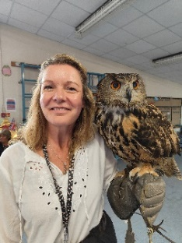  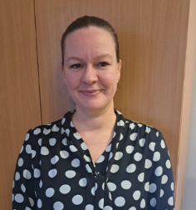
  Special Educational Needs | At Seven Stars Primary School we support children with a variety of differing special educational needs and disabilities and we pride ourselves on being a highly inclusive school with an ethos which encourages and celebrates diversity and difference.  SEND is categorised into the following areas in the SEN code of practise 2014:
   | Cognition and Learning
   | Communication and Interaction
   | Social, Emotional and Mental Health
   | Sensory and Physical
  Identifying and Assessing Need | At Seven Stars Primary School, we work closely as a team and if staff have a concern about a child, they fill in an Initial form and discuss concerns with the SENDCo or Assistant SENDCo and parents. The child’s needs and progress will then be monitored for a period of time following the Graduated Response approach of ‘Assess, Plan, Do and Review’.  After a period of time (which may differ depending on the need of the child) we will decide if a child needs to be placed on the SEND register. If so, a Targeted Learning Plan (TLP) will be developed which will detail the support in place for the child and the targets they are working towards. Parents are consulted on the contents of the plan and it is reviewed and updated regularly across the school year.  Academic progress for some children will be monitored using PIVATS, this allows the children who are working at below key age-related standards to have small step targets set in lessons to allow them to achieve and begin to work independently.  Some children may require more support than is ordinarily available and we may ask outside agencies to support us in ensuring that we are offering the best support we can.  We have an extensive Universal Offer in place that is detailed on each TLP. This is a list of things that are ordinarily available for all children to support them in their learning however children with additional needs are more likely to have these adaptations in place for them.  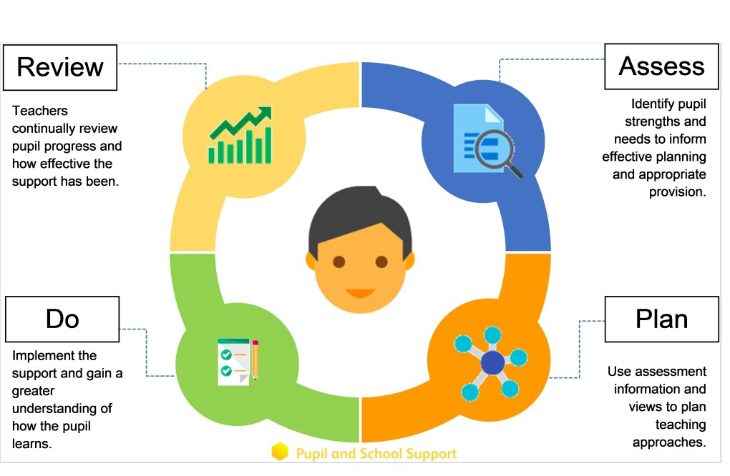
  Our approach to teaching children with SEND | We are an inclusive school. Wherever possible children are taught alongside their peers in flexible teaching groups.  Teachers adapt their high-quality teaching to cater for their pupils’ needs and plan individual timetables where necessary. When appropriate, staff are deployed to give children additional interventions in small groups outside the classroom, or to provide one-to-one support.  We use the EEF guidance ‘Five-a-day’ and embed the key principles into all our lessons.  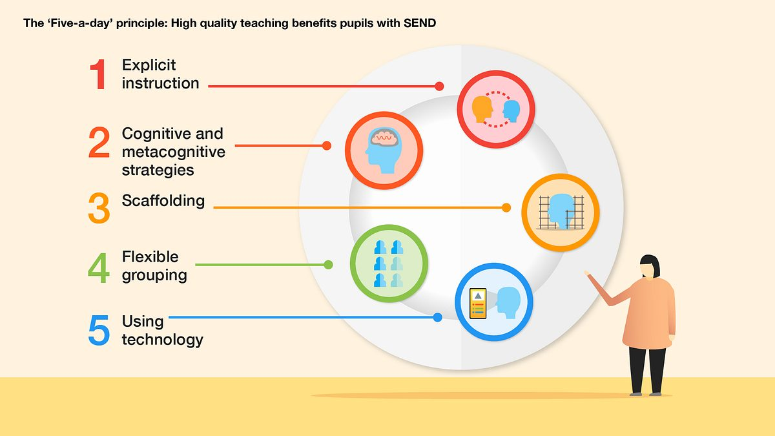
  Curriculum adaptations | We use a range of strategies across our lessons to ensure we offer an inclusive approach to learning and allow all children to access the classroom environment.  We also seek advice and equipment from outside agencies as and when the need arises.
   |  | 
  Visual timetables | Task boards | Adult support
   |  | 
  Assistive technology | Talk partners | Peer marking
   |  | 
  Self-assessment | Word banks | Positive behaviour
   |  | 
  Ear defenders | Timers | Explicit instruction
  Parent Consultations | At Seven Stars Primary School we work closely with parents and carers and recognise that they have much to contribute to our support for children with SEND.  We have an open-door policy regarding contacting the SENDCo and Assistant SENDCo; both are linked to every class on Class Dojo to allow parents to easily contact them. Both Mrs Walsh and Miss Lemon are also available at parents’ evenings to discuss any concerns.  For the current academic year, we are planning on holding some drop-in sessions and coffee mornings for parents of children with SEND. During these sessions we will gather parent feedback on SEND provision at Seven Stars, signpost to training courses and support groups and offer opportunities to meet up with outside agencies.  For children who have an Education, Health and Care Plan, we will invite you to an Annual Review meeting. Other professionals may be invited to contribute to this meeting. These meeting are used to celebrate your child’s learning, looking at the progress they have made against the outcomes set, create new targets and discuss next steps. A summary report of this will always be sent home after the meetings and is also submitted to the Local Authority.
Child Consultations | Pupil’s views are very important; they have a right to be involved in decisions about their education and they are made aware of the support that surrounds them in school.  Children are fully involved and their views feed directly into all policies, procedures and daily teaching of children with SEND.  Pupils are given regular opportunities to:
   |  | 
  Self-assess how they are doing | Attend meetings and help decide the support needed. | Feedback and Review progress/interventions.
  Evaluating Provision | At Seven Stars Primary School, we regularly evaluate our SEND provision. Some of the ways we do this are:  Reviewing progress in Senior Leadership Team meetings.  Developing a SEND Action Plan to plot out key actions for the academic year.  Discussing and sharing ideas in staff meetings to ensure up to date research and policy is in place.  Reviewing children’s individual progress towards their goals at regular intervals, as a minimum every term.  Establishing children’s baseline before receiving interventions and reviewing the impact of interventions at regular intervals.  Asking our children if they feel the adjustment or intervention is helpful and makes a difference.  Monitoring by the SENDCo and Assistant SENDCo through meetings with staff, learning walks and quality assurance checks on TLP’s.  Regularly tracking PIVATS progress.  Holding annual reviews for children with Education Health Care Plans.
  Staff Training | At Seven Stars Primary School, we believe in professional development and aim to ensure all our staff have the understanding they need to enable them to support your child.  When a new member of staff joins the school, we ensure they understand the systems within school and they are given information about the children they are working with.  The Senior Leadership Team within school are constantly moderating needs within the school and, where an area of concern is highlighted, whole school training may be organised to ensure all staff understand specific learning difficulties and appropriate teaching or support strategies that could be utilised.  If your child needs specialist support from an outside agency, such as the Speech and Language Service (SALT), Educational Psychologist (EP), Occupational Therapist (OT) or school nurse, we will always discuss this with you first.  Some of our staff have completed training in the following areas. When staff go on a course, they have an opportunity to give feedback to the rest of the staff during staff meeting sessions.
   |  |  | 
  Play Therapy | Lego Therapy | Child Development | Bucket time
   |  |  | 
  Autism | Makaton | Phonics (catch-up) | Team Teach
   |  |  | 
  Specific Learning Difficulties | Universal Provision | Nurture support | Speech and Language
   |  |  | 
  De escalation | Attachment | Reading for those who struggle | Sensory needs
  Transition Support | Nursery to Reception  We hold a parent and carer session in the summer term for our new reception starters, providing parents with the opportunity to meet with the class teacher and SENDCo.  We hold ‘taster’ sessions in the second half of the summer term in preparation for their September start.  Transition to Reception, and then into each successive year-group, is supported by meetings and taster sessions in each new class.  End of Year transition  When children move up a year, the teachers meet to discuss each pupil’s strengths and areas of need. The current teacher ensures TLP targets that are in place for the start of the new academic year and that the receiving teacher is familiar with them.  We hold a transition session during the summer term allowing the children to go up to their new classroom and meet their teacher and teaching assistants.  Some children may require extra transition visits to their new classroom to help reduce their anxiety and ensure that the transition is successful and positive. Sometimes teachers will make videos of the new classroom to post on Class Dojo to further support the upcoming change.  Secondary Transition  We liaise very closely with our partner schools to ensure that the transition from primary school to the secondary school is as smooth as possible. Staff from secondary schools visit us to talk to the Y6 teacher, the SENDCo and our Family Support Manager to ensure that any additional needs and support are communicated clearly.  Some of our partner high schools also organise additional transition visits for pupils with SEND.  Mid-Year new starters  When we are aware that pupils joining us from other settings have identified special educational needs, we arrange a meeting with the family to enable us to gain a greater understanding on the support we need to put in place.  Where possible, we will also request any documents detailing the additional needs and provision required, prior to the child starting with us to ensure we can have provision in place and aim for the smoothest transition possible.
  Outside Agencies | We work with the following agencies to provide support for children with SEND:  Educational Psychology Service – Applied Psychologies  Lancashire Specialist Teacher Service  School Nursing Team  Speech and Language Therapy  Visual and Hearing Impairment Team  Reach Behaviour Support  Inclusion & Engagement Support Team (IEST)  Occupational Therapy  We will ask your permission before we arrange for any outside agencies to come in and work with your child. Once the feedback has been received we will share it with you via either their report and/or a meeting in school.
  Clubs and Trips | Our extra-curricular activities and school visits are available to all our children wherever possible, including our before-and after-school clubs.  In cases where a risk-assessment has been completed and it has been deemed unsafe for a child to participate in an extra-curricular activity or visit, we will discuss this with you. The aim is always for children to participate in activities and we will strive to make any adaptations to allow for this.  All children are encouraged to go on our trips such as the Y6 residential trip, visits off-site and into the local community.  All children are encouraged to take part in sports day, school competitions, school assemblies and performances, workshops, etc.  All children are encouraged to apply for roles of responsibility in school e.g. Pupil Parliament, assembly helpers, register monitors, lunchtime helpers etc.  No child is ever excluded from taking part in these activities because of their SEN or disability.  Please read the school’s accessibility plan for further information about the steps we have taken to prevent disabled children from being treated less favourably than other children and the arrangements we have made to help children with SEND access our school.
  Raising Concerns | Your first point of contact is your child’s class teacher.  If you feel that your concern has not been fully addressed, then you may make an appointment to speak to the SENDCo, who is also the Deputy Head Teacher. If they cannot solve your issue, then an appointment can be made to speak to the Headteacher.  If you are not happy with the response, we have a complaints procedure that can be found on the school website, here: https://seven-stars.lancsngfl.ac.uk/parents/policies  Carol Stunell – Chair of Governors  Colin Sharples – SEND Governor
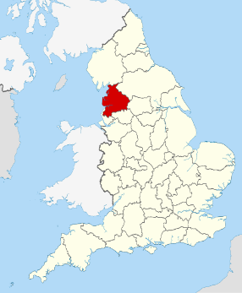  Lancashire Local Offer | The Lancashire Local Authority Local Offer can be found at:  https://www.lancashire.gov.uk/children-education-families/special-educational-needs-and-disabilities/
  SEND Helpline | 01772 533900
  Lancashire SEND Directory | https://senddirectory.lancashire.gov.uk/kb5/lancashire/directory/home.page
  IPSEA (Independent Legal Advice) | 0300 222 5899  https://www.ipsea.org.uk/
  Lancashire Parent Carer Forum | https://www.lancashireparentcarerforum.org.uk/
  Inclusion Service Team | 01772 531 597
  SEND Information Advice Support Service | 0300 123 6706  https://lancssendias.org.uk/
  Feedback | “Thank you so much and for all you have done for our son. He has come on leaps and bounds whilst at Seven Stars.”  “Seven Stars is an absolutely amazing school and they are absolutely second to none with SEND children.  My daughter moved to Seven Stars in year 1 and has come on leaps and bounds, she is the happiest little girl and absolutely thriving, I cannot fault the school in anyway.  As a parent you know your child and I can honestly say school are fully supportive of parents in the school and do listen to your concerns and will do their best to help you get what is right for your child.  My daughter has physical, medical and neuro diverse disabilities and school have always gone above and beyond. Nothing is too much for them.  The staff are fantastic and very supportive and want the best for every child, they genuinely care about the children and it shows.  My child's behaviour and social skills are coming on beautifully and any issues with this are always dealt with very sensitively. Seven Stars are the best school and I would recommend them to anyone.”

If you would like to provide us with any feedback about our SEND provision, please feel free to contact either Mrs. Walsh or Miss Lemon.

