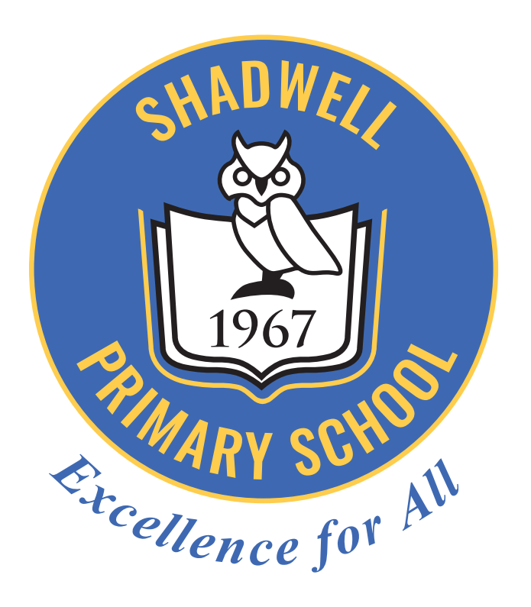


Equality Ambassadors
24th June 2019

The badges are being worn with pride. They look amazing.
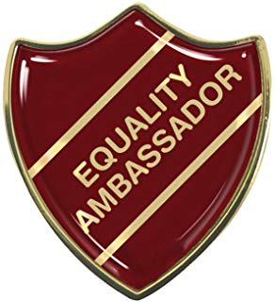
Attendees:
Year 3 – Rahsaan, Sharon, Olivia
Year 4 – Anton, Amelia, Olivia, Grace, Ruby, Harpreet
Year 5 – Tom, Amrit, Amaya
Year 6 – Isla, Poppy.

- We looked at the suggestions that you made in your class equality meetings.

We are going to consider one of your suggestions to make some improvements each time we meet.

Our first task is to speak to Mrs Whittaker regarding the tasks that the children do in the dinner hall. These tasks range from:
- Clearing the table ready for the next sitting.
- Pouring the water for everyone on the table.
- Setting the table.
- Making sure the younger children have an enjoyable lunch time by talking to them and encouraging them to eat their lunch.
Year 4 felt that some people were avoiding their task and this was not fair. We felt that the lunch time arrangement was a good representation of a family and we should encourage everyone to take responsibility.

- We asked if there was anything that you think we should do at school that shows the diverse culture that makes up our school.

Class: | Your suggestion: | Our discussion:
Year 2 | Experience using chop-sticks at lunch time | We liked this idea but we thought it would take too long to eat our lunch.
Year 4 | To have songs from other religions in singing.  To experience food from different countries.  To have food from different festivals | Some of us felt we already did this but we will mention it to Mrs Crawley.  We discussed the food we already have from different countries such as:  Curry from India  Pizza and pasta from Italy  Sweet and sour from China  Fish and chips from Britain  Roast dinner from Britain  We currently have Christmas dinner.
Year 5 | To have a prayer in assembly that reflects a different religion to Christianity | We always say the Lord’s prayer. Mrs Wilson is going to look for other prayers that she might use in assembly when she is reflecting on a festival from a different religion.

These are all excellent suggestions.
Thank you to everyone who gave such good ideas.

- We discussed the equality actions that have already been happening in school
this week.

Year 4 carried out the assembly on the Tom Palmer Live World Cup Story - Rocky Rovers that they have been working on in class. This looked at the equality for ladies football.
Through the assembly we learnt that in 1895 there was a ladies football team but this was banned in 1921 as the FA did not think it was appropriate for ladies to be playing football.
The ladies were not happy with this decision and after much persuasion (50 years later) in 1971, the FA agreed for ladies to once again have a team. From that date, the FA have seen a huge growth in women playing football with now 137 UK teams registered and big competitions being played. The ladies are now doing amazingly well in the World Cup.
Women's football has seen 2 players honoured in the Queen's honours list this year, female coaches appointed, mixed teams in huge charity competitions (Soccer aid) and 22 centres of excellence for girl's football.
Equality for women!

- Further whole school actions to promote Equality are:
The Village Summer flower show that takes place in August on our school field.
This is aligned to the centenary of the suffragette movement.
We are using the associated colours of purple / silver / green to create art work and poetry.
Each class is also responsible for a planter that will be placed near our school entrance.

- Reception and KS1 are using i-pads to take for photographs of flowers (grown in school). The photos will be submitted for judging.
- Y3 and Y4 are sketching and painting some of the planted flowers. The sketches and paintings will be submitted for judging.
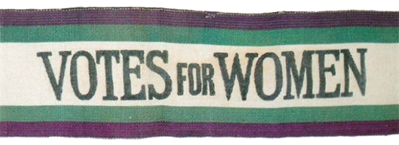
- Y5 and Y6 are creating poetry linked to the suffragette movement or to flowers. The poems will be submitted for judging.
All the submissions will be short-listed by some members of Horticultural Society so that eg. 10 from each category are displayed in show.

- We would like to know more about the diversity in school, so we have put together a questionnaire for you.
Some questions are simple yes, no or sometimes, for others you need to make a choice.
Please help us find out more.

Do you pray?

Yes | No | Sometimes
Do you go to a place of worship (once a month or more)?

Church | Synagogue | Mosque | Gudwara | Hindu temple at home | Never go

Do you feel you are judged by the way you speak?

Yes | No | Sometimes

Do you feel you are judged if you wear glasses?

Yes | No | Sometimes

In this school do you feel your skin colour is noticed?

Yes | No | Sometimes

Thank you for helping with our research. We will feed back the results to you, along with any actions that we think we might need to take?

- We asked if we could continue being Equality Ambassadors in September as we have only been in this role since April.

Huraah! Mrs Wilson said we would continue until next April 2020. We will need some more children from Year 3 as we will lose our current year 6 children to high school.

We were all very pleased with this decision.

We had a great meeting.

