**Shavington Primary School**

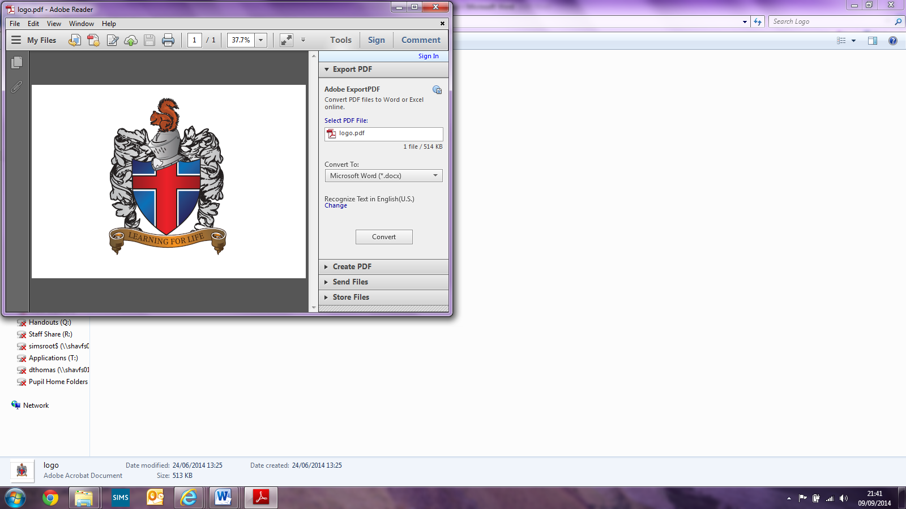

**Art & Design Policy**

Signed: _____________________(Head of School)

Signed: _____________________(Subject Leader)

Signed: _________________________(LAB Chair)

**Shavington Primary School**

**Art Policy**

**Introduction**

The Art and Design curriculum at Shavington fosters creativity, individuality and resilience. It gives children the opportunity to learn new skills, develop learnt skills and put their own creative flare into their creations. Through collaborative work and reflection, it also builds social and communication skills. Art and Design allows the children to develop and consolidate their vocabulary as well as exposing children to many well-known artists and their work. Children will develop a range of skills and techniques using a variety of mediums and materials.   
At Shavington Primary School it is our firm belief that, in order to to enhance and enrich all children’s learning we must provide a full and rounded education; we must be committed to the art and design curriculum. The teaching of art, therefore, is taught discreetly as well as allowing many links to other topics and areas of the curriculum.

**Intent**  
At Shavington Primary School, we aim to provide children with a broad and enriching Art and Design curriculum that develops their skills whilst also encouraging children to explore their own creativity and style. Our vision is for children to be immersed in and enthusiastic about art by celebrating their artwork and inspiring them through high quality teaching and delivery of the curriculum. Whilst at Shavington, children will create final pieces that have been inspired by a research phase of different artists and/or techniques from different cultures and eras. They will be creative as they demonstrate their ability to apply new skills and experiment with newly learnt techniques; as well as refine previously leant skills. Children will be given opportunities to display their individuality and creativity through research, designing, making and evaluating their work. Whilst Art and Design is taught as a discreet subject, we are committed to helping children develop skills that are transferable and relevant across the wider curriculum.

**Implementation**  
At Shavington Primary School, we follow the National Curriculum programme of study for Art and Design; we aim to make learning real and relevant by planning units that are related to and can be integrated into learning across different subject areas (where possible). Using this approach, children can apply their artistic skills to real life scenarios and in other areas of their learning; this giving meaning to their work. The main areas for teaching taken from the National Curriculum are drawing, painting, colour, printing, pattern and form and these are taught multiple times throughout a child’s school career to ensure that all children have chance to keep building upon these skills and embedding them. We research and explore pieces of artwork and famous artists, forming our own opinions through discussion and evaluation; allowing for the introduction and discussions around new vocabulary. We then use this to inspire our own artwork and help us to develop new technical skills. We foster an environment that allows for risks to be taken, independence to be developed and all work is celebrated and evaluated.

**Impact**  
A high-quality Art and Design education should engage, inspire and challenge pupils, equipping them with the knowledge, vocabulary and skills to experiment, invent and create their own works of art, craft and design. As pupils progress, they should be able to think critically and develop a more rigorous understanding of Art and Design.

Children’s evaluations should reflect their growing confidence and understanding of techniques and vocabulary that they have learnt, practised and applied. They should begin to have a sense of independence and understand and utilise their artistic strengths as well as any areas for change or development.

Through high quality teaching we ensure that all children are able to:

· Enhance their artistic knowledge and develop their creative awareness, eventually being able to apply their skills to create their own pieces of artwork.

· Explore artists and develop an appreciation and passion for a variety of artistic styles.

· Use a variety of materials, resources and techniques.

· To build their sense of selves by working creatively, with perseverance and resilience.

· To develop a sense of imagination and passion, with a confidence to take risks in their own artwork.

**Aims and Objectives**We aim to provide all pupils with:

* A broad and balanced range of arts activities which are practised and developed over their time at Shavington.
* The desire to continue an interest in the arts and develop their visual awareness and appreciation.
* The opportunity to progress their skills and creativity through the arts.
* The varied experiences from different cultures and traditions through the arts.
* The opportunity to achieve higher attainment in other curriculum areas through the arts.
* The opportunity to use art and design skills to apply their subject knowledge from across the curriculum.
* The opportunity to raise and develop their self-esteem through class activities.
* Opportunities to take part in performances, exhibitions and a wide range of extra-curricular activities and individual work.

**Planning the Arts**  
All class teachers link the National Curriculum key skills to their planning on a half termly basis. Over the course of the year children will be taught all of the key skills for their key stage, these are to be built upon each year. At Shavington Primary School, teachers and support staff are actively encouraged to always consider how to enrich the learning opportunity for pupils in other curriculum areas through the arts.

Teachers plan and assess using the national curriculum.All teachers have access to a yearly overview (long-term planning) which allows them to consider units well in advance; including specific skills and objectives and any resources they may need. Teachers will then use medium and short-term planning for to deliver their art lessons. Short term planning provides details of what learning will look like and the opportunities to achieve the given objective, as well as provide opportunities to build on prior knowledge, plan for specific individuals and plan in time for reflections and evaluations of the learning that has taken place. Each art lesson has an individual lesson plan.

**Teaching and Learning**Class teachers use a variety of strategies to teach the arts from the use of ICT, inspiration from educational visits and visiting practitioners. Practice also includes teacher exposition, discussion, practical work, first-hand experience and investigation as well as open-ended activities in both indoor and outdoor learning environments. Children are taught with a mix of whole class learning, group and individual work. All teaching staff embrace opportunities to enhance other subjects with Art and Design. Teachers have access to a widely stocked art cupboard and there are opportunities for large orders for more specific units.

**Opportunities to take part in competitions, exhibitions and other extra curriculars within the school and outside of school.**

* Non-negotiables to ensure that art work is continually displayed throughout the year.
* Whole school days planned where Art and Design are planned as strong components.
* Across MAT projects where all school work towards a common goal.
* Christmas fair, where all children make and sell their own crafts.
* Workshops focused around the Arts.
* Arts and crafts extra-curricular clubs offered during the year.
* Art competitions held throughout school.
* Design opportunities for the Christmas play.

**Assessment**

Assessment in the arts is regular and ongoing. It includes reflections with pupils’ previous work and self and peer evaluations by the children. Where appropriate, units may use cold and hot tasks to assess learning at the beginning of the topic and then again at the end of the topic to measure progress. Art is an individual experience where we assess the opportunities children have and their own self-confidence within the objective, as well as their understanding of different methods, materials and the use of resources. In a typical lesson, you will see discussions between staff and pupils, allowing pupils to elaborate on their choices and influences. You may see discussions between peers; including what the pupils like about each other’s work and why. You will also see children responding to their learning and commenting on their learning and progress across a unit. Individual progress in Art and Design is also discussed at our termly Parents Evenings.

**Equal Opportunities**

All children are given equal access to the Art and Design curriculum regardless of their level of ability or need. Support is available to those who should need. We aim to make access to Art and Design equal for all our pupils including our SEN pupils and our Greater Depth pupils.

Art and Design sessions are delivered in a whole class environment. Occasionally the sessions may be delivered across a whole year group. Children will all receive the same teaching of skills, model and will all attempt the same tasks. Children with additional needs may work with additional support to complete. Differentiation will be by outcome, technical skills and creativity. Whilst this is fundamentally reflected in teachers planning, we do not specifically differentiate planning for specific individuals, unless this is required. This is because we feel that art reflects the individual and no pieces of art work should be the same; nor should they be a direct replication of another artist. Therefore, all children access their Art session on their own level and will make individual interpretations and representations of what they have learnt.