**Shavington Primary School**

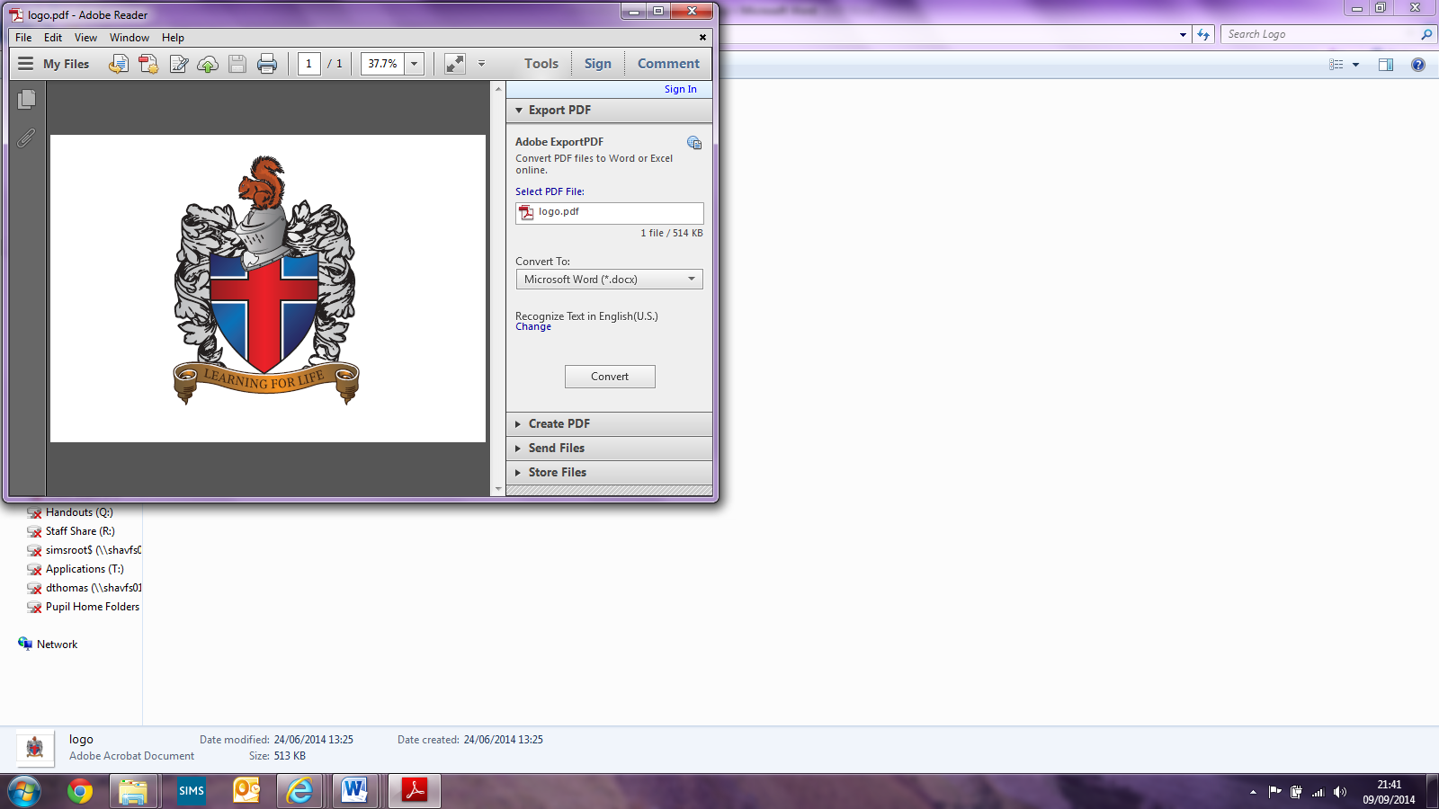

**Design & Food Technology Policy**

Written by Hayley Barber (Shavington Primary School)

Implemented: September 2022

Review date: September 2024

Signed: _________________________(Head of School)

Signed: Hayley Barber (Subject Leader)

Signed: _________________________(LAB Chair)

**Shavington Primary School**

**Design & Food Technology Policy**

**Introduction**At Shavington Primary School the Design and Food Technology curriculum is taught discreetly and aims to develop technical knowledge and skills. Units aim to link to other areas of the curriculum; such as English, Science, History and Geography. This allows children to engage with their learning; for learning to be real and exciting, and also to allow children to develop a broader and deeper knowledge of their unit. Planning links to the D&T National Curriculum and aims to give children multiple opportunities to develop and refine their skills across their primary school career. It aims to develop resourcefulness and creativity and well as allowing children to be innovative. The Design and Food Technology curriculum aims to provide children with a skills rich curriculum which is underpinned by vocabulary and technical knowledge.

One unit is taught at least once a term and during this time will be taught for an hour a week. Planning is developed to link to learning in topic and is planned and delivered by class teachers

and/or teaching assistants.

**Intent**

At Shavington Primary School, we aim to provide children with a broad and enriching Design and Food Technology curriculum that develops their skills whilst also encouraging children to explore their own ideas and inventions. Our vision is for children to be immersed in and enthusiastic about their Design and Food Technology projects by making learning real; inspiring them through high quality teaching and delivery of the curriculum. Whilst at Shavington, children will create final projects that have been developed through a research phase where children explore previous designs that are currently on the market. They will show resilience, determination and perseverance as they demonstrate their ability to apply new skills and experiment with newly learnt techniques; as well as refine previously leant skills. Children will be given opportunities to display their thoughts, ideas and processes through research, designing, making and evaluating their work. Children will be encouraged to work both individually and as part of a team during their projects. Children will learn about food groups and how to design and make healthy choices in their Food Technology. They will learn about food safety and hygiene as well as how to make their dishes varied and appealing. Whilst Design and Food Technology is taught as a discreet subject, we are committed to helping children develop skills that are transferable and relevant across the wider curriculum.

**Implementation**

At Shavington Primary School, we follow the National Curriculum programme of study for Design and Food Technology; we aim to make learning real and relevant by planning units that are related to and can be integrated into learning across different subject areas (where possible) such as English, History, Geography and Science. All units begin with a design brief where children are given a statement requiring them to create something specific. This allows each unit to have a user and a purpose for the project; allowing children to apply their skills to real life scenarios and giving meaning to their work.

The main areas for teaching taken from the National Curriculum are textiles, structures, mechanisms and cooking and nutrition and these are taught multiple times throughout a child’s school career to ensure that all children have chance to keep building upon these skills and embedding them. We research and explore past and present design technology as well as looking at successful structures, mechanisms and textiles and discussing new and related vocabulary. We learn about the principles of nutrition as well as where foods come from and can be sourced. We then use this to inspire our own inventions and help us to develop new technical skills. We foster an environment that allows for risks to be taken, independence and resourcefulness to be developed, and all work is celebrated and evaluated.

**Aims and Objectives**We aim to ensure that children progress in their Design and Food Technology through:

* Termly units – one hour to be taught each week.
* Children to learn about past and present designs.
* Children to begin each unit with a design brief to give learning a user and purpose.
* Children being given multiple opportunities to practise and refine their skills.
* Children to develop their technical knowledge and vocabulary.
* Children to be given multiple opportunities to use various tools, materials and equipment.
* Children to learn how to use equipment safely and appropriately.
* Children to learn how to prepare food safely and hygienically.
* Children to learn about the principles of nutrition.
* Children to work on a design prior to making.
* Children to complete an evaluation at the end of the unit.

**Planning Design and Food Technology**  
All class teachers link the National Curriculum key skills to their planning on a half termly basis. Over the course of the year children will be taught all of the key skills for their key stage, these are to be built upon each year. At Shavington Primary School, teachers and support staff are actively encouraged to always consider how to enrich the learning opportunity for pupils in other curriculum areas through Design and Food Technology.

Teachers plan and assess using the national curriculum.All teachers have access to a yearly overview (long-term planning) which allows them to consider units well in advance; including specific skills and objectives and any resources they may need. Teachers will then use medium and short-term planning for to deliver their Design and Food Technology lessons. Short term planning provides details of what learning will look like and the opportunities to achieve the given objective, as well as provide opportunities to build on prior knowledge, plan for specific individuals and plan in time for reflections and evaluations of the learning that has taken place. Cooking and Nutrition units will be taught at least once each year. Each Design and Food Technology lesson has an individual lesson plan.

**Teaching and Learning**

Design and Food Technology units are taught once in every term. It is taught for at least one hour a week or the equivalent during this time. It is delivered by a class or year group teacher or a teaching assistant.

**Opportunities to take part in competitions, exhibitions and other extra curriculars within the school and outside of school.**

* Non-negotiables to ensure that Design and Technology work is continually displayed throughout the year.
* Whole school days planned where Design and Food Technology are planned as strong components.
* Across MAT projects where all school work towards a common goal.
* Christmas fair, where all children make and sell their own crafts.
* Workshops focused around the Design and Food Technology.
* Design and Food Technology competitions held throughout school.
* Design opportunities for the Christmas play.

**Assessment**

Assessment in the arts is regular and ongoing. It includes reflections with pupils’ previous work and self and peer evaluations by the children. Where appropriate, units may use cold and hot tasks to assess learning at the beginning of the topic and then again at the end of the topic to measure progress. Design and Food Technology is an individual experience where we assess the opportunities children have and their own self-confidence within the objective, as well as their understanding of different methods, materials and the use of resources. In a typical lesson, you will see discussions between staff and pupils, allowing pupils to elaborate on their choices and influences. You may see discussions between peers; including what the pupils like about each other’s work and why. You will also see children responding to their learning and commenting on their learning and progress across a unit. Individual progress in Design and Food Technology is also discussed at our termly Parents Evenings.

**Equal Opportunities**

All children are given equal access to the Design and Food Technology curriculum regardless of their level of ability or need. Support is available to those who should need. We aim to make access to Design and Food Technology equal for all our pupils including our SEN pupils and our Greater Depth pupils.

Design and Food Technology sessions are delivered in a whole class environment. Occasionally the sessions may be delivered across a whole year group. Children will all receive the same teaching of skills, model and will all attempt the same tasks. Children with additional needs may work with additional support to complete. Differentiation will be by outcome, technical skills, resourcefulness and creativity.

This is because we feel that Design and Food Technology reflects the individual and no pieces of work should be the same. Therefore, all children access their Design and Food Technology sessions on their own level and will make individual interpretations and representations of what they have learnt.

This policy will be reviewed at least every 2 years

Signed : H. Barber

Print : H.Barber

Date : September 2022