**Shavington Primary School**

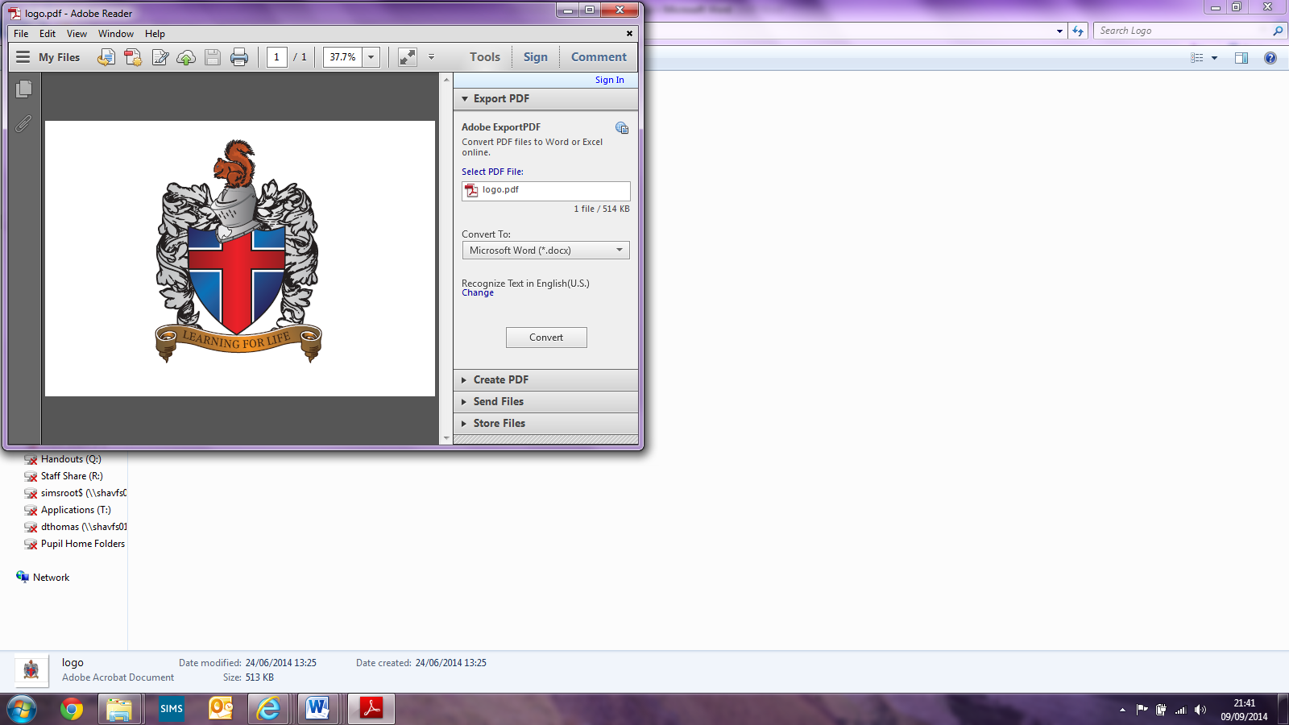

**R.E Policy**

Written by Laura Simms (Shavington Primary School)

Signed: _________________________(Headteacher)

Signed:________________________ (Subject Leader)

Signed: _________________________(LAB Chair)

**Introduction**

Religious education enables children to investigate and reflect on some of the most fundamental questions asked by people. At Shavington Primary School, we develop the children’s knowledge and understanding of the major faiths, and address fundamental questions. Children reflect on what it means to have a faith and to develop their own spiritual knowledge and understanding. We help the children learn about religions, as well as from religions.

### ****Intent****

At Shavington, our Religious Education (RE) lessons allow children to encounter different religions and cultures, develop understanding and tolerance and have the opportunity to discuss their ideas, thoughts and learning. Our aim is to help children to develop knowledge, acceptance and understanding of different religions and cultures, so that they are empathetic towards people’s religious beliefs and values in their local community and in the wider world. During their RE lessons, our children will engage in and explore people’s beliefs and commitments, using various resources and stimulus.

**These include:**

* *Artefacts*
* *Educational-clips*
* *Drama*
* *Art*
* *Discussion*

We take time to explore the different places of worship – this is done both by using the Internet, and where possible through first-hand experiences. This helps to develop their knowledge and understanding of the different religious rituals. We also provide opportunities throughout the year for our children to visit the two local Churches and take part in a range of activities.

### ****Implementation****

RE is taught from reception to year 6. This is usually done though weekly lessons, however, this may look slightly different in each year group. At Shavington, we follow the expectations of the Cheshire East locally agreed syllabus. To aid and reinforce our teaching of RE, the children are able to handle artefacts and have opportunities to visit our local Churches. We also often have assemblies lead by people who are part of these Churches.

As part of our RE curriculum, we teach the religious beliefs and practices of several religions.

**We focus mainly on:**

* *Christianity*
* *Judaism*
* *Humanism*
* *Hinduism*
* *Islam*

This knowledge enables the children to explore RE further as they go to high school.

If, for any reason, parents wish to withdraw their child from an R.E. lesson or an act of worship, they should contact the Head teacher and alternative arrangements will be made.

We ensure that our RE lessons are inclusive. This means that children of all abilities are encouraged to join in; this is achieved through use of support, outcome or similar simplified tasks.

Before each unit of RE is taught, the children are given a task to assess any prior knowledge they may have of that unit of work. It also ensures that our subsequent planning suits the needs of all children. This can also be a great opportunity for discussion and allows children to share any experiences they may have had outside of school that link to their RE unit of work. At the end of each unit, the children will complete a similar task to assess their learning and understanding of the unit of work.

### ****Impact****

At Shavington, we strive to make sure that all Religious Education lessons are engaging and that all learning is inclusive to ensure children make good progress.

**This allows children to:**

* *Engage in learning about religion by developing their understanding and tolerance.*
* *Experience a wide range of enquiry questions and challenges within the subject.*
* *Deepen their appreciation of religious beliefs and become empathetic towards people’s religious beliefs, cultures and values, in their local setting and beyond.*
* *Visit places of worship and see religious artefacts in a different setting.*
* *Develop British and moral values of tolerance, mutual respect between those of different faiths, cultures and beliefs.*
* *Build a richer vocabulary when discussing a range of religions.*
* *Express their findings or thoughts though questioning or reflection.*
* *Gain a good knowledge of religious buildings, symbols and rituals specific to the religions taught.*
* *Understand how people show their commitment to their God and religious beliefs.*
* *Achieve their best (regardless of their ability), which is reflected through our continued links and engagement with our local communities.*

**The legal position of religious education**

Our school curriculum for religious education meets the requirements of the 1988 Education Reform Act (ERA). The ERA stipulates that religious education is compulsory for all children, including those in the reception class who are less than five years old. RE is part of the basic curriculum. It is taught in accordance with the Cheshire East Agreed Syllabus (2016). It makes contributions to the spiritual, moral, social and cultural development. RE is not taught to propagate religion in general or a particular religion, it is not to nurture or convert. It is an academic discipline with levels of achievements.

Parents who wish to withdraw their children, because of personal choice or religious affiliations are permitted to do so, once they have made a formal written request to the school, and this has been agreed by the head teacher and LAB. A record of withdrawals is kept by the RE coordinator.

**Curriculum planning in religious education**

RE is a part of the whole school curriculum. The Cheshire East agreed syllabus plans are used to support the teachers’ planning which outlines the key questions/ concepts covered each term during each Key Stage and by each year group.

At the Foundation Stage RE is not taught as a distinct curriculum area. However, many of the early learning goals lead into the two RE attainment targets.

Key Stage 1 and 2 there is a systematic study of Christianity and the other 4 principal religions in the UK (Hinduism, Islam, Judaism and Sikhism). There is opportunity for other religions to be studied as well as atheist and agnostic points of view within any of the support units. The units highlight opportunities to learn outside the classroom as well creatively through the arts. In KS1 and LKS2, we use the medium-term plan from the Cheshire East Syllabus to inform our short-term planning. This usually means that we cover one religion at a time. In UKS2, we still follow the Cheshire East Syllabus, however, we focus on a key concept/question each half term. During this half term the children will learn about how this concept/question relates to Christianity, Judaism, Islam, Hinduism and other worldviews, such as Humanism. This allows children to make comparisons between religions.

In Key Stage 1, RE is taught for 36 hours a year and in Key Stage RE is taught for 45 hours a year.

**Assessment for learning**

Children demonstrate their ability in religious education in a variety of different ways. Younger children in Key Stage 1 might, for example, concentrate on learning through a range of speaking and listening activities, whilst older pupils may write a ‘question and answer’ style report on the concept they have been focusing on.

Children also complete a ‘hot task’ after each unit of work. This can then be compared against their ‘cold’ task so that teachers can assess their child’s learning. Teachers will also assess children’s work by making informal judgements during lessons. On completion of a piece of work, the teacher assesses the work and uses this information to plan for future learning.

Written or verbal feedback is given to the child to help guide his or her progress.

A system of assessment will be developed in line with the school system of assessment – this is ongoing and in development.

The RE subject leader keeps samples of children’s work in the R.E subject file. These demonstrate coverage and quality.

**Resources**

There are sufficient resources for all religious education-teaching units in the school and these can also be ordered from the Education Library Service.

There is a cupboard in school (situated in KS1), which contains a large amount of books used to aid the teaching and leaning of R.E.

**Monitoring and review**

The coordination and planning of the religious education curriculum are the responsibility of the subject leader, who also:

* Supports colleagues in their teaching, by keeping informed about current developments in religious education.

This policy will be reviewed at least every two years.

**Shavington Primary School**

**RE Policy**

Policy reviewed October 2005.

Policy reviewed October 2007.

Policy reviewed February 2010

Policy reviewed February 2012  
Policy reviewed September 2015  
Policy reviewed April 2017

Policy reviewed January 2021