**Shavington Primary School**

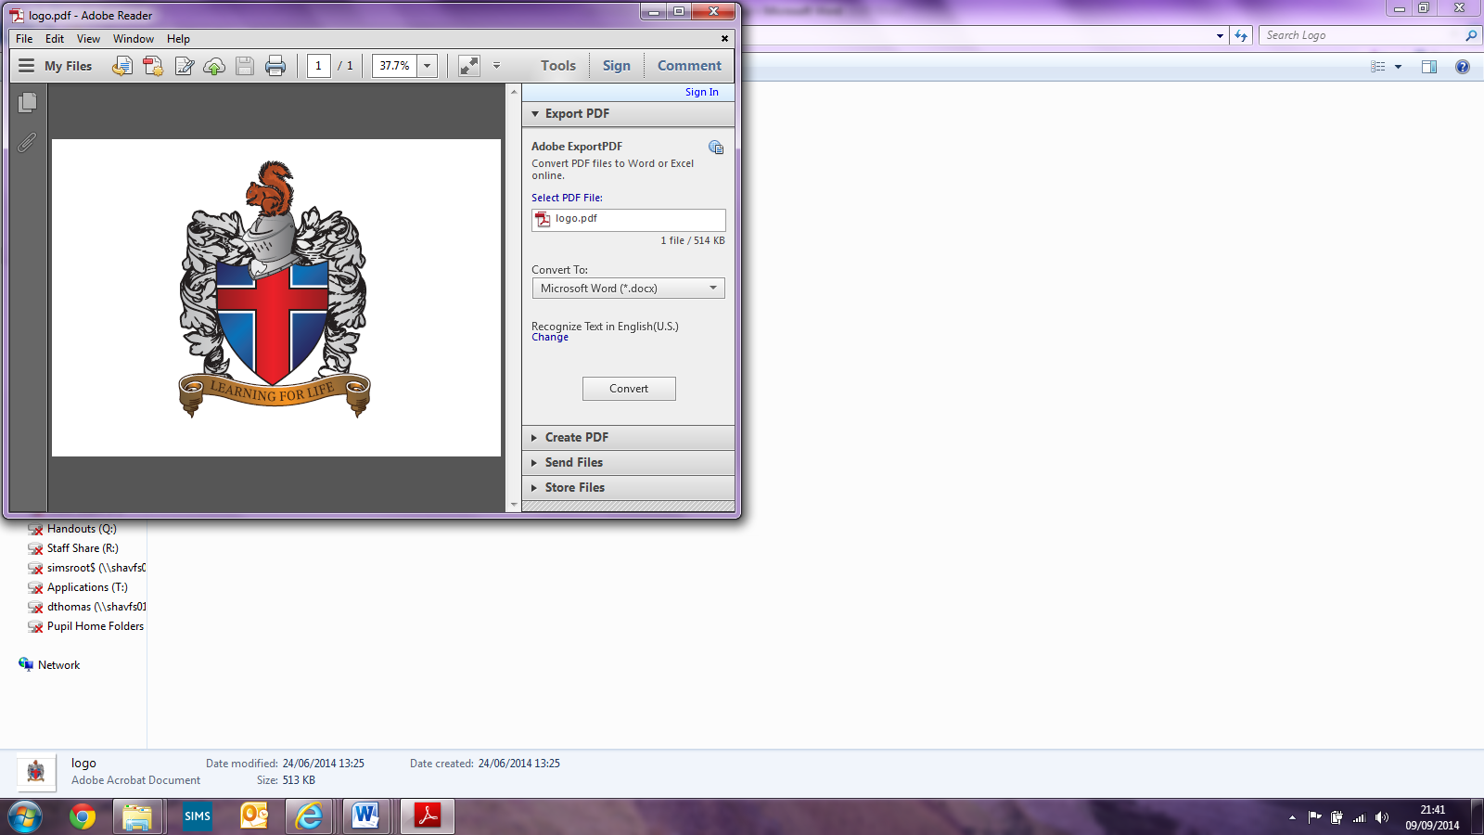

**ICT Policy**

Written by Robert Lawrie (Shavington Primary School)

Implemented: December 2020

Review date: December 2022

Signed: _________________________(Headteacher)

Signed: _________________________ (Subject Leader)

Signed: _________________________(LAB Chair)

**Shavington Primary School**

**ICT Policy**

# Introduction

The use of information and communication technology is an integral part of the national curriculum and is a key skill for everyday life. Computers, tablets and programmable robots are a few of the tools that can be used to acquire, organise, store, manipulate, interpret, communicate and present information. At Shavington Primary School we recognise that pupils are entitled to quality hardware and software and a structured and progressive approach to the learning of the skills needed to enable them to use it effectively. The purpose of this policy is to state how the school intends to make this provision.

This document is intended for

* All teaching staff
* All staff with classroom responsibilities
* School LAB members
* Parents
* Inspection teams

**Intent**

When planning and teaching computing at Shavington Primary School, we believe that it is an essential part of the curriculum; a subject that not only stands alone but is woven and should be an integral part of all learning.  Computing, in general, is a significant part of everyone’s daily life and children should be at the forefront of new technology, with a thirst for learning what is out there.  Computing within schools can therefore provide a wealth of learning opportunities and transferrable skills explicitly within the Computing lesson and across other curriculum subjects. Through the study of Computing, children will be able to develop a wide range of fundamental skills, knowledge and understanding that will equip them for the rest of their life.  Computers and technology are such a part of everyday life that our children would be at a disadvantage would they not be exposed to a thorough and robust Computing curriculum.  Children must be taught in the art form of ‘Computational Thinking’ in order to provide them essential knowledge that will enable them to participate effectively and safely in the digital world beyond our gates.

**Implementation**

Computing is taught for one session per week through the Switched On Computing scheme of work but also woven into other subjects wherever possible. Through using a range of iPads, data-loggers, digital cameras, laptops and other technology, pupils will develop their confidence and understand that computing is all around us and plays a huge part in our daily lives. During creative, practical lessons, pupils are taught computer literacy and coding skills. Pupils will learn how to stay safe online and be taught what to do if they ever feel unsafe on the internet. Internet safety is taken extremely seriously at Shavington Primary School and we invite parents to attend an e-safety meeting to educate them how to keep their children safe outside school too. We have an e-safety squad that promote online safety.

**Impact**

Our approach to the curriculum results in a fun, engaging, and high-quality computing education. Much of the subject-specific knowledge developed in our computing lessons equip pupils with experiences which will benefit them in secondary school, further education and future workplaces. From research methods, use of presentation and creative tools and critical thinking, computing at Shavington Primary School gives children the building blocks that enable them to pursue a wide range of interests and vocations. They will be creative, confident, competent and responsible users of technology, preparing them for life and work in today’s society.

**Resources and access**

* Every classroom from Nursery to Y6 has a computer connected to the school network and an interactive CTOUCH board. Each classroom also has at least two iPads and a teacher laptop, which can be used to facilitate the learning of the whole class or those with specific needs.
* There is a bank of computers (based inside the classroom) for all of KS1 and KS2.
* There are 3 iPad trolleys in school containing 66 iPads with Internet access available to use in classrooms. These can be booked out to facilitate any element of the curriculum at any time.
* There are 16 laptops in a trolley with internet access and all of the necessary software needed to support the teaching of ICT.
* Pupils may use resources independently, in pairs, alongside a TA or in a group with a teacher.
* The school has an ICT and computing technician who is in school one afternoon every other week.
* Additional iPads have been allocated to staff / groups that aid in the teaching and learning of children within and outside of school hours (PE, LINKS, BASC, RP)

# Curriculum Development, Organisation and Assessment

As a whole school approach, we use ICT planning from Switched on Computing. This covers all the objectives clearly in each year group in a fun and creative way. The units are designed so that the children can build upon what they have learnt in the previous year and develop it in their subsequent learning. Teachers are encouraged to teach the skills within other subjects to allow a cross curricular approach so that the use of ICT adds to them progressing as a learner and so that all skills are relevant.

Planning of ICT is to be done within curriculum areas, not sole ICT planning, to maintain a cross curricular approach. Whilst planning, teachers are to take into account additional needs of children (SEN, attainment of mastery, EAL) and look at appropriate options in which the given resource can be used.

Assessment of the children’s progress is recorded in KS1 on the school’s network. Reception, Year 1 and Year 2 have a year group log on where work is stored. This allows the children to begin to learn how to save their work and this facilitates their ability to retrieve and edit what they have created. Doing this on the network allows KS1 teachers to access all children’s work and also allows a collaborative approach, where appropriate for all the children. When work is created on IPADS teachers use either use Airdrop or pictures to obtain evidence of the children’s work. Where units of study do not provide the opportunity for work to be saved teachers may use photos and teacher’s judgement in the ‘Switched on computing’ assessment database tool.

When children enter into ks2 they become more responsible for being able to save and retrieve their own work. Work that is done on iPads will be saved in Showbie, where all children have their own individual log on and where teachers can assess work as well as respond to submissions from children so that they can edit and improve what they have done. Showbie also allows teachers to be able to set work for children to be able to complete on both iPads and laptops, or the relevant year group folder on the network.

Teachers are to regularly assess capability through observations and looking at completed work. Assessment of children is to then be recorded in the rising stars assessment database.

Assessing ICT and computing work is an integral part of teaching and learning and central to good practice. It should be process orientated - reviewing the way that techniques and skills are applied purposefully by pupils to demonstrate their understanding of the concepts of ICT and computing. As assessment is part of the learning process it is essential that pupils are closely involved. Assessment can be broken down into;

* Formative assessments are carried out during and following short focused tasks and activities. They provide pupils and teaching staff the opportunity to reflect on their learning in the context of the agreed success criteria. This feeds into planning for the next lesson or activity.
* Summative assessment should review pupils' capability and provide a best fit level. Use of independent open-ended tasks, provide opportunities for pupils to demonstrate capability in relation to the programme of study statement that is being covered. There should be an opportunity for pupil review and identification of next steps. Summative assessment should be recorded for all pupils – showing whether the pupils have met or shown mastery in a particular skill

**Monitoring and evaluation**

The subject leaders are responsible for monitoring the standard of the children’s work and the quality of teaching in line with the schools monitoring cycle. This may be through lesson observations, reviewing of the work saved or looking at assessment data. The subject leader is also responsible for supporting colleagues in the teaching of computing, for being informed about current developments in the subject, and for providing a strategic lead and direction for the subject in the school. In addition, the subject leader makes sure that all children can access ICT and computing.

Assessment data is stored on the school data system, Insight Tracking, and provides the subject lead with a whole school / year group / class view of how the children are progressing throughout the year.

# Roles & responsibilities

# Senior Management

The overall responsibility for the use of ICT rests with the senior management of a school. The Headteacher, in consultation with staff:

* determines the ways ICT should support, enrich and extend the curriculum;
* decides the provision and allocation of resources;
* decides ways in which developments can be assessed, and records maintained;
* ensures that ICT is used in a way to achieve the aims and objectives of the school;
* ensures that there is an ICT policy and identifies an ICT subject leader and coordinator.

# ICT Coordinator

There are two designated ICT Co-ordinators to oversee the planning, delivery and correct use of ICT within the school.

The ICT coordinators will be responsible for:

* raising standards in ICT;
* facilitating the use of ICT across the curriculum in collaboration with all subject coordinators;
* provide or organise training to keep staff skills and knowledge up to date;
* advising colleagues about effective teaching strategies, managing equipment and purchasing resources;
* monitoring the delivery of the ICT curriculum and reporting to the Headteacher on the current status of the subject.

# The Subject Coordinator

There is a clear distinction between teaching and learning in ICT and teaching and learning with ICT. Subject coordinators should identify where ICT could be used in their subject. This might involve the use of short dedicated programs that support specific learning objectives or involve children using a specific application which they have been taught how to use as part of their ICT study and are applying those skills within the context of another curriculum subject.

Subject coordinators work in partnership with the ICT coordinator to ensure all National Curriculum statutory requirements are being met with regard to the use of ICT within curriculum subjects.

# The Classroom Teacher

Even though whole school co-ordination and support is essential to the development of ICT capability, it remains the responsibility of each teacher to deliver each unit of study in a cross curricular way and assist the coordinator in the monitoring and recording of pupil progress in ICT. In addition, it is the responsibility of the classroom teacher to use ICT to facilitate the children’s learning. In doing this, teachers should create an environment where children recognise when ICT could be used to further their learning and become increasingly independent in how to select appropriate software and devices to do this.

**Monitoring**

Monitoring ICT will enable the ICT coordinator to gain an overview of ICT teaching and learning throughout the school. This will assist the school in the self-evaluation process identifying areas of strength as well as those for development.

In monitoring of the quality of ICT teaching and learning the ICT coordinator will:

* Scrutinise plans to ensure full coverage of the ICT curriculum requirements
* Analyse children’s work
* Observe ICT teaching and learning in the classroom
* Hold discussions with teachers
* Analyse assessment data

There is an annual review of this policy by the ICT coordinator.

# Health & Safety

We will operate all ICT equipment in compliance with Health & Safety requirements. Children will also be made aware of the correct way to sit when using the computer and the need to take regular breaks if they are to spend any length of time on computers.

# The school has an alarm system installed throughout. Each computer system has individual security against access to the management system. BCBC manages the intranet using ‘Surf Control’ for security and safety. The files and network system are backed up regularly. The virus checker is updated regularly when possible.

# Home school links

# Children are given the option to complete some homework tasks, when appropriate, using ICT out of school. Teachers are sensitive to the fact that children may not have access to ICT or may not wish to use it to complete tasks out of school. Any work brought into school must be scanned for viruses. In addition, to ensure that parents can readily contact the school or send work from their children, the school email address (admin@shavingtonpri.cheshire.sch.uk) has been given to parents and is listed on the website. More parents are now using this to contact staff, arrange meetings etc.

Showbie may also be used as appropriate to upload homework competed at home. The subject co-ordinators have a secure list of account log in details for children in the school.

# The school website is an important part of the school ethos and it is regularly updated. It allows constant communication with parents, promotes the school’s achievements as well as providing information and communication between the school, parents and the local community.

**Appropriate legislation, including copyright and data protection**

All software loaded on school computer systems must have been agreed with the designated person in the school.   
All our software is used in strict accordance with the license agreement.  
We don’t allow personal software to be loaded onto school computers.

**Effective and efficient deployment of ICT resources**

ICT resources are deployed throughout the school to maximise access, to enhance teaching & learning and to raise attainment.

To support the cross curricular nature of ICT computers are located in each class and IPADS and Laptops can be booked at any time. CTOUCH boards are also present in both KS1 and KS2 halls to be able to use mobile devices to support all aspects of learning.

Policy reviewed May 2018

Policy reviewed January 2021