**Shavington Primary School**

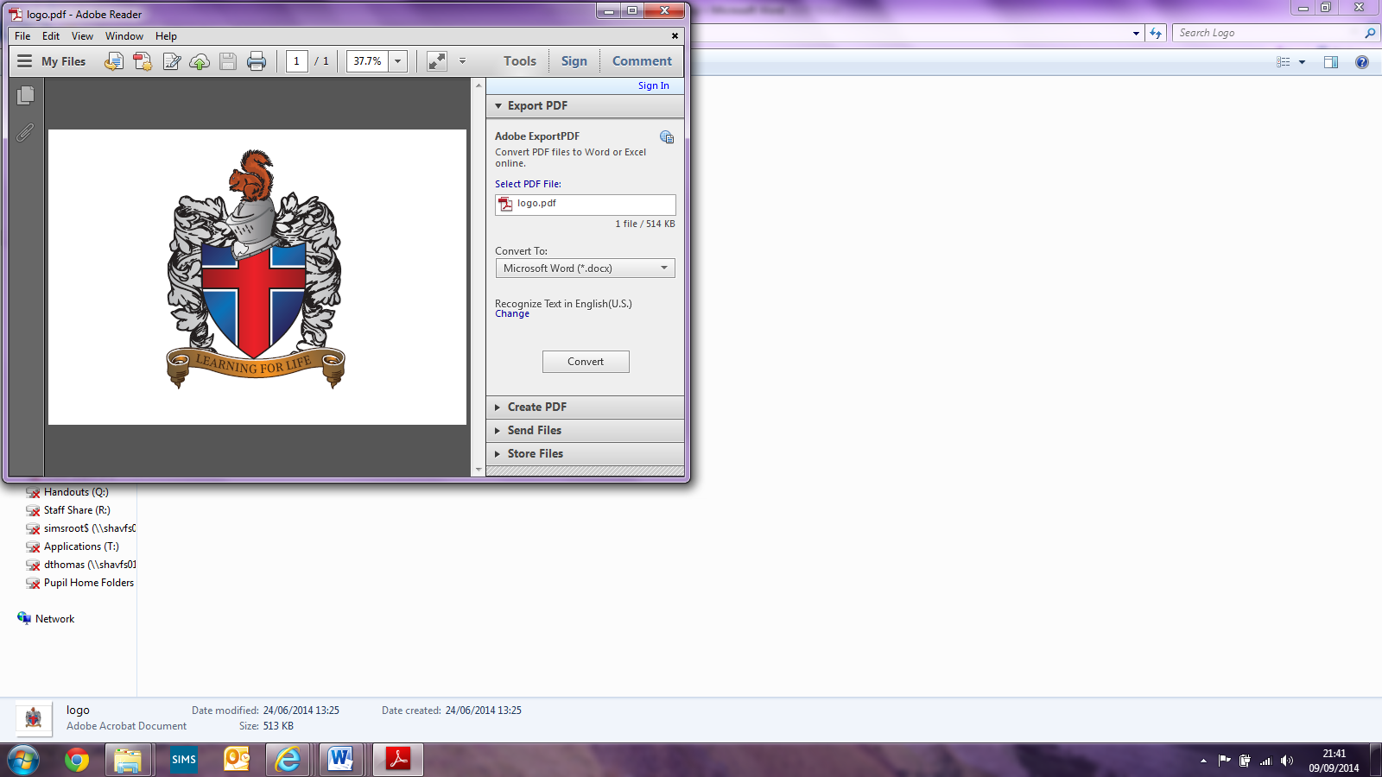

**Geography Policy**

Written by Emma Kinsey (Shavington Primary School)

Signed: _________________________(Head of School)

Signed: _________________________ (Subject Leader)

Signed: _________________________(LAB Chair)

**Shavington Primary School**

**Geography Policy**

# Introduction

Geography is an essential part of the curriculum; it provides a means of exploring, appreciating and understanding the world in which we live and how it has evolved. Geography explores the relationship between the Earth and its people through the study of place, space and environment. It contributes to the cultural, social, spiritual and moral life of children as they acquire knowledge of a range of different cultures and traditions, and learn tolerance and understanding of other people and environments. Geography is the subject where pupils learn the skills of understanding a locality and how and where people fit into its overall structure. Developing geographical skills is essential as children live in a world that is wide open to them. With opportunities to travel and work in different cities and countries across the world, pupils need to use efficiently maps, charts and other geographical data. The opportunities for the children to carry out geographical enquiry are also of value. The teaching of Geography would be difficult without acknowledging the future of our planet. The Geography Curriculum places great importance on the interaction between the physical and the human environment. Many areas of study give opportunities to make children aware of these effects upon their surroundings, their own responsibilities and how they can contribute to improving the environment, however small that contribution might be.

The objectives of teaching geography in our school are:

* To enable children to gain knowledge and understanding of places in the world;
* To increase children’s knowledge of other cultures, and in doing so, teach a respect and understanding of what it means to be a positive citizen in a multi-cultural country;
* To allow children to learn graphic skills, including how to use, draw and interpret maps;
* To enable children to know and understand environmental problems at a local, regional and global level;
* To encourage in children a commitment to sustainable development, and an appreciation of what ‘global citizenship’ means;
* To develop in children a variety of other skills, including those of enquiry, problem solving, ICT and investigation.

## Intent

Here at Shavington Primary, geography is taught using many different learning styles and strategies. We encourage the children to explore the world around them, both locally and globally. This is done via fieldwork, research and other practical activities.

Our curriculum is designed to give children the opportunity to explore and imagine destinations outside of their lived experience. Linking to British Values, we look at locations of other cultures and allow them to explore the differing landscapes that make up our world. With studies completed on local, national and international level, we are hopeful that all of our pupils leave with a knowledge base that promotes an understanding of the world, and a natural curiosity of other locations.

Across the curriculum, both human and physical topics are covered, looking at the impact we have upon our earth, and the geographical skills we acquire each year as a means for children to be able to present and explain their findings to different audiences.

## Implementation

At Shavington, we follow the National Curriculum programme of study for Geography, with units of work being taught as part of a cross curricular approach that can be integrated into learning across different subject areas.

Using our centralised English scheme of ‘Pathways’, our geography topics link with our class texts allowing our children to ‘travel’ to a multitude of destinations around the globe.

A cycle of lessons, are planned with progression and deeper understanding of the geographical skills covered across each year group. Teachers ensure there are opportunities for children to work practically as a means to illustrate geographical knowledge.

Children are able to question and explore each topic in detail, allowing them to make choices and give reasoning behind their findings. By giving children access to a multitude of resources (eg, iPads and atlas’) it allows them to problem solve and risk take in order to complete a geographical challenge.

## Impact

Shavington primary endeavour to provide our learners with engaging lessons and that all learners are included in their geographical journey through school.

Class teachers instil a responsible and methodical approach to their high quality geography sessions, ensuring children are engaged and happy in the skill they are covering. They experience a wide range of learning challenges within the subject and know appropriate responses to them, such as informed choices regarding current environmental issues e.g. limiting the use of plastics.

Children of all abilities and backgrounds achieve well in Geography which is reflected through a consistent learning journey and clear progress. We feel that that all of our learners leave us with a good subject knowledge of geography and take this out into the local area and beyond!

# Curriculum Development, Organisation and Assessment

We follow the National Curriculum for geography as the basis for our curriculum planning. We adapt the national scheme to the local circumstances of our school, i.e. we make use of the local environment in our fieldwork and we also choose a locality where the human activities and physical features provided a contrast to those that predominate in our own immediate area.

Our curriculum is taken from the Pathways planning. Our long-term plans map the geography topics studied in each term during each key stage. We use the National Curriculum as the to complement the pathways planning ensuring coverage is achieved. This gives details of each unit and the objectives. Each class teacher creates a plan for the erm, allowing a broad and balanced curriculum to be taught, but the fundamental geographical skills to be taught- these are outlined in our skill progression documents.

We plan the topics in geography so that they build on prior learning. Children of all abilities have the opportunity to develop their skills and knowledge in each unit and, through planned progression built into the scheme of work, we offer them an increasing challenge as they move up the school.

**Early Years**

Geography is taught in Early Years Foundation Stage as an integral part of the topic work covered during the year. As the reception class is part of the Foundation Stage of the National Curriculum, we relate geographical aspects of the children’s work to the objectives set out in the Early Learning Goals (ELGs), in particular the area of development ‘Understanding the World’. Geography makes a significant contribution to the development of each child’s knowledge and understanding of the world, through activities such as comparing homes across the world, collecting postcards from different places, singing songs from around the world or investigating and designing a new playground and school

**Key stage 1**

Pupils should develop knowledge about the world, the United Kingdom and their locality. They should understand basic subject-specific vocabulary relating to human and physical geography and begin to use geographical skills, including first-hand observation, to enhance their locational awareness.  Pupils should be taught to:

**Locational knowledge**

* Name and locate the world’s seven continents and five oceans
* Name, locate and identify characteristics of the four countries and  capital cities of the United Kingdom and its surrounding seas

**Place knowledge**

* Understand geographical similarities and differences through studying the human and physical geography of a small area of the United Kingdom, and of a small area in a contrasting non-European country

**Human and physical geography**

* Identify seasonal and daily weather patterns in the United Kingdom and the location of hot and cold areas of the world in relation to the Equator and the North and South Poles
* Use basic geographical vocabulary to refer to:

- Key physical features, including: beach, cliff, coast, forest, hill, mountain,  sea, ocean, river, soil, valley, vegetation, season and weather

* - Key human features, including: city, town, village, factory, farm, house, office, port, harbour and shop.

**Geographical skills and fieldwork**

* Use world maps, atlases and globes to identify the United Kingdom and its countries, as well as the countries, continents and oceans studied at this key stage
* Use simple compass directions (North, South, East and West) and locational and directional language [for example, near and far; left and right], to describe the location of features and routes on a map
* Use aerial photographs and plan perspectives to recognise landmarks and basic human and physical features; devise a simple map; and use and construct basic symbols in a key
* Use simple fieldwork and observational skills to study the geography of their school and its grounds and the key human and physical features of its surrounding environment.

**Key stage 2**

Pupils should extend their knowledge and understanding beyond the local area to include the United Kingdom and Europe, North and South America. This will include the location and characteristics of a range of the world’s most significant human and physical features. They should develop their use of geographical knowledge, understanding and skills to enhance their locational and place knowledge. Pupils should be taught to:

**Locational knowledge**

* Locate the world’s countries, using maps to focus on Europe (including the location of Russia) and North and South America, concentrating on their environmental regions, key physical and human characteristics, countries, and major cities
* Name and locate counties and cities of the United Kingdom, geographical regions and their identifying human and physical characteristics, key topographical features (including hills, mountains, coasts and rivers), and land-use patterns; and understand how some of these aspects have changed over time
* Identify the position and significance of latitude, longitude, Equator, Northern Hemisphere, Southern Hemisphere, the Tropics of Cancer and Capricorn, Arctic and Antarctic Circle, the Prime/Greenwich Meridian and time zones (including day and night)

**Place knowledge**

* Understand geographical similarities and differences through the study of human and physical geography of a region of the United Kingdom, a region in a European country, and a region within North or South America

**Human and physical geography**

* Describe and understand key aspects of:
* - Physical geography, including: climate zones, biomes and vegetation belts, rivers, mountains, volcanoes and earthquakes, and the water cycle
* -  Human geography, including: types of settlement and land use, economic activity including trade links, and the distribution of natural resources including energy, food, minerals and water

**Geographical skills and fieldwork**

* Use maps, atlases, globes and digital/computer mapping to locate countries and describe features studied
* Use the eight points of a compass, four and six-figure grid references, symbols and key (including the use of Ordnance Survey maps) to build their knowledge of the United Kingdom and the wider world
* Use fieldwork to observe, measure, record and present the human and physical features in the local area using a range of methods, including sketch maps, plans and graphs, and digital technologies.

**Resources and access**

As a school we make use of the Cheshire Library Education Service. The Library Education Service provides learning materials and resources for each subject of National Curriculum. Teachers can order resources online or visit the Library Education Centre to gain such resources.

The school also has banks of technology including iPads and laptops that can be used by children for different geographical tasks, and programs are used in line with this, for example, Google earth for map work

We are now part of the Geographical Society and all staff have access to these planning materials to support.

**Monitoring and Evaluation**

Children demonstrate their ability in geography in a variety of ways. Younger children might, for example, dress up in costumes from different parts of the world, whilst older pupils might produce a presentation based on their investigation of a geographical objective. Teachers will assess children’s work by making informal judgments during lessons. On completion of a piece of work, the teacher assesses the work (see marking policy) and uses this information to plan future learning. Written or verbal feedback is given to the child to help guide their progress. Older children are encouraged to make judgments about how they can improve their own work.

We assess work in geography by making informal judgments as we observe the children during lessons. Once the children complete a piece of work, we mark and comment as necessary. Once they complete a whole unit, we make a summary judgment of the work of each pupil in relation to the objectives from the National Curriculum. Each child will be working towards, working at or exceeding the expected level. We use these judgments to plan future work with that pupil, to provide the basis for assessing the progress of the child, and to pass information on to the next teacher at the end of the year.

The subject leader is responsible for monitoring the standard of children’s work and quality of teaching in geography. The subject leader is also responsible for supporting colleagues in their teaching, for being informed about current developments in the subject and for providing a strategic lead and direction for geography in the school. The subject leader gives the head of school an annual summary that evaluates the strengths and weaknesses in the subject, and indicates areas for further improvement. We allocate time for reviewing samples of children’s work, visiting classes and other schools in the hub to observe teaching in geography.