Shavington Primary School

Handwriting Policy
Written by Wendy Bloor
Written: March 2022
To be Reviewed:

Signed: Rachael Nicholls (Head Teacher)
Signed: Wendy Bloor (Subject Leader)

Signed: _________________________(LAB Chair)

Contents
1. Introduction.
2. Aims.
3. Legislation and guidance.
4. Roles and responsibilities.
5. Organisation.
6. Planning.
7. Assessment.
8. Inclusion and accessibility
9. Monitoring arrangements
10. Links with other policies

- Introduction:

At Shavington Primary School, we recognise that handwriting is an important skill and children’s ability to write fluently for the rest of their lives depends on a good foundation of taught handwriting in the early years of their education.
We believe that handwriting is a developmental process with its own distinctive stages of progression from readiness for handwriting, through to letter joins, practicing speed and fluency and higher presentation skills.
A flexible, fluent and legible handwriting style empowers children to write with confidence and creativity. This is an entitlement that needs skilful teaching if each individual is to reach their full potential. Penpals (Cambridge University Press) is the handwriting scheme which we have decided to follow from Foundation Stage through to Year 6.

- Aims

Formal handwriting skills will be taught regularly and systematically through the use of the Penpals Handwriting scheme (Cambridge University Press).

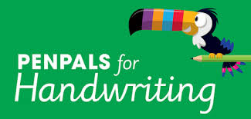

Five stages are identified and these form the basic organisation of the scheme:

1. Readiness for writing: gross and fine motor skills leading to letter formation (Foundation Stage-Nursery and Reception)
2. Beginning to join (Lower KS1- Yr1 and 2)
3. Securing joins (Upper KS1/Lower KS2- Y2 and Y3)
4. Practising speed and fluency (Lower KS2- Y3 and Y4)
5. Presentation skills (Upper KS2- Y5 and Y6)

Opportunities for linking handwriting with early phonics and spelling work are fully exploited through the Penpals scheme.

Posture:
Children should be taught the importance of sitting upright and correctly on their chair, with their feet on the floor.

Pencil grip:
Children should use a tripod grip. Children should be shown how to place their pencil on the table in front of them with it pointing towards their bodies and to then pick it up and allow the pencil to fall back into the tripod grip.

The Sassoon Font:
Penpals uses the Sassoon font. It is cursive, but not fully cursive. This means it:
Does not start on the line with the lead in but the letters do have the exit flicks.
Does not loop the f, g or y. Teaches the ‘k’ with a loop.
Capital letters stand alone and are not joined to the next letter.

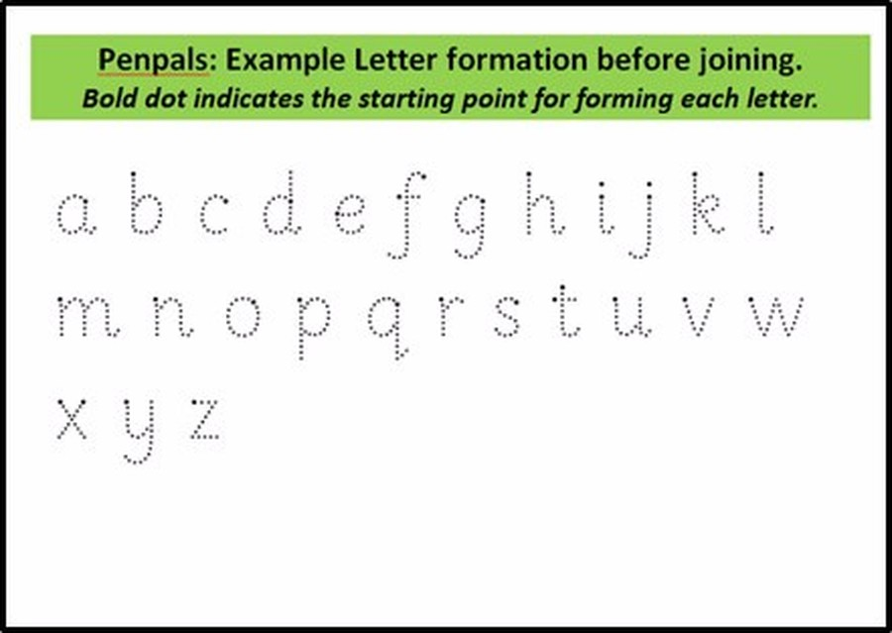

Example letter formation for joining:

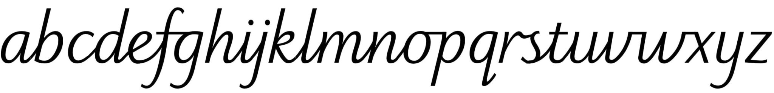

3. Legislation and guidance
This policy reflects the requirements for academies to provide a broad and balanced curriculum as per the Academies Act 2010, and the National Curriculum programmes of study, which the school has chosen to follow.
It also reflects requirements for inclusion and equality as set out in the Special Educational Needs and Disability Code of Practice 2014 and Equality Act 2010, and refers to curriculum-related expectations of governing boards set out in the Department for Education’s Governance Handbook.
It complies with our funding agreement and articles of association.
In addition, this policy acknowledges the requirements for promoting the learning and development of children set out in the Early Years Foundation Stage (EYFS) statutory framework.

4. Roles and responsibilities
4.1 The Local Advisory Board.
The Local Advisory Board will monitor the effectiveness of this policy and hold the Head of School to account for its implementation.
The Local Advisory Board will also ensure that:
- A robust framework is in place for setting curriculum priorities and aspirational targets.
- The school is complying with its funding agreement and teaching a "broad and balanced curriculum" which includes English, maths, and science, and enough teaching time is provided for pupils to cover the requirements of the funding agreement.
- Proper provision is made for pupils with different abilities and needs, including children with special educational needs (SEND).
- The school implements the relevant statutory assessment arrangements.
- It participates actively in decision-making about the breadth and balance of the curriculum.

4.2 Head of School
The Head of School is responsible for ensuring that this policy is adhered to, and that:
- All required elements of the curriculum, and those subjects which the school chooses to offer, have aims and objectives, which reflect the aims of the school and indicate how the needs of individual pupils will be met.
- The amount of time provided for teaching the required elements of the curriculum is adequate and is reviewed.
- The school’s procedures for assessment meet all legal requirements.
- The Local Advisory Board is advised on whole-school targets in order to make informed decisions.
- Proper provision is in place for pupils with different abilities and needs, including children with SEN.

4.3 Other staff
Other staff will ensure that the school curriculum is implemented in accordance with this policy.
Supported by the Curriculum Leader for English, teachers are expected to keep up to date with subject knowledge and use current materials that are available in school. Training needs are identified as a result of whole school monitoring and evaluation, performance management and through induction programmes.
Additional adults who are involved with intervention programmes will receive appropriate training.

5. Organisation

The highest priority is given to teaching the correct letter formation before any attempt is made at joining. All children have at least one 30-minute handwriting lesson per week with further ‘short burst’ opportunities to revisit and practise skills.

Key Stage 1:
Children will continue to develop fine and gross motor-skills with a range of multi -sensory activities. Teachers and support staff continue to guide children on correct letter formation using a comfortable tripod pencil grip that allows for efficient control. Through the Penpals scheme children will begin to learn how to join letters in Year 1 and continue to practice this skill throughout Year 2.

Key Stage 2:
Children will continue to have regular practice of handwriting, securing the joins and developing speed and fluency. By the end of Year 6 pupils should have a clear, fluid handwriting style.

Handwriting Feedback and Marking:
This should be timely and relevant. Teaching staff should give immediate feedback during handwriting lessons, modelling correct formation and joins in children’s books before giving opportunity for the pupil to practise.

Assessment and Progress over time:
On-going assessment in handwriting gives you the chance to spot errors or inconsistencies that are likely to impede a fast, fluent handwriting style. For children in KS1 there is a beginning of year assessment (in Penpals teacher handbook) which assesses the previous year’s work and gives an indication of what needs to be consolidated before beginning new work. Teachers in KS1 can use these at the start of the academic year.
From Yr3 onwards the final unit in each book can be used as the basis of a summative assessment. Teachers can make a summative assessment of children by answering these questions in relation to the end of year expectations for their year group:

− Are all letters formed correctly?
− Are letters consistently sized?
− Are the known joins used?
− Are the known joins used correctly?
− Are ascenders and descenders parallel?
− Are the spaces within and between words regular?
− Is good handwriting carried over into other areas of the curriculum?
− What are the next handwriting targets for this child?

6. Planning

A weekly handwriting lesson needs to be planned into the timetable of each class.
Each Year group has a Penpals Teaching Handbook which lists the letters and joins to be taught or practised.
Each class also has access to whole class interactive lessons. Here, the children have an opportunity to practise fine and gross motor skills and watch how letters and joins are formed.

7. Assessment

8. Inclusion and accessibility
Teachers will plan lessons so that pupils with SEN and/or disabilities can study every National Curriculum subject, wherever possible, and ensure that there are no barriers to every pupil achieving.
Teachers will also take account of the needs of pupils whose first language is not English. Lessons will be planned so that teaching opportunities help pupils to develop their English, and to support pupils to take part in all subjects.
Further information can be found in our statement of equality information and objectives, and in our SEN policy and information report.

Guidance for Left-handers:
Left-handed children (approximately 10% of the population), will not in any way be discouraged from favouring the left-hand in their work. However, special rules apply for left-handers. They should sit on the left-hand side of double desks or tables. They must be able to rest their left forearms on the edge of the desk. The book or paper must slope in line with the left forearm. As writing is completed down the page, the paper must be moved away from the body in the same line. The aim is to keep the left arm in much the same position at all times to avoid the elbow being cramped by the chest. Moving the paper away from the body prevents writing becoming cramped at the foot of the page. Practise on a vertical board could help this position. The right hand must be used to control the movement of the page. The left hand should end up below the line of writing to avoid smudging and to give a clear view of what is being written. Children should be discouraged from hooking their left hand above the line of writing to avoid smudging. The tripod grip (thumb and first finger grip the pencil, which then rests on the side of the second finger) should be encouraged.

The vast majority of children are able to learn to write legibly and fluently. However, some children may need more support. Children who are not yet ready to write are provided with a range of pre-writing activities (see Foundation 1 and Foundation 2 Penpals teacher handbooks). Further intervention may be arranged with specialist advice from the SENCo and the Occupational Therapist who may provide targeted support for individual children. Additional resources will be provided by the SENCO where deemed necessary such as sloping surfaces, special seat cushions and pencil grips.

ACCESSIBILITY:
At Shavington Primary School, we are committed to providing an accessible environment which values and includes all pupils, staff, parents and visitors, regardless of their education, physical, sensory, social, spiritual, emotional and cultural needs. We are committed to challenging negative attitudes about disability and accessibility to develop a culture of awareness, tolerance and inclusion.
9. Monitoring arrangements
At Shavington Primary School, the Local Advisory Board monitor whether the school is complying with its funding agreement and teaching a “broad and balanced curriculum” which includes the required subjects, through:
- Organised visits from members of the LAB
- Meetings with staff to discuss areas of the curriculum.
- Analysis of whole school data.

The English Subject Co-ordinator monitors the way Handwriting is taught throughout the school by:
- Book Looks.
- Learning walks.
- Analysis of whole school data.
The English co-ordinator also has responsibility for monitoring the way in which resources are stored and managed.
The Head of School will review this policy. At every review, the policy will be shared with the Local Advisory board.

10. Links with other policies
This policy links to the following policies and procedures:
- EYFS policy
- Assessment policy
- SEN policy and information report (Including Pupil Premium)
- Equality information and objectives
- Phonics policy
- English policy

