**Shavington Primary School**

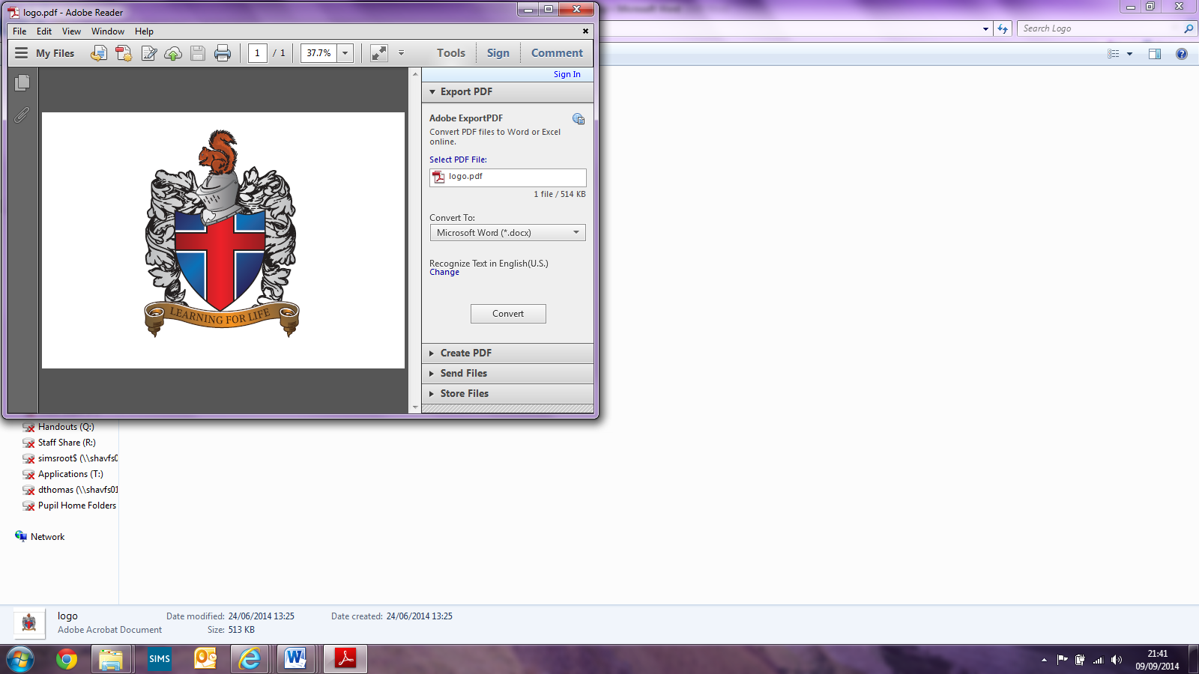

**Modern Foreign Languages Policy**

Written by Mr J Hazeldine (MFL Lead)

Reviewed: January 2022

Signed: Jack Hazeldine (MFL Leader)

Signed: (Principal)

Signed: (LAB Chair)

**Introduction & Aim of this Policy**

We believe that a Modern Foreign Language prepares pupils to participate in a rapidly changing world in which work and other activities are often carried out in languages other than English. The rise of international commerce means that pupils need to be equipped with the skills needed by the international workplace. The choice of which language to teach is secondary to the lifelong language learning skills that the pupils will be encouraged to develop. Skills that they will be able access in the future will help them to learn new languages or to improve their competence in an existing language. Increased capability in the use of MFL promotes initiative, confidence and independent learning and encourages diversity within society.

Foreign language learning has now become part of the National Curriculum from Key Stage 2 onwards. However, Shavington recognises the value of providing age appropriate language learning opportunities throughout school. The focus of language taught in Key Stage One is done by learning through songs, games and some supporting activities and then develops further into Key Stage Two following planning from the ‘Primary Languages Network’.

1. **Aims & objectives**

French is the modern foreign language that is taught throughout our school. However, we also offer the opportunity for children to experience other languages by celebrating the European Day of languages each year, where staff and children are encouraged to learn a different language with their class as a shared experience.

The national curriculum for languages aims to ensure that all pupils:

* understand and respond to spoken and written language from a variety of authentic sources
* speak with increasing confidence, fluency and spontaneity, finding ways of communicating what they want to say, including through discussion and asking questions, and continually improving the accuracy of their pronunciation and intonation
* can write at varying length, for different purposes and audiences, using the variety of grammatical structures that they have learnt
* discover and develop an appreciation of a range of writing in the language studied

We also teach the children to know and understand how to:

* ask and answer questions
* use correct punctuation and intonation
* memorise words
* interpret meaning
* understand basic grammar
* use dictionaries
* use online learning tools and websites
* work in pairs and groups, attempting to use the learned language.
* look at life in another culture.

Learning another language presents opportunities for the reinforcement of knowledge, skills and understanding developed in other curriculum areas.   These opportunities can be enhanced through aspects of:

**English:** development of speaking and listening skills, knowledge and understanding of grammar and sentence construction.

**ICT:** Online communication with schools abroad, materials from the internet and satellite television, video and audio, presentation of data.

**PSCHE:** the multilingual society, knowledge of other countries and cultures.

**Maths:** counting, the time and the date, money.

**Geography:** work relating to the study of other countries, weather.

**Science**: work on parts of the body, animals, and names of planets.

**Music:** rhyming, rhythm, singing, composition, world music.

**RE:** international or multicultural work, celebration of festivals, storytelling, calendars, customs.

**History:** family trees of the children.

**Art:** look at painting/artists.

**PE:** physical responses to the teacher's instructions issued in the language being learnt.

(dependent on areas of learning for that specific year group on the school LTP)

1. **3 I’s**

**Intent**

Here at Shavington Primary, we learn French as our Modern Foreign Language. We aim for children to foster an enthusiastic and positive attitude towards learning an additional language. Children are taught not only to speak French, but also enhance their reading and listening skills too. By giving pupils the confidence to develop their skills, it will allow them to engage in an understanding of linguistics and the nations that use this language.

Our curriculum is designed to manifest a life-long love of language learning, in order to support their understanding of our multi-linguistic world. Children are not only taught the basics of a conversation, but also the structure of sentences, the use of masculine and feminine verb forms and how to engage in listening to instructions or information in non-native dialect.

By teaching the fundamentals of French speaking, listening and writing, we feel we prepare our learners ready for life after Shavington Primary in their secondary settings, and hope that this basis will encourage them to pursue this further than KS3.

**Implementation**

During their time at Shavington, pupils are taught using a variety of different activities that allow our learners to understand that getting things wrong helps us to learn. By showing resilience and self-belief, children can overcome barriers that will help them to succeed when learning a new language. Following a curriculum re-launch, our learners are working at an appropriate level to ensure gaps in learning are addressed before moving onto more complex vocabulary and language concepts.

We use the Primary Languages Network to deliver high-quality French lessons in class. The resources aim to support not only our pupils, but also our staff who are not usually language specialists. Primary Languages Network, allows our teachers to teach interactively, have the opportunity to practice conversationally and make use of videos of native speakers to support pronunciation and accent. Primary Languages Network has given our teachers and pupil’s confidence to speak another language and our teachers to support the children’s language-learning at home. Teachers are also able to find resources from a variety of places to further support learning of new skills or concepts.

Pupils at Shavington can expect to learn the following objectives of the National Curriculum through the use of songs, rhymes, stories, poems and games.

The children will:

* Listen attentively to the spoken language and show understanding by joining in and responding.
* Explore the patterns and sounds of language and link spelling, sound and meaning of words.
* Engage in conversations; ask and answer questions; express opinions and respond to those of others; seek clarification and help.
* Speak in sentences, using familiar vocabulary, phrases and basic language structures.
* Develop accurate pronunciation and intonation so that others understand when they are reading aloud or using familiar words and phrases.
* Present ideas and information orally to a range of audiences.
* Read carefully and show understanding of words, phrases and simple writing.
* Broaden their vocabulary and develop their ability to understand new words that are introduced into familiar written material, including through using a dictionary.
* Write phrases from memory, and adapt these to create new sentences, express ideas clearly.
* Describe people, places, and things orally and in writing.
* Understand some of the basic grammar in French.

**Impact**

Shavington Primary endeavour to provide our learners with engaging lessons and that all learners are included in their linguistic journey through school.

By passing on their books each year, children and teachers are able to see clear progression and application of skills taught previously. Pupils can focus on persevering during new learning and have courage to challenge and explain their thinking. By using games and song, children are able to recall previous knowledge and allow them to have fun whilst doing so, promoting a love of French.

Children of all abilities and backgrounds strive to achieve success in class work and assessments and prepare our learners to reflect on their knowledge base and feel empowered to continue this in KS3 and beyond.

1. **Organisation**

Each class has a timetabled lesson on a rolling timetable with other foundation subjects throughout the term (KS1) with the frequency of this increasing in KS2 to a weekly delivery of the French units in each year group. French could also be revisited in short sessions throughout the week to consolidate knowledge and ensure new language is retained. French lessons provide a variety of sources to model the language, use games and songs to maximise enjoyment and make as many connections to real life situations as possible. Lessons focus on speaking and listening.

The topics for lessons can be found in the table below (taken from MFL long term plan):

|  |  |
| --- | --- |
| **Year 3:**  Autumn Term 1: A New Start  Autumn Term 2: Calendar and Celebrations  Spring Term 1: Animals I like and don’t like  Spring Term 2: Carnival colours, playground games  Summer Term 1: Breakfast, fruit nouns and a hungry giant  Summer Term 2: Going on a picnic | **Year 4:**  Autumn Term 1: Welcome to school – super learners  Autumn Term 2: My local area, your local area  Spring Term 1: Family tree and faces  Spring Term 2: Celebrating carnival/body parts  Summer Term 1: Feeling unwell/jungle animals  Summer Term 2: Summer time |
| **Year 5:**  Autumn Term 1: My school, my subjects  Autumn Term 2: Time in the city  Spring Term 1: Healthy eating and going to the market  Spring Term 2: Carnival clowns and clothes  Summer Term 1: Out of this world  Summer Term 2: Going to the seaside | **Year 6:**  Autumn Term 1: Everyday life  Autumn Term 2: Where I live, where you live  Spring Term 1: Playing and enjoying sports  Spring Term 2: This is me, hobbies and fun  Summer Term 1: Café culture, restaurants  Summer Term 2: Performance Time. |

1. **Resources**

Short, medium & long term planning is available from Primary Languages Network, we use their teaching package, resources and virtual learning environment to deliver our languages lessons.

1. **Staff development**

Teachers and staff are offered CPD opportunities when appropriate CPD becomes available. The languages subject leader will identify relevant CPD opportunities to improve subject knowledge and teaching practices.

1. **Assessment**

Most assessment is formative during lessons through questioning and oral feedback and is used to support teaching and learning and inform future planning. Assessments are based on observation of children working on different oral activities and (where appropriate) written product. Puzzle it out assessments are delivered at the end of a unit for each child to practice their reading, writing and understanding of the unit content. The Subject Leader monitors the effectiveness of the procedures implemented regularly in line with the school’s monitoring calendar.

Work can be viewed by looking in the children’s French books. Each child has a French book which is created in Year 3 and follows the children through each year of school.

1. **Monitoring**

The MFL subject leader will discuss lessons and teaching with members of staff on a termly basis. Findings will then be collated and discussed with management, with whole school targets shared with staff to implement in the following term. Some lesson observations may be carried out for purposes of professional development, teaching & learning in line with the whole school monitoring timetable.

**8. Inclusion**

All KS2 pupils shall have the opportunity to develop MFL capability. The school promotes equal opportunities and fairness of distribution of MFL resources. Children with other languages at home are encouraged to use them for educational benefit our families are offered advice about what is appropriate. Efforts are made to ensure that languages used at home are highlighted in the classroom once a teacher has been notified. MFL is, however, a highly inclusive subject and although the principal aim of the teaching is to develop children’s knowledge, skills and understanding, there is also an emphasis on enjoyment.

"We are committed to providing an accessible environment which values and includes all pupils, staff, parents, carers and visitors regardless of their education, physical, sensory, social, spiritual, emotional and cultural needs.   We are committed to challenging negative attitudes about disability and accessibility to develop a culture of awareness, tolerance and inclusion".

**9. Links outside school**

French gives us an ideal opportunity for making links outside school. We encourage children to share their experiences of visiting or living in other countries. We welcome visiting speakers who are able to talk about life in the countries where the focus language is spoken. We have formed a relationship with a school from Penistone and our children are writing to their children. We are currently forming a relationship with a school in France to start communications.

**10. Review**

This policy will be reviewed by the MFL leader