**Shavington Primary School**

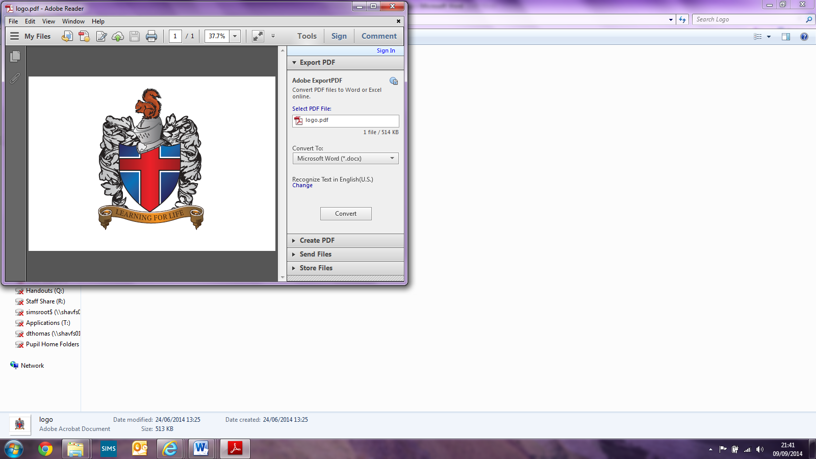

**Early Years Policy**

Written by Sally Earl (EYFS Senior Leader)

Updated: July 2021

Signed: (Principal)

Signed:_________________________ (Subject Leader)

Signed: _________________________(LAB Chair)

**Shavington Primary School**

**Early Years Policy**

**Contents**

1. Aims……………………………………………………………………………………………………………2

2. Legislation……………………………………………………………………………………………………2

3. Structure of the EYFS…………………………………………………………………………………...3

4. Curriculum……………………………………………………………………………………………..…….4

5. Assessment………………………………………………………………………………………….……...6

6. Working with parents………………………………………………………………………..…………7

7. Safeguarding and welfare procedures…………………………………………………………..8

8. Accessibility……………………………………………………………………………………….………...9

9. Monitoring arrangements …..............................................................................9

Appendix 1. List of statutory policies and procedures for the EYFS………………..….9

# 1. Aims

This policy aims to ensure:

* That children access a broad and balanced curriculum that gives them the broad range of knowledge and skills needed for good progress through school and life
* Quality and consistency in teaching and learning so that every child makes good progress and no child gets left behind
* Close partnership working between staff and parents and/or carers
* Every child is included and supported through equality of opportunity and anti-discriminatory practice

# 2. Legislation

This policy is based on requirements set out in the [2021 statutory framework for the Early Years Foundation Stage (EYFS).](https://www.gov.uk/government/uploads/system/uploads/attachment_data/file/596629/EYFS_STATUTORY_FRAMEWORK_2017.pdf)

# 

# 3. Structure of the EYFS

The Early Years foundation Stage applies to all children from birth to 5 years. At Shavington Primary School, this refers to children in our Nursery and Reception classes.

We have a maintained Nursery class for children aged 3 until the academic year in which they turn 5. The Nursery class is staffed by a qualified teacher and supported by teaching assistants with relevant qualifications and experience in supporting the learning of young children. Children in our Nursery class can attend either 5 mornings a week, 5 afternoons or 5 full days.

All children are entitled to 15 hours a week (equivalent to 5 x 3 hour sessions) funded by Cheshire East LA starting the term after they turn 3. We have opted to offer the 30 hours childcare as funded by the Government for those families who meet the relevant criteria. Parents/ carers must apply on the government website and provide their funding code to us for verification. The 30 funded hours may be spread over the 39 weeks of our academic year.

A cost is charged to parents/ carers who access more than the 15/30 funded hours each week, as well as for lunch, before and afterschool clubs. There will also be a cost for children who are 3 but not yet are able to access the funding. Please see our Charging policy.

Children who turn 5 in the academic year (September- August) attend our Reception Class. It is a large, open plan and well-resourced room where children work in classes, small groups, or individually. Children will work with a number of staff at different points of the day and have access to child initiated play inside and outside.

The Nursery and Reception classes work closely together to meet the needs of all children. There may be times when a child’s needs are best met through spending part of the day in each classroom or joining the other class for phonics sessions etc. Sharing the care of children between the classes will be discussed with parents/carers and the impact and progress monitored carefully.

# 4. Curriculum

Our Nursery and Reception classes follow the curriculum as outlined in the 2021 statutory framework of the EYFS. We also use the non-statutory guidance given in Development Matters (July 2021) to help guide our practice and inform our assessment.

The EYFS framework includes 7 areas of learning and development that are equally important and inter-connected. However, 3 areas known as the prime areas are seen as particularly important for igniting curiosity and enthusiasm for learning, and for building children’s capacity to learn, form relationships and thrive.

**The Prime Areas are:**

* **Communication and Language**

Listening, Attention and Understanding

Speaking

* **Personal, Social and Emotional Development**

Self-Regulation

Managing Self

Building Relationships

* **Physical Development**

Gross Motor

Fine Motor

**The specific areas:**

* **Literacy**

Comprehension

Word Reading

Writing

* **Mathematics**

Numbers

Numerical Patterns

* **Understanding the World**

People, Culture and Communities

The Natural World

* **Expressive Arts and Design**

Creating with Materials

Being Imaginative and Expressive

The Early Years Framework also provides a set of Characteristics of Effective Teaching and Learning that should be used to provide pupils with experiences that allow them to develop strong learning skills. The Characteristics of Effective Learning detail the ways in which children should be learning from their environment, experiences and activities.

**Characteristics of Effective Learning:**

**Playing and Exploring**

Finding out and exploring

Playing with what they know

Being willing to ‘have a go.’

**Active learning**

Being involved and concentrating

Keeping trying

Enjoying achieving what they set out to do

**Creating and Thinking Critically**

Having their own ideas

Making links

Choosing ways to do things

At Shavington Primary School we associate these characteristics of teaching learning with our Building Learning Power animals:



* The ant that encourages us to work with and learn from others.
* The rhino that encourages us to be resilient and learn from our mistakes.
* The beaver who encourages to develop and use a range of resources and approaches to help us.
* The tortoise who teaches us to be reflective and think about what helps us to learn.

**4.1 Planning**

Staff plans activities and experiences for children that enable them to develop and learn effectively.

Staff also take into account the individual needs, interests, and stage of development of each child in their care, and use this information to plan a challenging and enjoyable experience. Observations of the children’s interests, questions, play and prior learning are used to structure future planning. Plans are annotated and children’s initials are added so that a link between needs and interests and next step learning is clear.

Planning is completed for different parts of the day, areas of the classroom and for specific taught lessons. Plans follow our school guidelines and may be completed by teachers or teaching assistants who work with those children.

Where a child may have a special educational need or disability, staff consider whether specialist support is required, linking with relevant services from other agencies, where appropriate. See Inclusion and Equal Opportunities policies.

**4.2 Teaching**

Each area of learning and development is implemented through planned, purposeful play, and through a mix of adult-led and child-initiated activities. Practitioners respond to each child’s emerging needs and interests, guiding their development through warm, positive interaction. Children have opportunities to direct their own learning through choosing where, how and with whom they play. They are supported through a well-resourced environment and staff that can interact skilfully to challenge and develop children’s skills.

The children have access to indoor and outdoor provisions. Each will have resources, opportunities and adult initiated activities to support each of the areas of learning.

At certain parts of the day children will be taught as a whole class, a small group or individually. Children may be taught by a variety of familiar adults through out the day. Teaching in the early years is play based, interactive, multi sensory and fun! There is a strong emphasise on the children trying, persevering and being active learners.

As children grow older, and as their development allows, the balance gradually shifts towards more adult-led activities to help children prepare for more formal learning, ready for year 1.

# 5. Assessment

At Shavington Primary School, on-going formative assessment is an integral part of the learning processes. Staff observe pupils to identify their level of achievement, interests and learning styles. Observations are made continuously on their play, speech, behaviour and work to carefully assess their next developmental needs. These observations are used to shape future planning. Practitioners also take into account observations shared by parents and/or carers.

We sometimes choose to record and share these observations using software called Tapestry. These online Learning Journeys allow all staff working with children to contribute to and allow parents to both see and make their own contributions. Not all observations are recorded, some maybe shared between staff informally or recorded as annotations on plans or children’s work. Tapestry is used to record new learning and something that is special or remarkable for that child.

When pupils start nursery or reception, staff take time to watch, observe and get to know them. All staff contribute to this on ‘on entry’ informal assessment and will share what they notice about a child’s interests, fascinations, abilities and needs. This information is used to inform planning and provision.

Pupils starting Reception will undertake the statutory reception baseline assessment with in the first 6 weeks of the autumn term. The 2 parts of the assessment: literacy, communication and language and mathematics, can be sat at/delivered the same time or separately depending on the pupil’s ability to concentrate and will be administered by someone known to the child.

Summative assessments are made 3 times are year to make judgements on a child’s development. Their development and learning will be assessed as being either on track or not on track. These judgements will be based up on our professional opinion, knowledge of child development and with reference to our curriculum model. Pupils identified as being not on track may benefit from specific interventions or targeted support in order to close gaps and accelerate progress. Assessment information is also analysed to help us identify areas of learning or specific groups of children who need different approach or additional resources.

Judgements and assessments are discussed and moderated internally between staff and with other early years staff in school across our MAT.

At the end of the EYFS Summer term in Reception staff complete the EYFS profile for each child. Pupils are assessed against the 17 early learning goals, indicating whether they have met the goals or not.

The profile reflects ongoing observations and discussions with parents and/or carers. The results of the profile are then shared with parents and/or carers and year 1 staff following the guidelines of the Reporting and Assessment Arrangements document.

Once the Early Years profile has been completed and submitted to the DFE, a small sample of the cohort’s online learning journeys will be kept to serve as evidence and to help future moderation and consistency of standards. However, most pupil’s online learning journeys, Tapestry accounts, will be closed and deleted as the children will move on to be assessed using tools and materials appropriate to the National Curriculum objectives. Although we allow parents to access their child’s learning journey at any time during their time in Nursery and Reception, we do not create digital or paper copes for them to keep. This is to ensure the safeguarding of all pupils and is in line with our e-safety and confidentiality procedures. Before being given access to their child’s learning Journey, parents must sign an agreement stating that they understand and will follow our guidelines.

# 6. Working with Parents

We recognise that children learn and develop well when there is a strong partnership between practitioners and parents and/or carers.

We have strong induction and transitions arrangements that build a positive relationship with parents and help children to settle quickly. We encourage parents to talk to us regarding any questions or concerns they have about their child.

Parents are invited to look at the child’s online learning Journey and to make contributions of achievements and special times at home. We also invite and include parents in celebrating their children achievements throughout the year with events such as Christmas Nativity, Class Assemblies, Homework Celebration afternoons etc.

We support parents by holding Information evenings before their child joins our Nursery and Reception Classes. They are also invited to subject specific workshops designed to help them to support their child. For example; phonics workshops, maths evenings etc.

Half termly, parents/ carers and other family members are invited to Stay and Play Sessions where they can come into class, play alongside their child, look at their work, meet their friends and chat to staff.

Any concerns regarding a child’s learning or development are discussed with parents throughout the year and at termly parents evenings.

Parents and/or carers are kept up to date with their child’s progress and development. The EYFS profile helps to provide parents and/or carers with a well-rounded picture of their child’s knowledge, understanding and abilities.

# 7. Safeguarding and Welfare Procedures

Our safeguarding and welfare procedures are outlined in our safeguarding policy. Please also see our Medication policy.

# 8. Accessibility

We are committed to providing an accessible environment which values and includes all pupils, staff, parents an visitors regardless of their education, physical, sensory, social, spiritual, emotional and cultural needs.   We are committed to challenging negative attitudes about disability and accessibility to develop a culture of awareness, tolerance and inclusion.

# 9. Monitoring Arrangements

This policy will be reviewed and approved by Sally Earl, Early Years Leader every 3 years.

At every review, the policy will be shared with the LAB (Local Advisory Board).

# Appendix 1. List of statutory policies and procedures for the EYFS

This checklist lists the policies and procedures that we must have according the EYFS statutory framework.

|  |  |
| --- | --- |
| Statutory policy or procedure for the EYFS | Where can it be found? |
| Safeguarding policy and procedures | See child protection and safeguarding policy |
| Procedure for responding to illness | See health and safety policy and medication policy. |
| Administering medicines policy | See Medication policy |
| Emergency evacuation procedure | See health and safety policy |
| Procedure for checking the identity of visitors | See safeguarding policy |
| Procedures for a parent failing to collect a child and for missing children | See safeguarding policy |
| Procedure for dealing with concerns and complaints | See complaints policy |

**Next Review: September 2023**