**Examples of activity sheets – second session of learning a new sound**

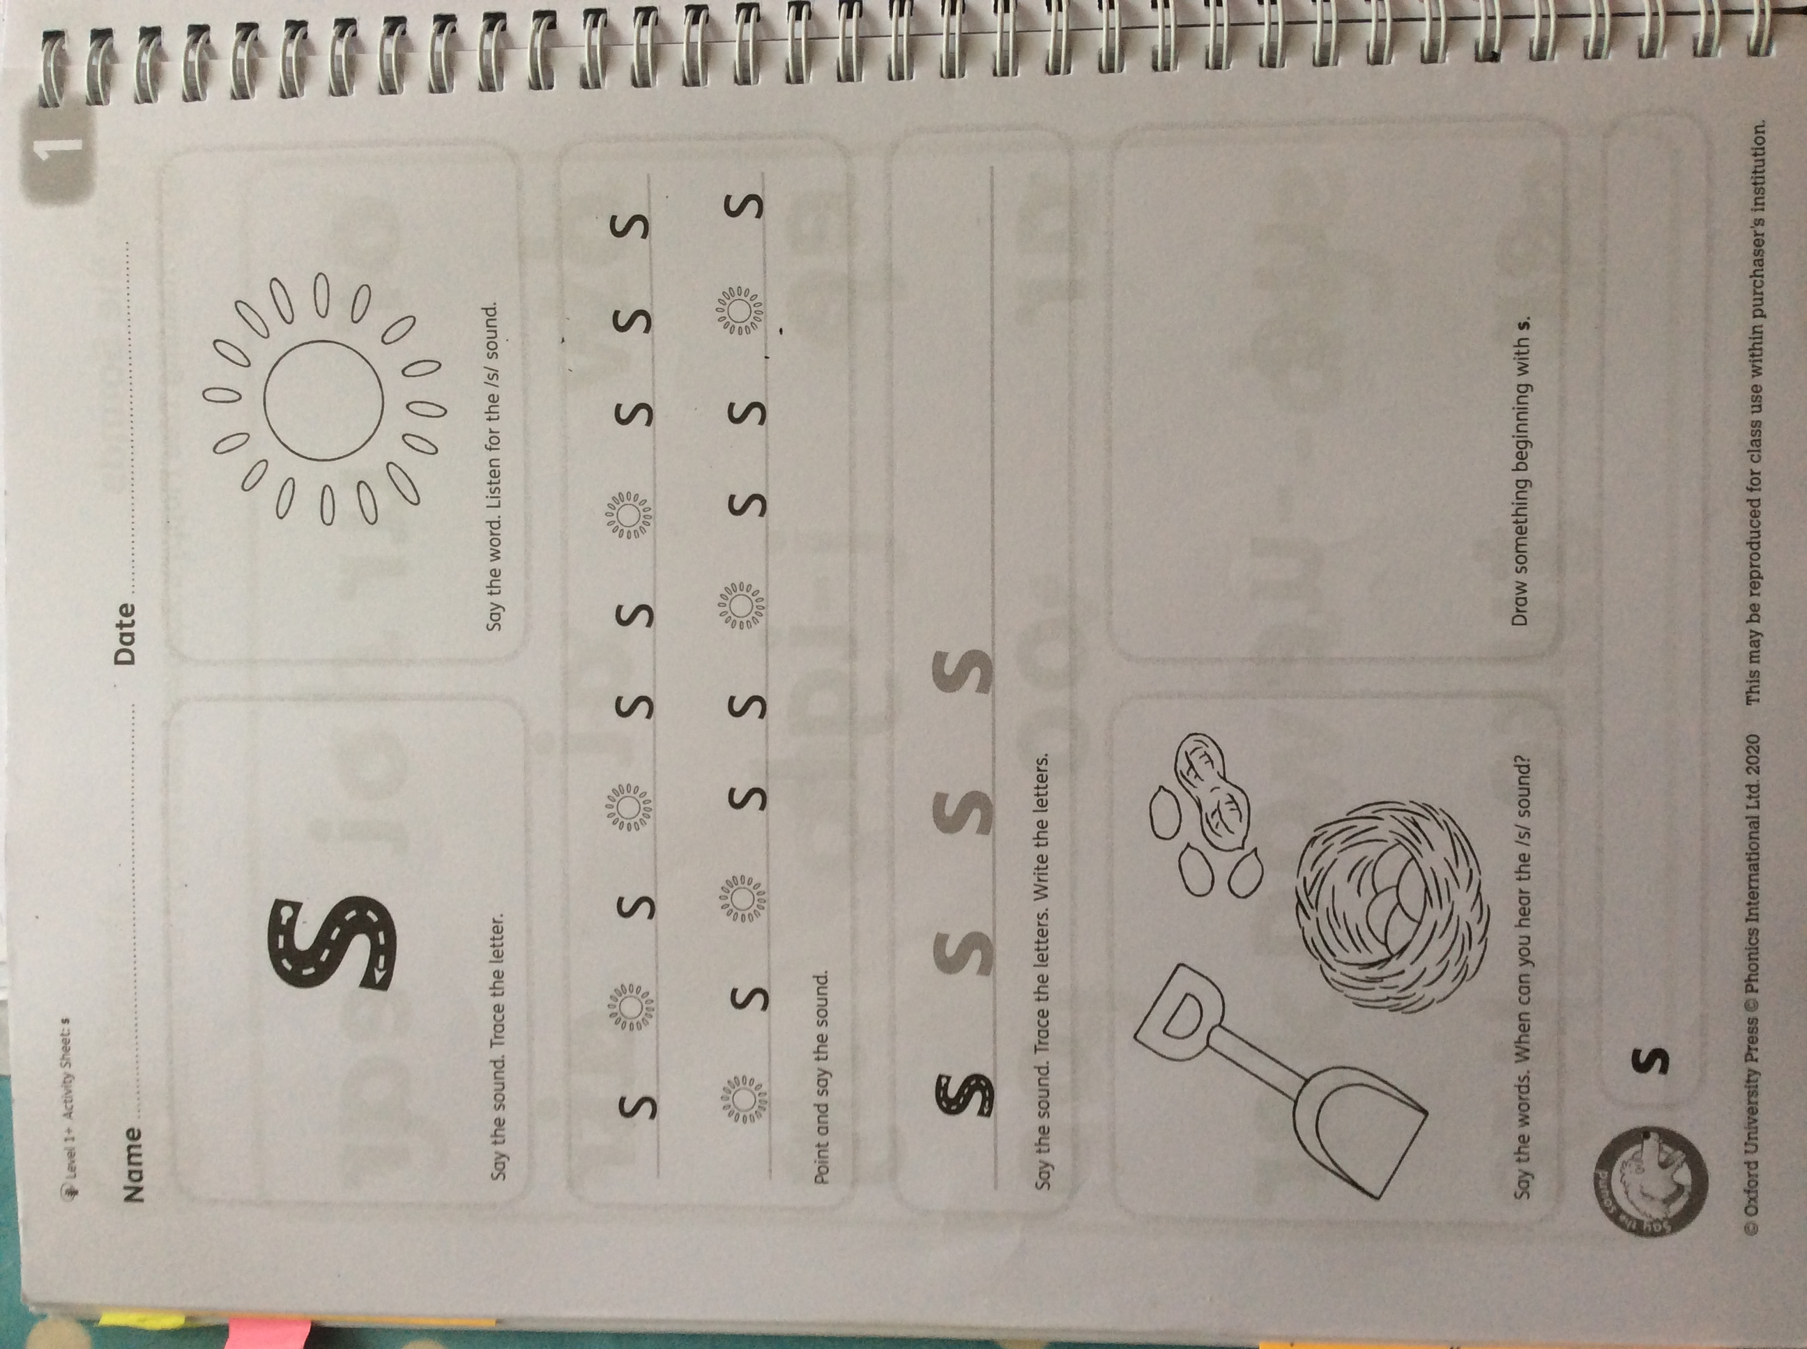

As children come into reception and they learn a new sound they associate the picture with the sound and look carefully at their letter formation.

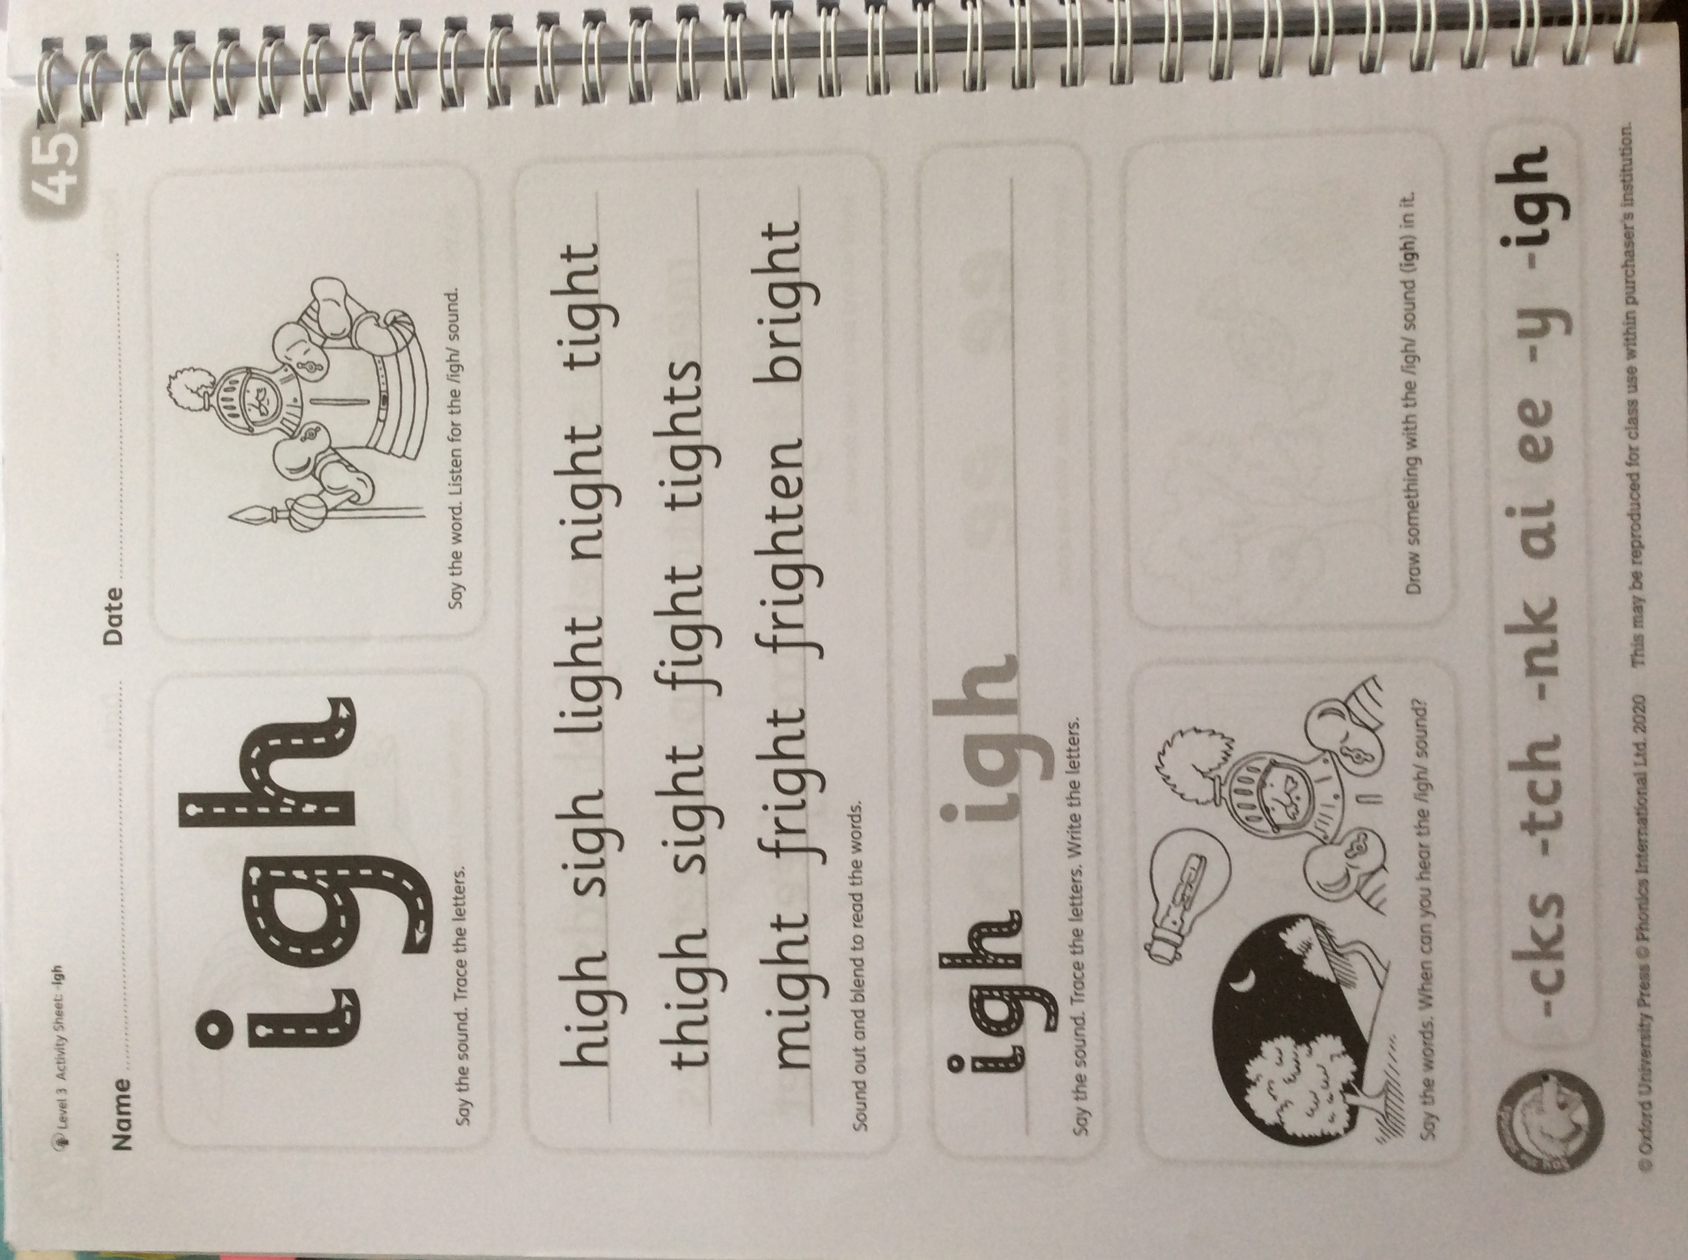

As they progress in their phonic journey they will be introduced to digraphs (2 letters for a sound) and trigraphs (3 letters for a sound) they continue to associate the sound with a picture. By this point they have become much more confident in blending sounds together and they are able to read words as well as identify words that they can read but that they don’t understand, thus generating their questioning skills and increasing their vocabulary. They can also transfer their reading skills into successful spelling strategies, using their fingers to count the sounds that they hear in a word.

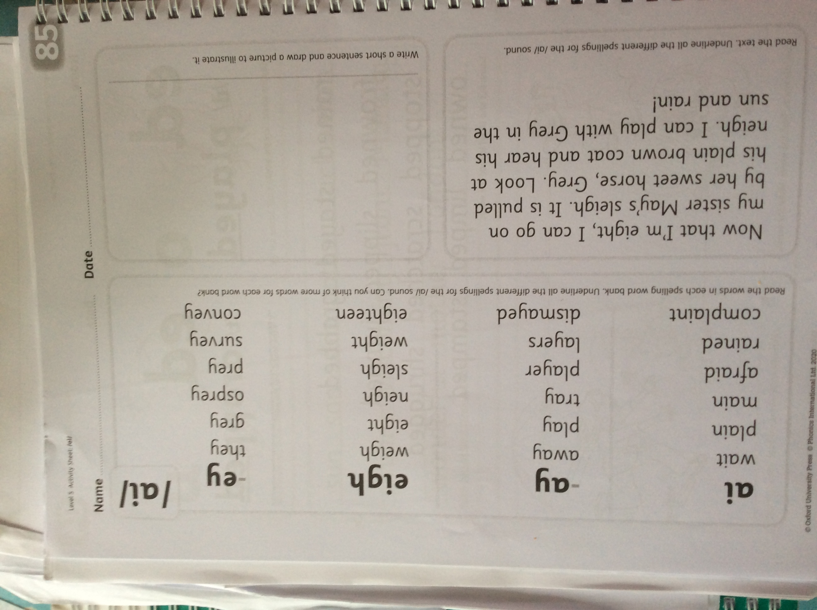

When children have become confident with the key sounds to support their reading they start to investigate alternative ways in which letters can make sounds that they know. As they learn alternatives they constantly revisit the sounds that they know so that they are confident and they can link known and alternatives together.