**Shavington Primary School**

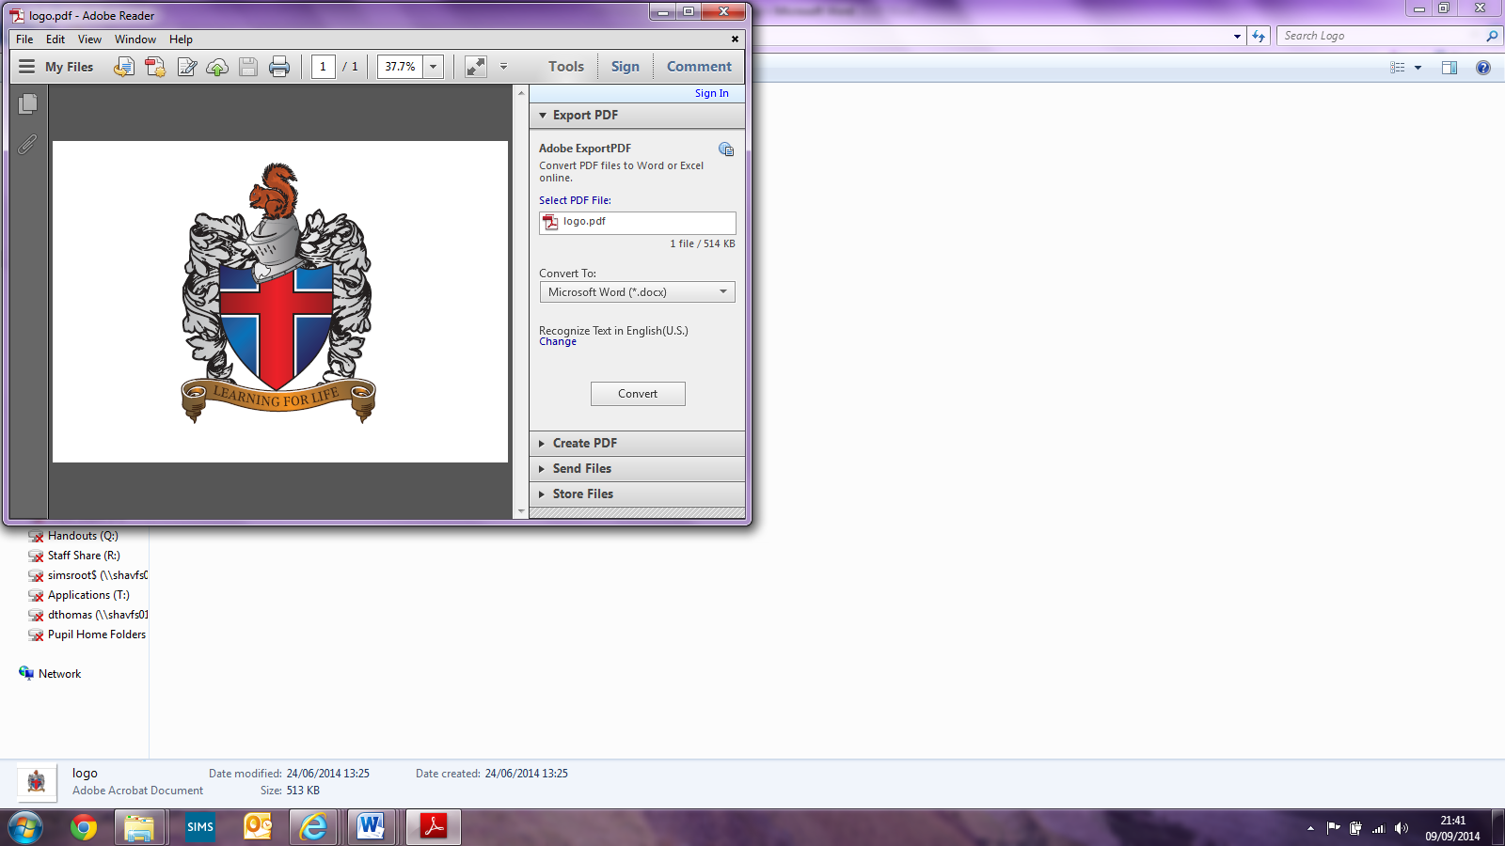

**Music Policy**

Written by Music (Shavington Primary School)

Implemented: December 2020

Reviewed: September 2023

To be Reviewed: June 2024

Signed: _________________________(Headteacher)

Signed:_________________________ (Subject Leader)

Signed: _________________________(LAB Chair)

**Shavington Primary School Music Policy**

**Intent**

Music is a unique way of communicating that can inspire and motivate children. We aim to provide opportunities for all children to create, play, perform and enjoy music, to develop the skills to appreciate a wide variety of musical forms, and to begin to make judgements about the quality of music. At Shavington Primary School, we see music as a practical and creative expression of ideas, thoughts and feelings. We are passionate about providing opportunities using music to promote children’s spiritual, moral, social and cultural development.

At Shavington Primary school our aims of music teaching are to enable all children to:

• perform, listen to, review and evaluate music across a range of historical periods, genres, styles and traditions, including the works of the great composers and musicians

• learn to sing and use their voices

• have the opportunity to learn to play a musical instrument

• to use technology appropriately

• to create and compose music on their own and with others

• understand and explore how music is created

**Implementation**

We encourage children to participate in a variety of musical activities. We provide opportunities for all children to sing and to listen to and appreciate different styles and genres of music. We teach them the skills of recognising, commenting and reflecting on pulse, pitch, rhythm, timbre, dynamics and texture in music. Children work collaboratively with others to make music and show how individuals compose and organise music. We also begin to teach children to explore some of the features of musical notation and to develop an understanding of the history of music.

As well as music lessons in class, children in Year 5 are given the chance to learn to play a brass instrument during the Autumn term which they can continue for another two terms. All children are offered the opportunity to learn to play an instrument with peripatetic music teachers. Peripatetic music teaching is provided by ‘Music for life’, ‘Rock Steady’ and ‘Love Music Trust’. Our school uses the National Curriculum for music as the basis for its curriculum planning, using both the Model Music Curriculum and the National Plan for Music Education too. This is done by by accessing the scheme of work from Love Music Trust and have continual access to their expertise. Music is often taught and used within other areas of the curriculum, and to support and enhance the work done within the topics planned.

**Impact**

At Shavington Primary School, we aim to provide high quality teaching of Music to ensure that we encourage children to be confident in their skills, ensuring progression through the school.

By the end of their time at Shavington Primary School, we ensure that children are able to:

* Enhance their musical knowledge and develop their musical awareness, eventually being able to perform with confidence and enjoyment.
* Explore musicians and develop an appreciation for a variety of musical styles.
* Practise and play a wide variety of instruments.
* Leave school with an understanding of notation and be able to create their own pieces of music.
* To build their sense of selves by working collaboratively, with perseverance and resilience.
* To create a foundation for a love of music that can be continued into high school and beyond.

**Aims and objectives**

The aims of music teaching are to enable all children to:

* develop a lifelong enjoyment of music of all kinds, both as a listener and a participant
* develop the capacity to understand and express ideas and feelings through the medium of music
* develop the ability to work constructively as a member of a group using skills of leadership, discussions, negotiation and the blending of different peoples’ ideas
* develop an awareness of musical heritage, traditions and developments in a variety of cultures and societies

**Teaching and learning style**

We aim to make music an enjoyable learning experience and encourage children to participate in a variety of musical activities.

* We provide opportunities for all children to sing and to listen to and appreciate different styles and genres of music.
* We teach them the skills of recognising and commenting on pulse, pitch, rhythm, timbre, dynamics and texture in music.
* We provide opportunities for children to work with others to make music and show how individuals compose and organise music.
* We also begin to teach them some of the features of musical notation and to develop an understanding of the history of music.

**Additional music teaching**

As well as music lessons in class, children are offered the opportunity to learn to play an instrument with peripatetic music teachers. Peripatetic music teaching is provided by ‘Music for life’ , ‘Love Music Trust’ and ‘Rocksteady’. For the ‘Music for Life’ parents who want their children to participate in the scheme can purchase or hire the instrument and pay the additional music lesson fees on a termly basis. These lessons are normally taught to small groups of children or individuals who have chosen to learn one of a variety of instruments, such as the guitar and piano. ‘Rocksteady’ provide the instruments and a band leader who teaches each child in a group/band to play an instrument which they choose, keyboard, guitar, drums or voice. Parents arrange this through ‘Rocksteady’ and pay directly to them. Each band learns one song per term and play this in an end of term concert to their parents and the rest of the school. This is in addition to the normal music teaching of the school, but usually takes place during curriculum time or lunchtime. ‘Love Music Trust’ provide whole class teaching of either a trombone or trumpet for a term to Year 5 pupils. They play in a concert to parents at the end of their period of lessons. The pupils can continue this for another 2 terms in if they choose to do so.

**Music curriculum planning**

Our school uses the National Curriculum for music as the basis for its curriculum planning, using both the Model Music Curriculum and the National Plan for Music Education too. We use the scheme of work from Love Music Trust and have continual access to their expertise. Music is often taught and used within other areas of the curriculum, and to support and enhance the work done within the topics planned. A wide range of resources are available to support music teaching. We give pupils the opportunity to appreciate a range of high-quality live and recorded music.

**Early Years Foundation Stage**

We teach music in Reception and Nursery classes as an integral part of the topic work covered during the year. In the Early Years Foundation Stage, music contributes to a child’s development in the area of expressive arts and design.

**Resources**  
We keep resources for music in a central store.

**The school choir** (singing group)

We believe that music enriches the lives of people, and so we wish to involve as many children as possible in musical activities. We have a school choir which we encourage all children from Y3-6 to join. The choir meets on a weekly basis and, although its primary aim is to enable children to enjoy singing together, it also performs in public at least once a term. A singing specialist is employed through Love Music Trust to work with the music coordinator on this.

**Assessment and Recording**

Teachers informally assess children’s progress through observation. The observations provide a basis for recording and reporting children’s achievements. Insight is used to record assessments. Additional evidence may be gained during school performances or other relevant events, and may be presented in the form of recordings or photographs. All evidence of photographs or videos/recordings are kept in a year group folder on one drive.

**Music and Inclusion**

At our school we teach music to all children, whatever their ability and individual needs. Music forms part of the school curriculum policy to provide a broad and balanced education to all children. We are committed to providing an accessible environment which values and includes all pupils, staff, parents and visitors regardless of their education, physical, sensory, social, spiritual, emotional and cultural needs.   We are committed to challenging negative attitudes about disability and accessibility to develop a culture of awareness, tolerance and inclusion.

**Role of Music Leader**

The music subject leader is responsible for keeping an overview of the standard of children’s work and for the quality of teaching. The work of the subject leader also involves supporting colleagues, being informed about current developments and providing a strategic lead and direction for the subject in the school.

.