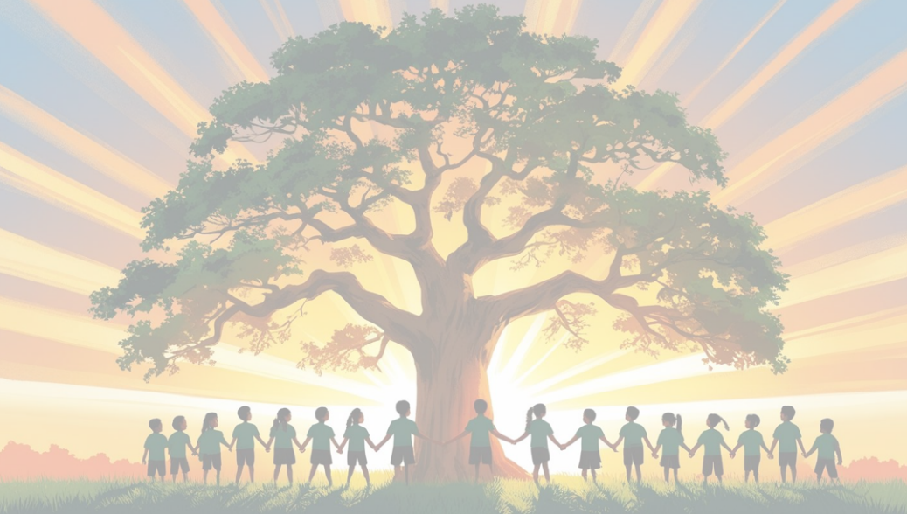
Geography
at
Shaw C of E Primary School
Curriculum Intent
Our intent is to help children understand that geography is about the physical and human features of the Earth and the spatial relationship between them. We want pupils to develop a strong sense of place, wonder and responsibility as they explore the world God created and the people who live within it.
Our curriculum is knowledge‑rich, teaching children about physical and human features, how they are formed and how they change over time. Pupils learn why places are similar or different and how physical and human processes interact at local, regional, national and global scales.
It is also skills‑rich, enabling children to observe, question, compare, map, measure and interpret geographical information. They learn to think like geographers—spotting patterns, making connections and explaining how and why places develop and change.
We nurture curiosity and enquiry, encouraging pupils to ask thoughtful questions about the world, investigate real geographical issues and explore the relationships between people, places and environments. Through discussion, debate and shared thinking, our curriculum is oracy‑rich, helping children speak confidently and respectfully about geographical ideas.
Our approach is rooted in our Christian Values, promoting respect, stewardship, compassion and responsibility as children learn about diverse communities, fragile environments and the impact of human choices on God’s world.
We want pupils to feel confident asking, “How will we be geographers today?”—ready to explore the climate of the UK, understand extreme environments around the world and compare these places with their own.

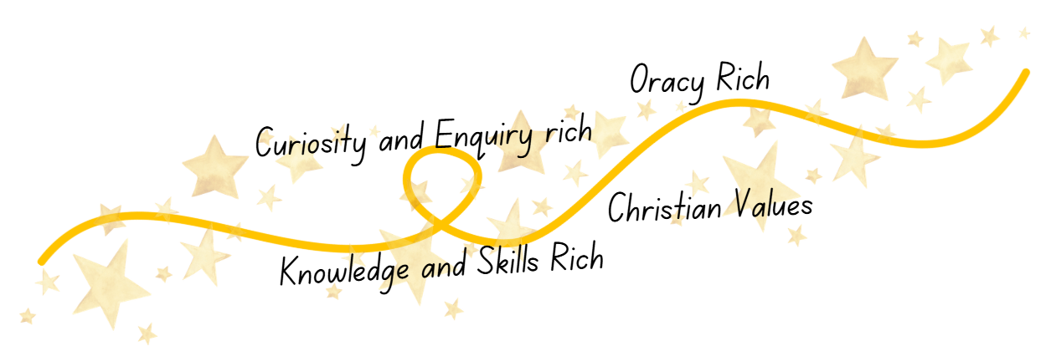
Curriculum Impact
The implementation of this curriculum, ensures that when all children leave our schools, they can:
- Hold a secure, knowledge‑rich understanding of physical and human geography across local, national and global scales.
- Use geographical skills confidently, including mapping, observing, measuring, comparing and interpreting information.
- Speak clearly and confidently about geographical ideas, reflecting our oracy‑rich approach.
- Show curiosity and enquiry, asking thoughtful questions and showing a genuine desire to explore the world.
- Demonstrate our Christian Values when learning about people, places and environments.
- Understand how physical and human features interact and how places develop and change over time.
- Recognise themselves as young geographers, ready to explore the world with open minds, caring hearts and thoughtful questioning.
Curriculum Implementation
At Shaw C of E Primary School, we bring our intent to life through a carefully sequenced curriculum that builds knowledge, skills and understanding year by year. Children learn through:
- Knowledge‑rich teaching that introduces key concepts, vocabulary and facts clearly and revisits them regularly.
- Skills‑rich learning where pupils practise observing, mapping, measuring, comparing and interpreting geographical information.
- Enquiry‑based units driven by big questions that encourage curiosity, investigation and thoughtful conclusions.
- Oracy‑rich experiences such as discussion, debate, storytelling, presentations and shared reasoning.
- Use of maps, atlases, digital tools and fieldwork to help children explore real places and geographical patterns.
- Christian Values woven through learning, encouraging pupils to reflect on stewardship, fairness, compassion and responsibility when studying people and environments.
- Progressive teaching of place knowledge, enabling children to compare the UK with contrasting regions, including extreme environments.
Through this approach, pupils learn to think and behave like geographers—asking questions, exploring evidence and explaining their ideas clearly and respectfully.

