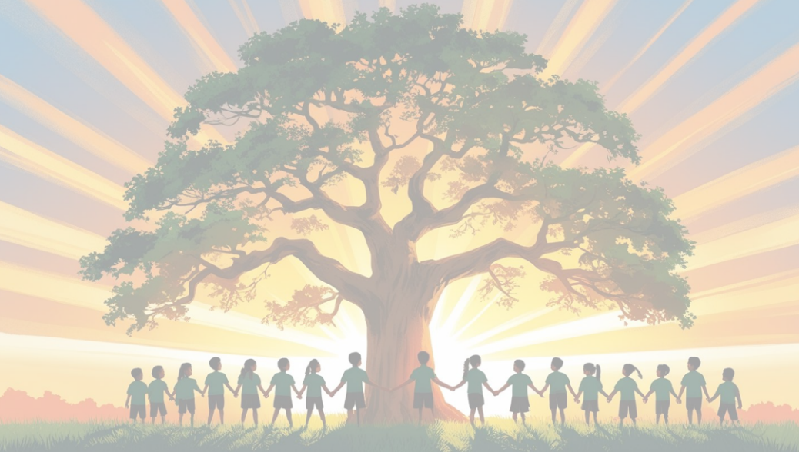
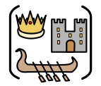
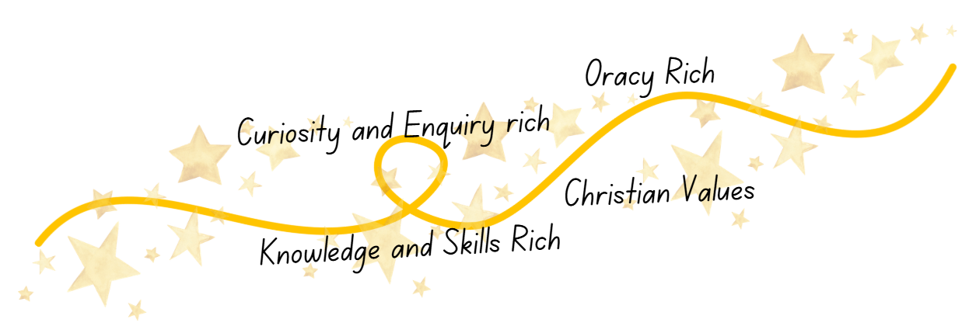
History
at
Shaw C of E Primary School
Curriculum Impact
The implementation of this curriculum, ensures that when all children leave our schools, they can:
- Use historical skills confidently, including questioning evidence, spotting clues, comparing viewpoints, and forming balanced interpretations.
- Children speak about the past with clarity and confidence, reflecting our oracy-rich approach through discussion, debate, and storytelling.
- Demonstrate our Christian Values when learning about the lives, beliefs, and experiences of others.
- Demonstrate strong curiosity and enquiry, asking thoughtful questions and showing a genuine desire to investigate the past.
- Understand that history is constructed from evidence and can explain how historians use sources and artefacts to build interpretations.
Children leave us feeling confident that they are historians, ready to continue exploring the past with open minds and thoughtful questioning.

Curriculum Implementation
At Shaw C of E Primary School, we bring our intent to life through a carefully sequenced curriculum that builds knowledge and skills year by year. Each unit is shaped by an enquiry question that encourages children to investigate, think deeply, and form their own interpretations.
Children learn through:
- Knowledge‑rich teaching, where key facts, vocabulary, and concepts are introduced clearly and revisited regularly.
- Skills‑rich learning, including analysing evidence, identifying cause and consequence, recognising change and continuity, and considering significance.
- Oracy‑rich experiences, such as discussion, debate, storytelling, role play, and presenting ideas to others.
- Curiosity‑driven enquiry, where pupils explore sources and artefacts, ask questions, and draw conclusions like real historians.
- Christian Values woven through learning, helping children reflect on fairness, justice, courage, compassion, and the impact of human choices across history.
Teachers ensure that learning builds progressively, connecting new knowledge to what pupils already know and helping them develop confidence in using historical vocabulary and concepts. Through this approach, children practise the habits of historians—questioning, investigating, interpreting, and communicating with clarity and respect.
Curriculum Intent
Our intent is to give children a rich understanding that history is the study of events that happened in the past, from ancient civilisations to the modern day. We want pupils to feel inspired by the stories of people who came before them and to recognise how their actions shaped the world we live in today.
Our curriculum is knowledge-rich, giving children secure chronological understanding and a strong grasp of key events, people, and civilisations. It is also skills-rich, teaching pupils how to question, investigate, and interpret the past using the evidence that remains—sources such as books, newspapers, and letters, and artefacts such as pottery, tools, and human or animal remains.
We nurture curiosity and enquiry, encouraging children to ask thoughtful questions, explore different viewpoints, and understand that history is constructed from evidence that must be examined carefully. Through discussion, storytelling, and shared thinking, our curriculum is oracy-rich, helping pupils speak confidently and respectfully about the past.
Our approach is rooted in our Christian Values, promoting respect, compassion, fairness, and responsibility as children learn about diverse cultures, beliefs, and experiences across time.
A person who studies the past is a historian, and we want every child to feel that we are learning to BE historians—curious, thoughtful, and ready to explore the world with open minds.

