Anti-Bullying Policy

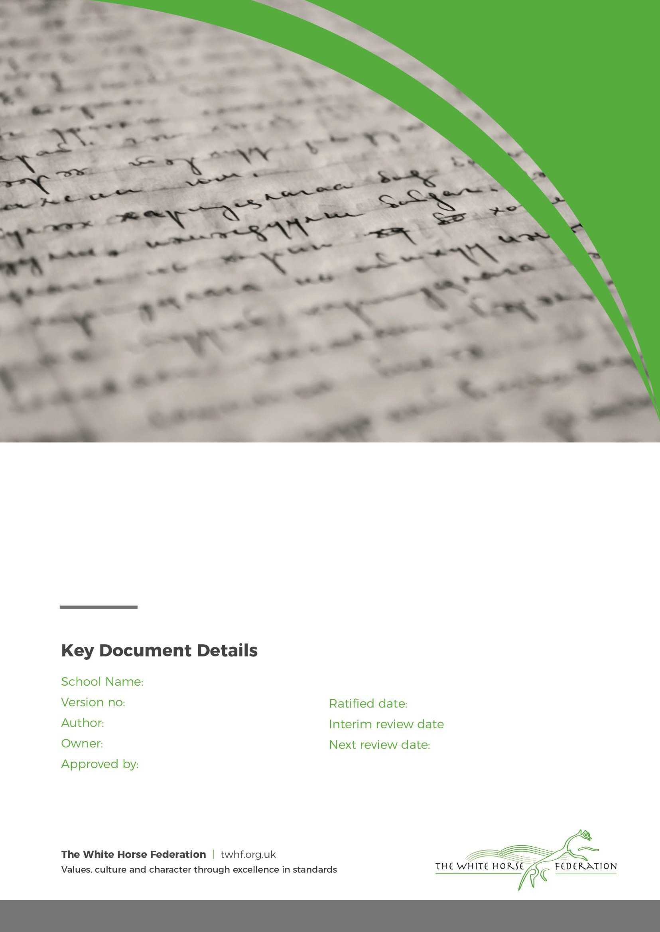
Shaw CofE Primary 1
Thomas Brewer Thomas Brewer Governors

March 24 n/a
Date for Review
March 26

Statement of Intent

We are committed to providing a caring, friendly and safe environment for all of our pupils so they can learn in a relaxed and secure atmosphere. Bullying of any kind is unacceptable at our school. If bullying does occur, all pupils should be able to tell and know that incidents will be dealt with promptly and effectively. We are a TELLING school. This means that anyone who knows that bullying is happening is expected to tell the staff.

Objectives of this policy

- All governors, teaching and non-teaching staff, pupils and parents should have an understanding of what bullying is.
- All governors and teaching and non-teaching staff should know what the school policy is on bullying, and follow it when bullying is reported.
- All pupils and parents should know what the school policy is on bullying, and what they should do if bullying arises.
- As a school we take bullying seriously. Pupils and parents should be assured that they will be supported when bullying is reported.
- Bullying will not be tolerated.

What is bullying?

Bullying is the use of aggression with the intention of hurting another person. Bullying results in pain and distress to the victim. Bullying usually involves DELIBERATELY doing something to hurt another person or their feelings “SEVERAL TIMES ON PURPOSE”.
The Anti-bullying Alliance states;

“Bullying is the repetitive, intentional hurting of one person by another, where the relationship involves an imbalance of power. Bullying can be carried out physically, verbally, emotionally or through cyberspace.”

Bullying can be:

- Emotional - being unfriendly, excluding, tormenting (e.g. hiding books, threatening gestures)
- Physical - pushing, kicking, hitting, punching or any use of violence
- Racist - racial taunts, graffiti, gestures
- Sexual - unwanted physical contact or sexually abusive comments
- Homophobic/Biphobic/Transphobic - because of, or focusing on the issue of sexuality or gender identity.
- Verbal - name-calling, sarcasm, spreading rumours, teasing
- Cyber - All areas of internet and mobile technology, such as text, snapchat, Facebook, email & internet chat room misuse.

Signs and Symptoms.

A child may indicate by signs or behaviour that he or she is being bullied. Adults should be aware of these possible signs and that they should investigate if a child:
- is frightened of walking to or from school
- doesn't want to go on the school / public bus
- begs to be driven to school
- changes their usual routine
- is unwilling to go to school (school phobic)
- begins to truant
- becomes withdrawn anxious, or lacking in confidence
- starts stammering

Page 2 of 4

- attempts or threatens suicide or runs away
- cries themselves to sleep at night or has nightmares
- feels ill in the morning
- begins to do poorly in school work
- comes home with clothes torn or books damaged
- has possessions which are damaged or "go missing"
- asks for money or starts stealing money (to pay bully)
- has dinner or other monies continually "lost"
- has unexplained cuts or bruises
- comes home starving (money / lunch has been stolen)
- becomes aggressive, disruptive or unreasonable
- is bullying other children or siblings
- stops eating
- is frightened to say what's wrong
- gives improbable excuses for any of the above
- is afraid to use the internet or mobile phone
- is nervous & jumpy when a cyber-message is received

These signs and behaviours could indicate other problems, but bullying should be considered a possibility and should be investigated

Why is it important to Respond to Bullying?

Bullying hurts. No one deserves to be a victim of bullying. Everybody has the right to be treated with respect. Pupils who are bullying need to learn different ways of behaving.
Why is it important to distinguish between “falling out” and bullying?

It is a natural and inevitable part of growing up that children will “fall out” with each other as a result of disagreements both within and beyond school. We teach children to deal with these occasions through talking, understanding, saying sorry and forgiving. It is not
helpful when adults use the term “bullying” to describe such occasions. They are almost always not bullying, they are part of growing up and understanding healthy relationships.

However, it is our belief that real bullying is NOT an inevitable part of growing up. It is when one child deliberately, with pre-planning and a lack of mutual respect picks on another child, unprovoked and several times on purpose
Procedures

Children are regularly reminded to report incidents to staff. Staff monitor and record these in line with our behaviour policy.
In cases of suspected bullying, the incidents will be recorded by staff and brought to the attention of Senior staff in line with our behaviour policy.

The bullying behaviour or threats of bullying will be investigated and the bullying stopped quickly. In serious cases parents will be informed and will be asked to come in to a meeting to discuss the problem.
If necessary and appropriate, police will be consulted

An attempt will be made to help the bully (bullies) change their behaviour.

Outcomes

- The bully (bullies) may be asked to genuinely apologise. Other consequences such as a playtime report card may be put in place.
- In serious cases, suspension or even exclusion will be considered.
- If possible, the pupils will be reconciled.
- After the incident / incidents have been investigated and dealt with, each case monitored.
Page 3 of 4

Prevention

We will use a variety of methods for helping children to prevent bullying. As and when appropriate, these may include:

  - writing a letter of apology
  - signing a behaviour contract
  - having discussions about bullying and why it matters
  - Meeting all parties together

We also have a child speak version of this policy
Please see appendix 1 – By School Council

Page 4 of 4

