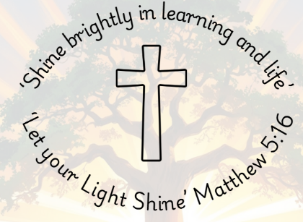

Computing Long Term Plan
2025 – 26

 | Term 1 | Term 2 | Term 3 | Term 4 | Term 5 | Term 6
Year 1 | Computing Systems and Networks | Creating Media A | Programming A | Data and Information | Creating Media | Programming B
Year 2 | Computing Systems and Networks | Creating Media A | Programming A | Data and Information | Creating Media | Programming B
Year 3 | Computing Systems and Networks  Connecting Computers | Creating Media A  Stop Frame Animation | Programming A  Sequencing Sounds | Data and Information  Branching Databases | Creating Media B  Desktop Publishing | Programming B Events and Actions in Programmes
Year 4 | Computing Systems and Networks  The Internet | Creating Media A  Audio Production | Programming A  Repetition in Shapes | Data and Information  Data Logging | Creating Media B  Photo Editing | Programming B Repetition in Games
Year 5 | Computing Systems and Networks  Systems and Searching | Creating Media A  Video Production | Programming A  Selection in Physical Computing | Data and Information  Flat-file Database | Creating Media B  Introduction to Vector Graphs | Programming B  Selection in Quizzes
Year 6 | Computing Systems and Networks Communication and Collaboration | Creating Media A  Web Page Creation | Programming A Variables in Games | Data and Information Spreadsheets | Creating Media B  3D modelling | Programming B Sensing Movement

