
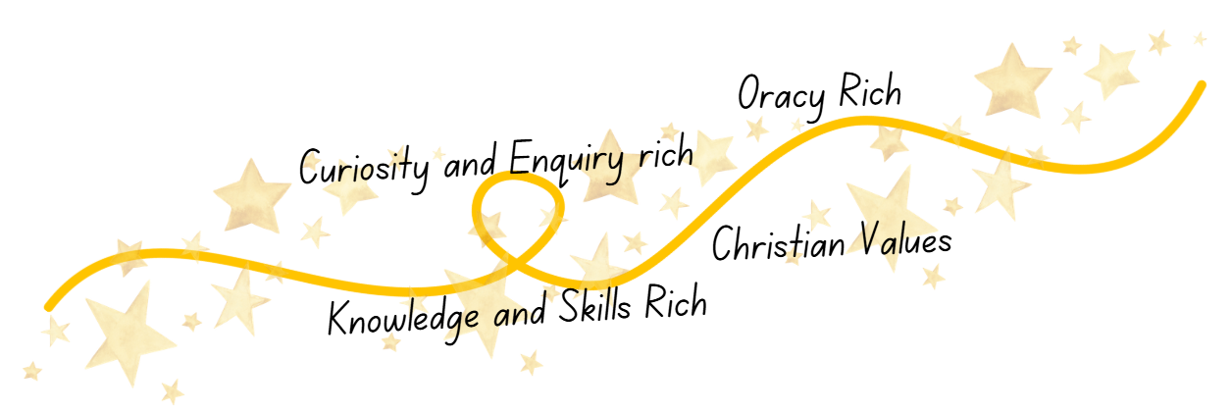

Curriculum Implementation
At Shaw C of E Primary School, French promotes curiosity, confidence and cultural awareness. Lessons use the Language Angels scheme and are carefully sequenced so knowledge and skills build progressively across Key Stage 2 in speaking, listening, reading and writing.
The curriculum is knowledge and skills rich, giving pupils secure understanding of vocabulary, sentence structures and grammar. It is oracy rich, with opportunities to practise pronunciation, perform dialogues and communicate ideas with increasing fluency. Learning is curiosity and enquiry rich, encouraging pupils to explore language patterns, make comparisons and apply knowledge creatively.
Although French is formally taught in Key Stage 2, pupils in Early Years and Key Stage 1 are introduced to languages through classroom experience.
Rooted in our Christian values, pupils demonstrate respect, compassion and openness, creating a supportive environment where all can thrive as confident language learners.

Languages
at
Shaw C of E Primary School
Curriculum Impact
The implementation of this curriculum ensures that when children leave Shaw C of E Primary School, they are confident communicators with a secure foundation in French and a growing appreciation of other cultures. They:
- Achieve well in French and apply a broad bank of vocabulary and grammatical knowledge in speaking, listening, reading and writing.
- Speak with increasing confidence and accurate pronunciation, using developed oracy skills to communicate ideas and ask questions.
- Read and understand age-appropriate French texts and write simple sentences with growing accuracy and fluency.
- Demonstrate curiosity and enquiry by exploring how language connects people and cultures around the world.
- Show respect, openness and compassion towards different languages and cultures, reflecting our Christian Values.
Pupils leave Shaw C of E Primary School with the knowledge, skills and cultural awareness to continue their language learning successfully at secondary school and to thrive in an increasingly connected world.

Curriculum Intent
At Shaw C of E Primary School, we believe that learning a modern foreign language broadens pupils’ horizons and deepens their understanding of the world. Our French curriculum inspires curiosity about language and culture, enabling all pupils to communicate with growing confidence.
Through the Language Angels scheme, pupils access engaging and inclusive lessons that develop vocabulary, pronunciation and grammatical understanding. The curriculum is progressive, building secure foundations in speaking and listening before extending to reading and writing in preparation for secondary school.
Our curriculum is intentionally knowledge and skills rich, securing progressive understanding of vocabulary and sentence structure. It is oracy rich, providing regular opportunities for pupils to practise pronunciation and speak with increasing fluency. Through curiosity and enquiry rich learning, pupils explore how language connects people and cultures.
Rooted in our Christian values, we foster respect, compassion and openness towards different cultures, celebrating diversity within our school community.

