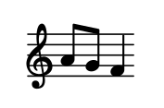
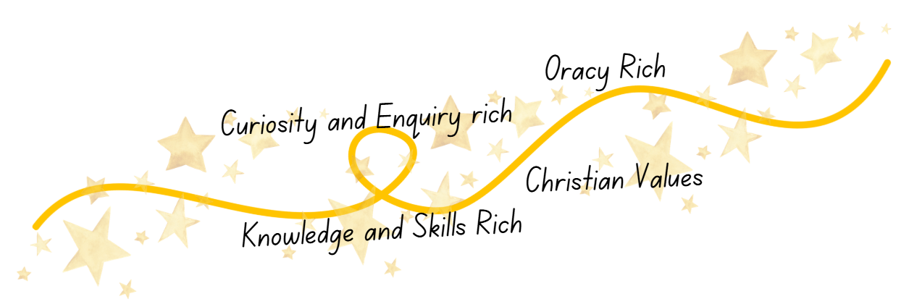
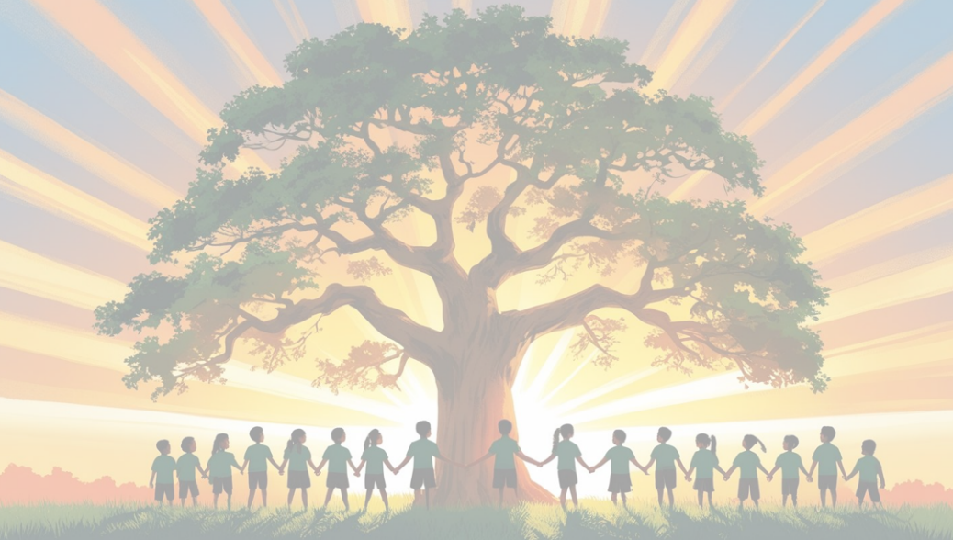
Music
at
Shaw C of E Primary School
Curriculum Impact
Through playing, singing, creating and performing, our children develop confidence, creativity, communication skills and emotional well‑being. They become musicians who can apply a secure and progressive set of knowledge and skills across a range of both tuned and untuned instruments.
Because our curriculum is Knowledge and Skills Rich, pupils leave each year group with a strong foundation of practical musicianship and technical understanding. Our Oracy Rich approach enables children to use musical vocabulary accurately, articulate opinions, evaluate music and communicate confidently in collaborative settings. Their musical learning is Curiosity and Enquiry Rich, reflected in their willingness to explore, investigate, ask questions and respond creatively to musical challenges. Rooted in our Christian Values, pupils demonstrate respect, teamwork, joy in music‑making, resilience in practice and pride in sharing their musical achievements with others.
As a result, our children develop a life‑long appreciation of music and the confidence to participate in musical opportunities both within school and beyond it.
Curriculum Implementation
At Shaw C of E Primary School, all children experience a sequenced, carefully designed programme of musical learning that enables them to develop practical musicianship, technical skills and an understanding of how music works. Every pupil engages with singing, performing, composing and listening throughout the year, with opportunities to build on prior learning so that knowledge and skills grow progressively.
The national curriculum forms the foundation for our planning, supported by the Charanga scheme, which ensures high‑quality, engaging and progressive learning across all year groups. Lessons are structured to be Knowledge and Skills Rich, enabling pupils to apply previously taught concepts while developing new musical techniques. Through Charanga’s emphasis on discussion, response frames and musical vocabulary, lessons are also Oracy Rich, providing pupils with regular opportunities to talk about what they hear and what they create. Our curriculum is Curiosity and Enquiry Rich, encouraging pupils to explore instruments, experiment with composition, and investigate a diverse range of musical traditions that reflect both our local context and wider world.
Specialists in guitar, piano and singing further enrich the curriculum. We also have Rocksteady providing children with opportunities to learn from experienced musicians. Learning is underpinned by our Christian Values, with collaboration, respect, perseverance and shared musical celebration embedded into classroom practice, ensemble work and performances. Our
Curriculum Intent
At Shaw C of E Primary School, we aim to provide a high‑quality music curriculum that is embedded in every aspect of school life and inspires a life‑long love of music in every child. Our ambition is for every child to recognise themselves as a musician, experiencing the joy, creativity and self‑expression that music enables. Through rich and inclusive musical opportunities, pupils develop the social, personal and transferrable skills that contribute to the growth of the whole child.
Our Music curriculum is intentionally Knowledge and Skills Rich, ensuring that children progressively build secure musicianship, developing technical skills, musical understanding and confidence over time. It is Oracy Rich, providing structured opportunities for children to talk about music, articulate preferences, use musical vocabulary and express themselves verbally with clarity and confidence. It is Curiosity and Enquiry Rich, encouraging pupils to explore sound, question musical ideas, experiment creatively and develop their own responses to a wide range of music. Grounded in our Christian Values, we nurture collaboration, joy, respect and confidence, ensuring that every child feels valued, supported and celebrated as a unique musician within our school community.

