



Religious Education at
Shaw C of E Primary School

Curriculum Intent
As a Church of England School, the Christian faith forms the foundations of everything that we do at Shaw. Our Christian faith influences not only what we teach, but how we teach, and we promote an environment where all children feel known, accepted, and valued as individuals, within a caring community. The teaching and learning of Religious Education offer opportunities to promote respect for others, to challenge stereotypes and to build understanding of other cultures and beliefs. This contributes to a positive and inclusive school ethos that champions diversity, responsibility, spirituality. We encourage children to develop an array of skills that will enable them to make their own positive influence in our global society, including:

- To provoke challenging questions about the ultimate meaning of life, beliefs about God, the nature of reality and morality.
- To develop pupils’ knowledge and understanding of Christianity, other principal world religions, religious traditions and worldviews, which offer answers to ultimate questions.
- To encourage pupils to develop their sense of identity and belonging, in order to flourish within communities, as responsible citizens in society and global communities.
- To teach pupils to develop respect for others and their beliefs and helps to challenge prejudice.
- To prompt pupils to consider their responsibilities to themselves and to others, and to explore how they might contribute to their communities and to wider society encouraging empathy, generosity and compassion.
- For children to be confident ‘retelling’ within the context of RE using the language structures.

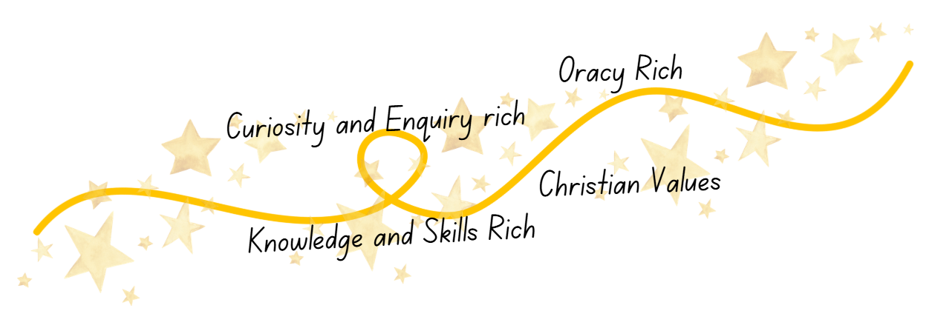

Curriculum Implementation
Christian Values Driver
At Shaw C of E Primary School, we believe it is fundamental for our children to belong to a safe, nurturing and inclusive community rooted in strong Christian values. Our Religious Education curriculum promotes secure knowledge of core Christian beliefs and teachings, while also fostering respect and understanding of other world faiths and worldviews.
Through carefully planned learning opportunities, we equip children with the knowledge, confidence and spiritual awareness to live well in today’s diverse society, rooted in the safety, purpose and hope that the Christian faith offers.
Our broad curriculum design, strong community links and tangible sense of spirituality enable all pupils to flourish and grow, regardless of background, ability or additional needs. We want every child to be confident in the knowledge that they are valued, loved and have a unique purpose. This is framed by our deeply embedded Christian vision:
“You are the light of the world… Let your light shine.” (Matthew 5:14–16)
At Shaw C of E Primary School, our vision ‘Let Your Light Shine’ underpins every aspect of school life. We believe each child has unique gifts and strengths, and through our RE curriculum, we nurture pupils to grow in confidence, compassion and faith.
Religious Education plays a vital role in enabling children to understand their identity as individuals made in God’s image, encouraging them to shine their light through courageous advocacy, kindness, service and respect for others. Through deep engagement with Christian theology and meaningful encounters with other faiths and worldviews, pupils are empowered to live out our vision in practical and purposeful ways.
Statement of Entitlement
The Church of England’s Statement of Entitlement outlines the right of every child to receive a high-quality Religious Education which supports them in all aspects of their development. It explains:
“Religious education in a Church school should enable every child to flourish and to live life in all its fullness.” (John 10:10)
At Shaw C of E Primary School, we ensure that we fully meet the requirements of the Statement of Entitlement through delivering a curriculum that is rich in substantive knowledge, disciplinary understanding and meaningful opportunities for reflection and discussion.
Curriculum Implementation – The Emmanuel Project
Our RE curriculum is delivered through The Emmanuel Project, the Church of England recommended scheme for primary schools. This ensures a coherent, progressive and theologically accurate approach to Religious Education across all year groups.
Through Project Emmanuel:
- Christianity is taught as a living and diverse global faith.
- Pupils explore key theological concepts including God, Creation, Fall, People of God, Incarnation, Gospel, Salvation and Kingdom of God.
- Children encounter a range of world religions and worldviews, developing respect, curiosity and critical thinking.
- Learning is structured to build depth over time, from EYFS through to Year 6.
- Pupils engage in enquiry-based learning, theological reflection and opportunities to express personal responses.
- Lessons include scripture study, discussion, creative reflection, philosophical questioning and links to real-life Christian practice. Pupils are encouraged not only to learn about religion, but to learn from religion — making connections to their own lives and the wider world.
Progression and Depth
Starting in the Early Years, children begin by exploring special stories, celebrations and belonging. As they move through the school, they develop:
- Secure knowledge of biblical narratives
- Understanding of Christian beliefs and their theological foundations
- Awareness of diversity within Christianity and other faith traditions
- The ability to ask thoughtful questions and articulate reasoned responses
- Religious literacy and appropriate subject vocabulary
By the end of Year 6, pupils leave Shaw C of E Primary School with a strong foundation in Christian theology, an informed understanding of other faiths, and the confidence to engage respectfully in discussion about belief and identity.

We use a variety of teaching methods including art, music, discussion, the development of thinking skills, drama, the use of artefacts, pictures, stories, and the use of reflection.

Curriculum Impact
How Our Golden Threads Are Evident in Religious Education
Through the implementation of Project Emmanuel, our Golden Threads are clearly visible in the impact of Religious Education across the school.

Christian Values  Religious Education at Shaw C of E Primary School enables pupils to live out our vision of ‘Let Your Light Shine’ (Matthew 5:14–16) in meaningful and practical ways.  Pupils:  - Ask and thoughtfully respond to challenging questions about the meaning of life, belief, morality and truth.  - Develop a strong sense of identity, belonging and purpose within our school and wider community.  - Show respect, tolerance and understanding towards people of all religions and worldviews.  - Demonstrate the ability to exemplify our school’s Christian values in daily life, rooted in biblical teaching.  - Grow in compassion, courage and responsibility as active, reflective citizens. | Knowledge and Skills Rich  Our RE curriculum ensures pupils leave with secure substantive knowledge and well-developed disciplinary skills.  Pupils:  - Have a strong understanding of how beliefs, values and practices within religions are interconnected.  - Retain key theological knowledge and vocabulary from the religions studied.  - Make meaningful links between biblical texts, Christian doctrine and lived faith.  - Confidently answer ‘ultimate questions’ using evidence and reasoning.  - Apply their knowledge to compare, analyse and reflect with increasing depth as they progress through the school.
Oracy Rich  RE provides rich opportunities for structured discussion, debate and theological reflection.  Pupils:  - Articulate thoughtful responses using accurate religious vocabulary.  - Engage in respectful dialogue, building on and challenging the ideas of others.  - Retell and interpret biblical narratives with clarity and understanding.  - Express personal reflections clearly, linking belief to meaning and purpose.  - Demonstrate confidence when discussing complex or sensitive issues. | Curiosity and Enquiry Rich  Religious Education nurtures curiosity about faith, belief and the wider world.  Pupils:  - Ask significant and reflective questions about religion and worldview.  - Demonstrate openness and intellectual curiosity when exploring different perspectives.  - Investigate concepts such as truth, justice, forgiveness, salvation and community.  - Show increasing independence in enquiry-based learning.  - Make connections between their learning in RE and real-life experiences.

Overall Impact
By the time pupils leave Shaw C of E Primary School, they are religiously literate, reflective and respectful individuals. They possess the knowledge, skills and confidence to engage thoughtfully with faith and belief, and they are equipped to let their light shine in their next stage of education and beyond.

