Shaw CE Primary School MFL Policy
July 2023
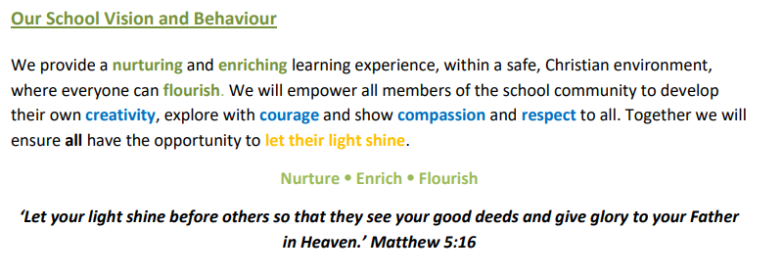

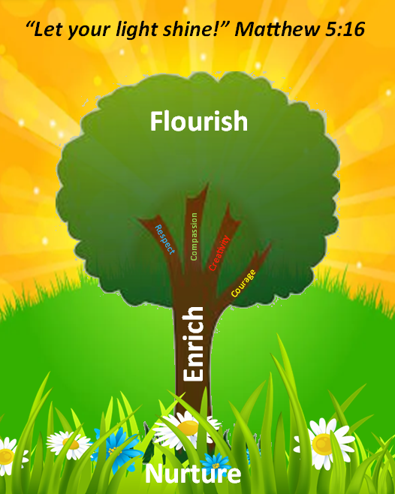
INTENT:
“Let Your Light Shine!” (Matthew 5:16)
Nurture Enrich Flourish
To ignite children’s passion for Modern Foreign Languages, through experience of vocabulary rich French lessons. To equip children with knowledge and strategies for learning a new language. To promote respect and understanding of different cultures and develop children’s oracy and communication skills and grammatical knowledge.

IMPLEMENTATION:
Core Christian Values: Respect Compassion Creativity Courage

Moden Foreign Languages Background
Children at Shaw are exposed to simple French phrases in Year 2 and Modern Foreign languages lessons from the start of Year 3. Their understanding of spoken and written language is then developed as they move through KS2 (to Year 6). The focus of study in modern foreign languages is on practical communication. Children have the opportunity to gain a respectful understanding of different cultures whilst further developing their geographical knowledge of key countries and landmarks within the world. The MFL French driven curriculum at Shaw, aims to inspire pupils to express their thoughts and ideas through another language and access literature in its original language. At Shaw, we believe that the MFL curriculum is an important aspect in children’s education as it provides children with the foundations for learning a new language and equips pupils with the necessary skills and knowledge needed to study and work in other countries.

What will be taught?
During children’s MFL lessons, children have opportunities to listen to the spoken French language and show understanding by joining in and responding. They explore the patterns and sounds of language through songs and rhymes, using actions to help memory and pronunciation. Daily instructions and simple phrases are used within and outside of lessons to embed this understanding and allow plenty of time for children to flourish with confidence as they apply these phrases naturally by the end of Year 6. This frequent practice further encourages children to speak in sentences, using familiar vocabulary, phrases and basic language structures.
During lessons, children engage in conversations; ask and answer questions; express opinions and respond to those of others as they learn about the grammatical aspects of the French language and compare these rules with our own language rules. As children become increasingly confident with their language, they will also have opportunities to build their French vocabulary bank through use of bilingual dictionaries helping them to further explore French spelling and grammatical rules such as masculine and feminine words and identify other language patterns.
When do we teach these skills?
Year 2- In Year 2 we build children’s confidence in learning language in preparation for their transition to Key Stage 2, At Shaw, we have introduced ‘French Friday’. Each week, children are taught how to speak and pronounce a French instruction or phrase that is used in everyday language such as ‘Silence s'il vous plait.’ (Silence please.) and ‘Salut’ (Hi). Children are then given the opportunity to learn, listen and practice this phrase over the course of the day, helping to expand their French vocabulary.
Year 3/Year 4- Knowledge/skills: Children will Introduce themselves and others, locate Paris on the map, continue to respond to French instructions, learn how to name the capital cities in the UK and be able to ask and answer questions about these capital cities, age and where people live, learn French numbers from 0-10, be able to follow a speaking frame to form sentences.
Spelling/Grammar: Children will Learn the phoneme [y] - and be able to identify it when they hear it, and when they see its grapheme ‘u’, be able to spell the names of countries in the UK, understand the importance of intonation, use conjunctions to link ideas and discuss the use of the circumflex accent.
Year 5/Year 6
In Year 5/6 French lessons, children will be introduced to key features and terminology of a bilingual dictionary, revise prior learning content, learn how to count up to 50, be able to tell the time using French phrases, practise using spoken questions and answers, create some written compound sentences and learn how to spell their name, and other familiar words, using French alphabet letters.
Spelling/Grammar: Children will, revise the concept of the grammatical gender of nouns, revise the agreement of an adjective with a feminine noun, use the preposition à with the definite article le: au.

Links across the curriculum:
At Shaw our language curriculum focuses on making links between the spoken language of French and French culture. This links to other areas of geography such as a study of a European country and looking at famous monuments such as La Tour Effiel and l’arc de Triompe.
Resources:
Currently, Shaw uses a learning scheme from ‘Institut Francais’ to support the teaching of French lessons. This scheme provides us with resources such as rhymes and songs which helps support and embed children’s understanding of language. Classes also have a list of frequent French instructions that are used daily to promote the use of spoken French within the classrooms.
Equal Opportunities
Learning a new language can be challenging. To best support pupils, activities and tasks are suited to pupil’s different abilities, needs and interests and balancing challenge with the likelihood of success to ensuring pupils at different starting points all make progress. Consistent oral practice of key instructions across year groups further helps to build children’s familiarity of listening to the French language thus building their confidence.
Why do we teach it?
The National Curriculum states that ‘Learning a foreign language is a liberation from insularity and provides an opening to other cultures.’ This is in keeping with our Shaw core value of respecting others. An understanding of a modern foreign language helps children broaden their knowledge of the world beyond the UK. It reinforces aspects of English language learning and gives them the opportunity to learn a completely new skill in KS2. In addition to this having a strong understanding of basic phrases and grammar rules in a child’s primary school will help to provide them with the foundations for expert languages teaching within secondary school.
IMPACT
Assessment and Monitoring: MFL (French) at Shaw CE Primary School is monitored through lesson observations, feedback from staff, and pupil voice. There should be evidence of MFL learning in children’s books once per topic taught so children have a record which they can refer back to in subsequent topics/lessons.
MFL at Shaw is assessed via, clear learning objectives for each lesson, Key end points for each unit of learning, Marking and ongoing verbal feedback.
Our end points:
As Linguists, children will be able to:
- Increasingly develop the confidence to speak French with good intonation and pronunciation.
- Be able to respond to French instructions given orally
- Be able to ask and answer a range of French questions
- Develop their fluency in reading simple French texts
- Demonstrate and increasing fluency and imagination in writing including the understanding of basic grammar rules
- Show a strong awareness of aspects of French culture
- Make use of a bilingual dictionary
- Express a passion for language learning

Review and evaluation of the policy
This policy was drawn up by the Modern Foreign Languages lead, working in consultation with staff. Its implementation is seen as the responsibility of all staff.

Signed …………………………………………………………………………………… Date ……………………………………………

